|  |  |
| --- | --- |
|  | **FPT ACADEMY INTERNATIONAL**  **FPT – APTECH COMPUTER EDUCATION** |

**Centre Name: ACE-HCMC-2-FPT.**

**Address: 590 Cach Mang Thang 8, District 3, Ho Chi Minh City, Viet Nam.**

**HKTT Store**

|  |  |  |
| --- | --- | --- |
| **Supervisor:** | MR. NGO PHUOC NGUYEN | |
| **Semester:** | 4 | |
| **Batch No:** | T1.1807.M0 | |
| **Group No:** | 1 | |
| **Order:** | **Full name** | **Roll No.** |
| 1. | LE NGOC DANG KHOA | Student1111538 |
| 2. | PHAM HUYNH | Student1107484 |
| 3. | HA MINH TAN | Student1113368 |
| 4. | HOANH THANH TAI | Student1120083 |

June 2020

This is to certify that

Mr. Le Ngoc Dang Khoa

Mr. Pham Huynh

Mr. Ha Minh Tan

Mr. Hoang Thanh Tai



have successfully designed and

developed 

Submitted by:

Date of Issue: ________

Authorized Signature: ___________



Contents

REVIEW I 7

Acknowledgment 8

Problem Definition 9

1. Problem Definition 9

1.1. Introduction 9

1.2. Existing scenario 9

2. Customer Requirements Specifications: 9

3. Functional Requirement Specification: 10

3.1. Guests (unregistered customers): 10

3.2. Members (registered customers): 10

3.3. Admin: 10

4. Technologies 11

5. Hardware / Software Requirements 12

5.1. Server, Admin Requirement 12

5.2. Mobile Requirement 13

6. Scope of project 13

Task Sheet Review I 14

REVIEW II 15

**I.** **USER CASE AND SEQUENCE DIAGRAM** 16

1. Guests (unregistered customers): 16

1.1 Register 16

1.2. View category, promotion, best product deals, recently added products 18

1.3. Search products by name 19

1.4. Get products list by sub category 20

1.5. Get product details 21

2. Members (registered customers) 22

2.1.1. Login 22

2.2. Change password 23

2.3. Update information 24

2.4. Add to cart / Increase quantity 25

2.5. View cart 26

2.6. Remove from cart / Decrease quantity 27

2.7. Check out 28

2.8. View orders list 29

2.9. View order details 30

3. Admin 31

3.1. Admin can manage category 33

3.2. Admin can manage sub category 37

3.4. Admin can manage unit 42

3.5. Admin can manage product 45

3.6. Admin can manage promotion 48

3.7. Admin can manage customer 51

3.8. Admin can manage order 54

3.9. Admin view report 55

II. Entity Relationship Diagram (ERD): 55

1. Logical 55

2. Entity Properties 56

2.1. Category 56

2.2. SubCategory 57

2.3. Manufacturer 57

2.4. Unit 58

2.5. Product 58

2.6. Promotion 59

2.7. Customer 60

2.8. Order 61

2.9. OrderDetail 61

2.10. Cart 62

2.11. CartDetail 62

2.12. Employee 63

III. Task sheet Review 2 64

REVIEW III 65

I. Database Relationship Diagram 66

II. Table Definition 66

1. Category 66

2. SubCategory 67

3. Manufacturer 67

4. Unit 67

5. Product 67

6. Promotion 68

7. Customer 69

8. Order 69

9. OrderDetail 70

10. Cart 71

11. CartDetail 71

12. Employee 71

III. Site map 72

1. Customer’s android application 72

2. Admin’s web site 73

IV. Customer GUI design 74

1. Splash screen 74

2. Login screen 75

3. Sign up 76

4. Home screen 77

5. Navigation Drawer when login as a guest 79

6. Navigation Drawer when login as a member 80

7. Profile 81

8. Account options 82

9. Change password 83

10. Update information 84

11. Product list filtered by sub category 85

12. Search by product name 86

13. Product’s details 87

14. My cart 88

15. Check out 89

16. Order history 90

17. Order’s details 91

V. Admin GUI design 92

1. Login page 92

2. Dashboard 93

3. Category page 94

4. Category insert page 95

4. Category update page 96

5. Subcategory page 97

6. Subcategory insert page 98

7. Subcategory update page 99

8. Unit page 100

9. Unit insert page 101

10. Unit update page 102

11. Manufacturer page 103

12. Manufacturer insert page 104

13. Manufacturer update page 105

14. Product page 106

15. Product insert page 107

16. Product update page 108

17. Promotion page 109

18. Promotion select product page 110

19. Promotion insert page 110

20. Promotion update page 111

21. Customer page 112

22. Customer page 113

23. Customer update page 114

24. Order page 115

25. Update order status page 115

26. Report page 116

VI. Task sheet Review 3 117

# REVIEW I

# Acknowledgment

We would like to acknowledge all those who have given support and help us make the project a success.

First and foremost, We wish to express our deep gratitude to our dedicated instructor Mr. Ngo Phuoc Nguyen, who suggestions and encouragement helped us to overcome not only technological challenges but also psychological tension. Without him, our work could not have been completed successfully.

Secondly, we highly appreciate the eProject Team at the Head Office which has provided us a golden opportunity to apply what we learned into practice. We are certain that the experiences we gained from this project will facilitate our future career greatly. Besides, we would also like to express my gratitude to all the staff members of my center for not only providing me with the opportunity to work with them on this project, but also for their support and encouragement throughout the process.

Finally, we would like to offer many thanks to all our schoolfellows for their valuable suggestions.

# Problem Definition

## Problem Definition

### Introduction

Online shopping is a form of electronic commerce (e-commerce) which allows consumers to directly buy goods or services from a seller over the Internet using a web browser. Consumers find a product of interest by visiting the website of the retailer directly or by searching among alternative vendors using a shopping search engine, which displays the same product's availability and pricing at different e-retailers.

### Existing scenario

With the development of mobile phone, now you can do a lot more in a mobile phone as in a computer and the amount of mobile apps are increasing by days, expecially e-commerce apps. With an e-commerce app you can do everything like using a web browser but more simpler. You can access an online shop using a web browser on your phone but it will depend a lot on what type of browser you are using. Maybe the browser can access to the website but it can not display correctly all the information the seller wanted, and because there are lot of web browser on mobile phone the sellers can not control all.

All of this leads to the grow of mobile e-commerce apps, because with a mobile app the seller will be easier to control what to display, how many functions needed… by themseft and not depend of any type of web browser. And using mobile app will be more convenience for delivery cause they can access to GPS easier than a browser.

## Customer Requirements Specifications:

* Mobile app will be a 24/7 sales channel to provide customers information about the product, order online at the app at any time. Specially, customers can:
* View detailed information about the product.
* Search products by name or filter products by categories.
* Customer have to register to manage their personal information, add product to cart, check orders history.
* Admin website will be a 24/7 so the seller can:
* Manage when they have new order.
* Store management: add, delete, edit components of the database.
* Report to manage business activities of the store.

## Functional Requirement Specification:

### Guests (unregistered customers):

1. Description:

* Guests can use basic functions of the website such as viewing: best product deals, newest product, product details, shop’s information contacts, searching products, making orders and manage carts, signing up to become members.

1. Functional Requirement

* When a customer first open the app, a login screen will show. Here the customer can enter email and pass word to login if they are registered or press Skip to go to Home screen.
* They can press signup to go to sign up screen to register a new account. Members should provide Email, Password, Name, Phone to create an account.
* In home screen will be a navigation drawer, if press the hambeger icon on the top left, you will see the categories and sub categories. If you selected a sub category, you will see all products belong to that sub category.
* At the top of the home screen also has a search bar to filtered product by name.
* The home screen also include a slider with promotion banner for products, list of best deals and newest products.
* The customer can also view product details.
* The unregistered customers can not add product to cart, they need to register first.

### Members (registered customers):

1. Description:

* Members can do all function as guests but they will be able to access more features after login. After login, they can update their information including password change.

1. Functional Requirement

* Members can add product to cart.
* View cart details, they can add more or remove that product from cart or change quantity of product.
* Check out: Members have to provide more information like name, phone, shipping address, note….
* View Order history to check their order status.

### Admin:

1. Description:

* Admis are store’s staffs. After login, they will manage information related to products and customers, follow customers’ orders, diagnostic shop’s business status via number of sales and charts.

1. Functional Requirement

Via admins’ pages, after log in using username and passwords, admins can:

* Manage information related to products and customers:
* View, add, update, delete: data in tables such as Category, SubCategory, Unit, Manufacturer, Product, Promotion, Customer.

Note: In table Product, if a product had been order, you can not delete it completely. If you do not what to sale that product, you can change the status IsActive to false.

* Follow customers’ orders: Have a page to change the orders’ status with values (listed base on real order): processing (default - 1), shipping (2) and completed (3).

Note: When update status, new value should be validated to make sure previous order of current order not be chosen (example: if current status is ‘shipping’, then ‘processing’ should not be chosen).

* View report about sales status.

## Technologies

- JavaEE 7

- JavaServer Faces 2.2

- Enterprise Java Bean (EJB) 3.0

- Bootstrap 3.7

- HTML 5 + CSS 3

- Javascript

- Jquery 2.1

- Jquery UI 1.11.1

- Android Studio

+ Retrofit

+ Recycler view

+ Picasso

+ Gson

- ASP.NET Core API

## Hardware / Software Requirements

### Server, Admin Requirement

* Hardware

|  |  |
| --- | --- |
| **Component** | **Requirement** |
| **CPU** | Processor type:  Pentium IV-compatible processor or faster  Processor speed:  Recommended: 2.0 GHz or faster |
| **OS** | Microsoft Windows Server 2012 with IIS |
| **Memory (RAM)** | RAM:  Minimum: 2 GB  Recommended: 4 GB or more |
| **Hard Drive** | Free space:  Minimum: 10 MB  Recommended: 50 GB or more  Maximum: Operating system maximum |

* Software

|  |  |
| --- | --- |
| Component | Requirement |
| Microsoft .NET Core | Version 3.1 or higher |
| IIS Manager | Version 10.0 or higher |
| RDBMS | Microsoft SQL Server 2017 |
| Netbean | Version 11.3 or higher |
| JavaEE | JavaEE 7 SDK |
| Java Development Kit | Java Development Kit (JDK) 1.7 |
| Glassfish Server | Glassfish Server 4.0 |
| Web browser | 1. or higher. |

### Mobile Requirement

* Hardware
* Android phone with Android 8.0 Oreo (API 26) or later.
* Atleast 2GB of RAM.
* Internet connection required.
* Software
* Allowing app installs from Unknown Sources since we can not publish to Google play.

## Scope of project

There are some functions not to be included in this project as follows:

* Manage the warehouse: all products will be always available, no import activity.
* Manage the shipping.
* Manage payment methods via credit card.
* Mobile app user can not review product.

|  |  |  |  |  |  |  |
| --- | --- | --- | --- | --- | --- | --- |
| Project Ref. No: | | Project Title:  HKTT Store | Date of Preparation of Activity Plan | | | |
| No. | Task | Description | Start Date | Complete Date | Team Member Names | Status |
| 01 | Review 1 | Problem Definition | 22/05/2020 | 27/05/2020 | All Members | Completed |
| 02 | Customer Requirements Specifications | Completed |
| 03 | Functional Requirement Specification | Completed |
| 04 | Technologies | Completed |
| 05 | Hardware / Software Requirements | Completed |
| 06 | Scope of project | Completed |

# Task Sheet Review I

|  |  |  |
| --- | --- | --- |
|  | Prepare By: Group 1 | Approved By: |
| Date: 01/06/2020 | Team Leader  Le Ngoc Dang Khoa | Mr. Ngô Phước Nguyên |

# REVIEW II

1. **USER CASE AND SEQUENCE DIAGRAM**

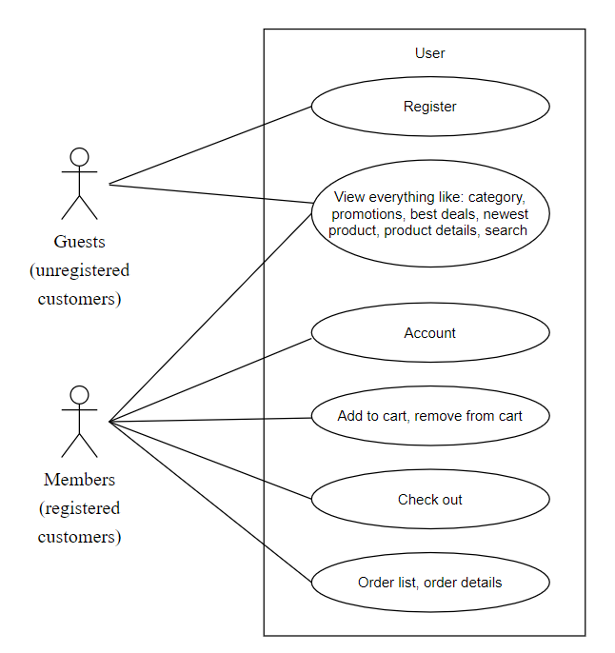

## Guests (unregistered customers):

* 1. Register

|  |  |  |
| --- | --- | --- |
| **Author** | Le Ngoc Dang Khoa | |
| **Use Case Name** | Register new account | |
| **Actors** | Guests (unregistered customers) | |
| **Description** | Actor registers an account on the register screen and becomes a member (customer) | |
| **Requirements** | Actor provides their register information | |
|  | **Actor Actions** | **System Responses** |
| **Basic flow** | 1. Input information like: Name, Email, Phone, Address, Password, Confirm password and click on Submit button | 2. Check the information  [Exception 1]  3. Create customer account  4. Show message to go to login screen. |
| **Exception** | [Exception 1]  1. Actor left Name blank  2. Actor left Email blank  3. Actor left Phone blank  4. Actor left Address blank  5. Email is in wrong format.  6. Password length is less than 3.  7. Confirm Password.  8. Email is registed by other customer.  9. Phone is registed by other customer. | Display error message:  1. “Name can not be blank”  2. “Email can not be blank”  3. “Phone can not be blank”  4. “Address can not be blank”  5. “Email is in wrong format”  6. “Password length must be greater  than 3”  7. “Confirm Password does not  match with Password”.  8. “Email is registed by other customer”  9. “Phone is registed by other customer” |

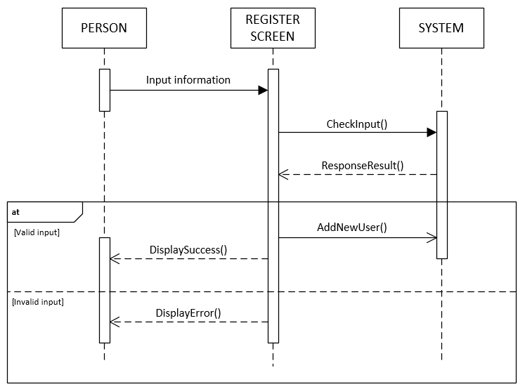

* 1. View category, promotion, best product deals, recently added products

|  |  |  |
| --- | --- | --- |
| **Author** | Le Ngoc Dang Khoa | |
| **Use Case Name** | View category, promotion, best product deals, recently added products | |
| **Actors** | Both guests (unregistered customers) and members (registered customers) | |
| **Description** | After the guest press skip button or a member login success, the home screen will show. | |
| **Requirements** |  | |
|  | **Actor Actions** | **System Responses** |
| **Basic flow** | 1. Application will try to connect to API and get information like: categories, promotions, best product deals, recently added products. | 2. System will get promotion and display in the slider.  Category will be loaded in the navigation drawer.  Best deals and recently added products will be loaded in two list.  3. If the actor enter home screen as a guest, no logout button will show and the actor can not see orders or cart list. |
| **Exception** |  | 2. If application can not connect to API to fetch information, application shows message: “Can not fetch data. Please check internet connection”. |

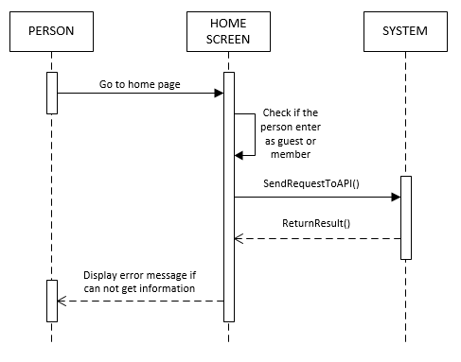

* 1. Search products by name

|  |  |  |
| --- | --- | --- |
| **Author** | Le Ngoc Dang Khoa | |
| **Use Case Name** | Search products by name | |
| **Actors** | Both guests (unregistered customers) and members (registered customers) | |
| **Description** | Actor enter search string in search bar and click on search button, search result screen will be displayed with result list of products and their information. | |
| **Requirements** | Search string can not be blank. | |
|  | **Actor Actions** | **System Responses** |
| **Basic flow** | 1. Actor input search string and click on search button. | 2. System check the search string  [Exception 1]  3. System create an empty list to  contain search result.  4. Send request to api, which will search in Product table to find  products which have names contain  the search string (ignore case) and  add them to result list. API will send back to result to application.  4. Display the result list in the search  result screen. |
| **Exception** | 1. Actor left the search string empty.  4. | 1. An error message will be display:  “Search string can not be empty”.  4. If application can not connect to API to fetch information, application shows message: “Can not fetch data. Please check internet connection”. |

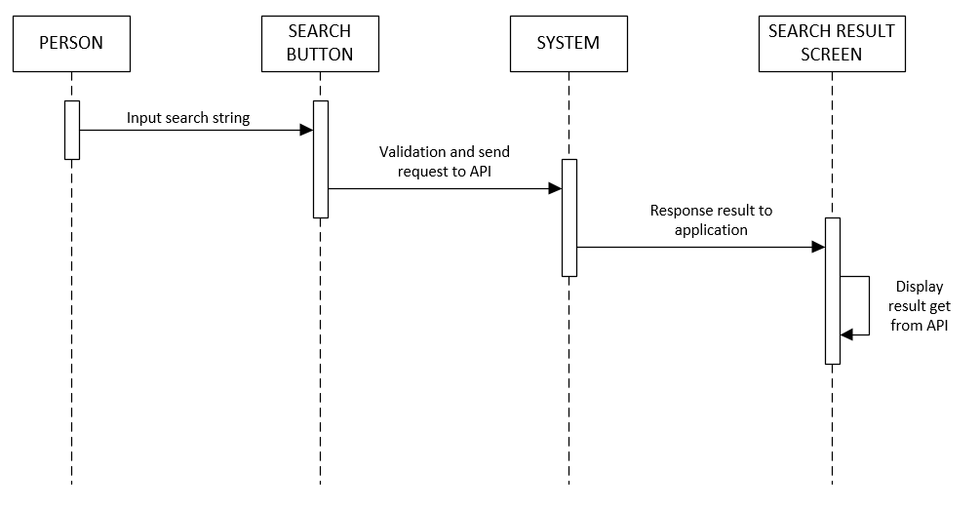

* 1. Get products list by sub category

|  |  |  |
| --- | --- | --- |
| **Author** | Le Ngoc Dang Khoa | |
| **Use Case Name** | Get products list by sub category | |
| **Actors** | Both guests (unregistered customers) and members (registered customers) | |
| **Description** | Actor select a sub category name in the navigation drawer, application will display all products of that sub category | |
| **Requirements** |  | |
|  | **Actor Actions** | **System Responses** |
| **Basic flow** | 1. Actor select a sub category name in the navigation drawer. | 2. Application will send request to API and system will response with the list of product belong to that sub category in the result screen. |
| **Exception** |  | 2.If application can not connect to API to fetch information, application shows message: “Can not fetch data. Please check internet connection”. |

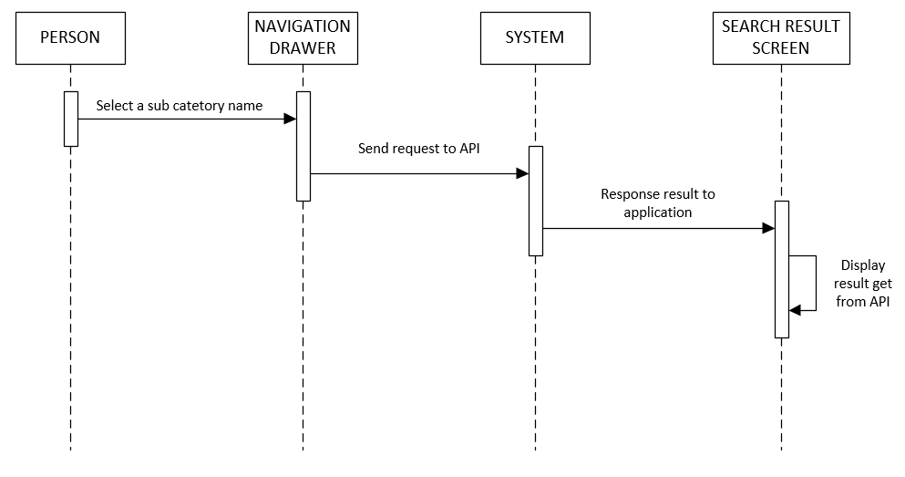

* 1. Get product details

|  |  |  |
| --- | --- | --- |
| **Author** | Le Ngoc Dang Khoa | |
| **Use Case Name** | Get product details | |
| **Actors** | Both guests (unregistered customers) and members (registered customers) | |
| **Description** | When the actor click on a product, application will send request to API with selected product ID and response with that product detals | |
| **Requirements** |  | |
|  | **Actor Actions** | **System Responses** |
| **Basic flow** | 1. Actor select any product and click on that product image or name. | 2. Application will send request to API with the product Id and system will response with the details of that product (if found) in the deatails screen. |
| **Exception** |  | 2.If application can not connect to API to fetch information, application shows message: “Can not fetch data. Please check internet connection”. |

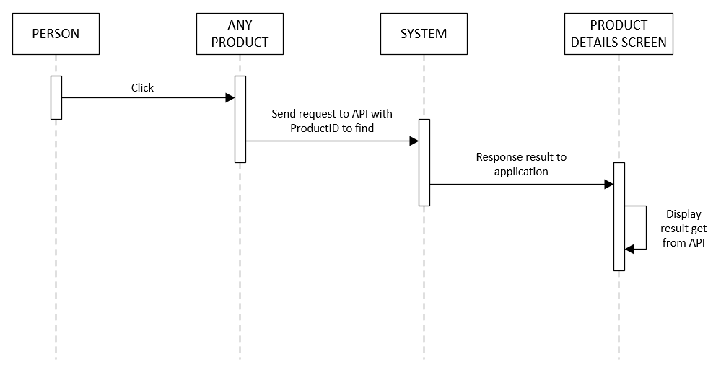

1. Members (registered customers)
   * 1. Login

|  |  |  |
| --- | --- | --- |
| **Author** | Le Ngoc Dang Khoa | |
| **Use Case Name** | Login | |
| **Actors** | Members (registered customers) | |
| **Description** | Customer who has registered an account can login | |
| **Requirements** | Actor provides email and password | |
|  | **Actor Actions** | **System Responses** |
| **Basic flow** | **Case 1:**  1. Actor press skip button.  **Case 2:**  1. Actor inputs Email and Password, then click the ‘Login’ button. | **Case 1:**  2. Show home screen.  **Case 2:**  2. System checks the information.  3. System start home screen. |
| **Exception** | **Case 2:**  1. Actor inputs invalid email and password.  2. Actor account is deactived cause the actor had try to login with wrong password more than 3 times. | **Case 2:**  1. System shows message: “Invalid email or password”.  2. System shows message: “Account is deactivated. Please contact us for more information”. |

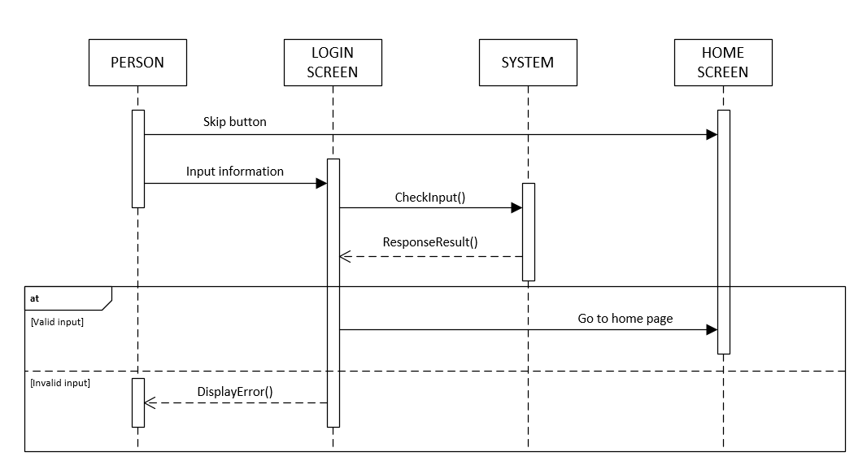

* 1. Change password

|  |  |  |
| --- | --- | --- |
| **Author** | Le Ngoc Dang Khoa | |
| **Use Case Name** | Change password | |
| **Actors** | Members (registered customers) | |
| **Description** | Customer want to change the registered password | |
| **Requirements** | Login as members | |
|  | **Actor Actions** | **System Responses** |
| **Basic flow** | 1. Input Old Password, New Password and Confirm Password | 2. Check information  [Exception 1]  3. Update New Password into  Customers table |
| **Exception** | [Exception 1]  1. Old Password is wrong.  2. New Password length is less than 3  3. Confirm Password does not match with  New Password | Display error message:  - “Old Password is wrong”  - “New Password length is less than  3”  - “Confirm Password does not match  with New Password” |

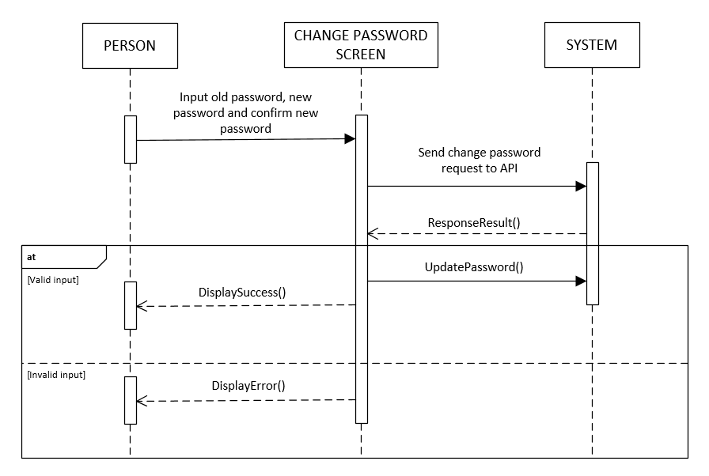

* 1. Update information

|  |  |  |
| --- | --- | --- |
| **Author** | Le Ngoc Dang Khoa | |
| **Use Case Name** | Update information | |
| **Actors** | Members (registered customers) | |
| **Description** | Customers want to change their private information | |
| **Requirements** | Actor provides email and password | |
|  | **Actor Actions** | **System Responses** |
| **Basic flow** | 1. Actors change Name,  Email, Phone, Address. | 2. System check information  [Exception 1]  3. Update new information to data in  Customers table. |
| **Exception** | [Exception 1]  1. Actor left Name blank  2. Actor left Email blank  3. Actor left Phone blank  4. Actor left Address blank  5. Email is not correct format  6. Email is registed by other customer.  7. Phone is registed by other customer. | Display error message:  1. “Name can not be blank”  2. “Email can not be blank”  3. “Phone can not be blank”  4. “Address can not be blank”  5. “Email is not correct format”  6. “Email is registed by other customer.”  7. “Phone is registed by other customer.” |

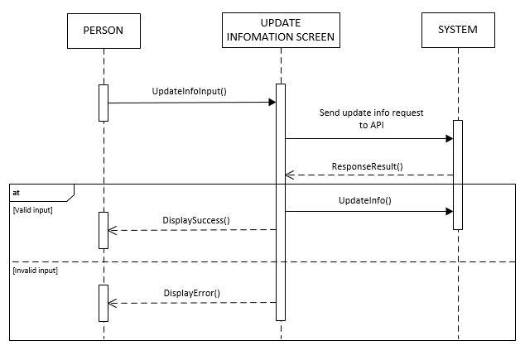

* 1. Add to cart / Increase quantity

|  |  |  |
| --- | --- | --- |
| **Author** | Le Ngoc Dang Khoa | |
| **Use Case Name** | Add to cart / Increase quantity | |
| **Actors** | Members (registered customers) | |
| **Description** | When customers select the quantity and clicks on “Add to Cart” in screen like Home screen, Product Details screen…., the selected product will be added/updated into list of cart items. | |
| **Requirements** |  | |
|  | **Actor Actions** | **System Responses** |
| **Basic flow** | 1. Selects the quantity and clicks on  “Add to Cart”. | 2. Check the added product:  + If existed in cart, system will add  the quantity to the existed item’s  quantity.  + Else, system will add the product  with the selected quantity into the list of cart items. |

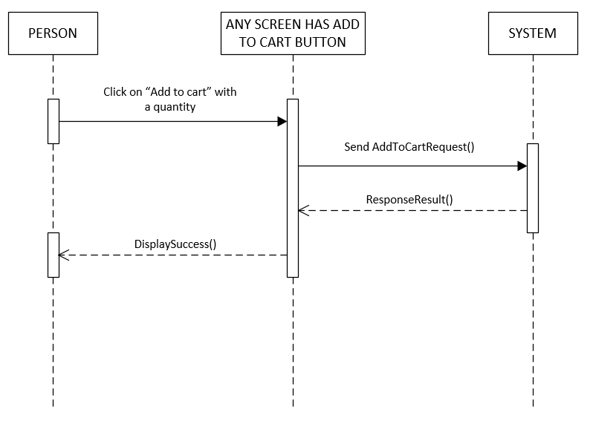

* 1. View cart

|  |  |  |
| --- | --- | --- |
| **Author** | Le Ngoc Dang Khoa | |
| **Use Case Name** | View carrt | |
| **Actors** | Members (registered customers) | |
| **Description** | When customers cart icon to see items in cart | |
| **Requirements** |  | |
|  | **Actor Actions** | **System Responses** |
| **Basic flow** | 1. Actor selects the cart icon. | 2. Respone with a list of item in cart base on Customer ID |

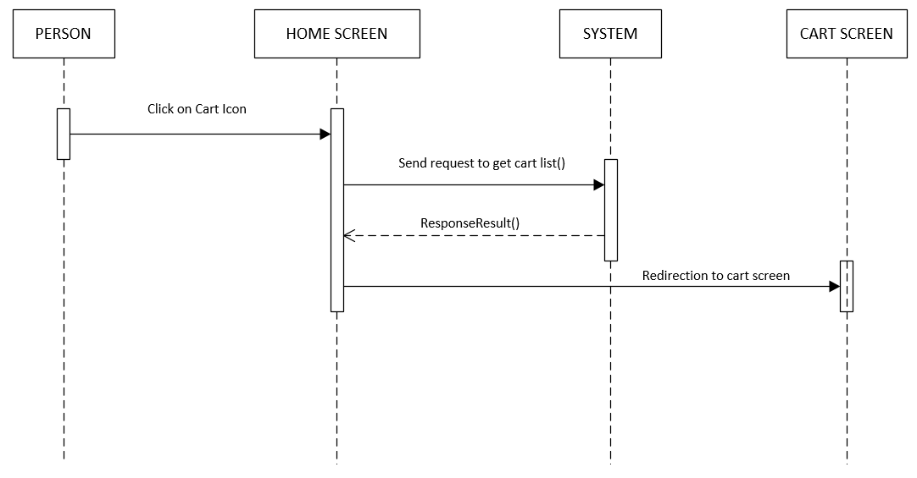

* 1. Remove from cart / Decrease quantity

|  |  |  |
| --- | --- | --- |
| **Author** | Le Ngoc Dang Khoa | |
| **Use Case Name** | Remove from cart / Decrease quantity | |
| **Actors** | Members (registered customers) | |
| **Description** | In Cart screen, when the customer click on Minus icon to decrease quantity or click on Trash can icon to remove product from cart | |
| **Requirements** |  | |
|  | **Actor Actions** | **System Responses** |
| **Basic flow** | 1. Click on Minus icon or Trash can icon | 2.  - Click on Minus icon, decrease quantity of product by 1.  - Click on Trash can icon: remove product from cart |

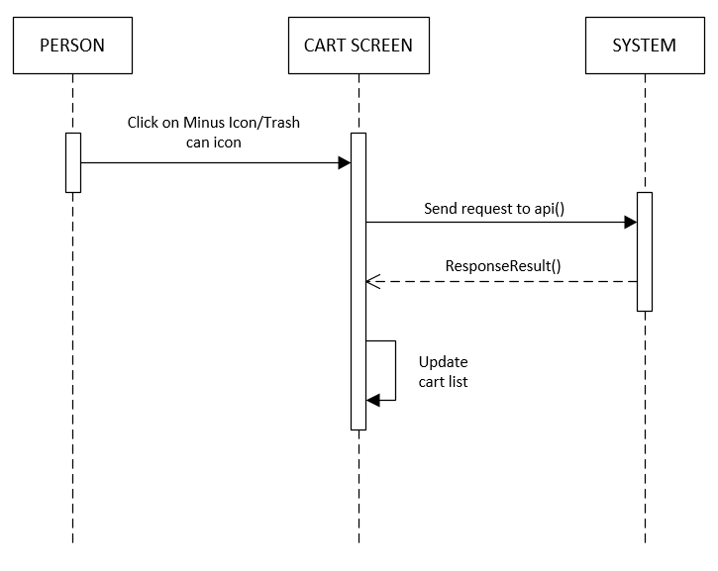

* 1. Check out

|  |  |  |
| --- | --- | --- |
| **Author** | Le Ngoc Dang Khoa | |
| **Use Case Name** | Check out | |
| **Actors** | Members (registered customers) | |
| **Description** | Display field for customers to input information about shipping and payment  method. | |
| **Requirements** | List of cart items can not be null. | |
|  | **Actor Actions** | **System Responses** |
| **Basic flow** | 1. Actor input shipping information (* character means that is a required field)  4. Actor click on OK | 2. System check information  [Exception 1]  3. System show a confirm message for Actor to confirm.  5. System add create a new Order. |
| **Exception** | [Exception 1]  1. Actor left Name blank  2. Actor left Phone blank  3. Actor left Address blank | Display error message:  1. “Name can not be blank”  2. “Phone can not be blank”  3. “Address can not be blank” |

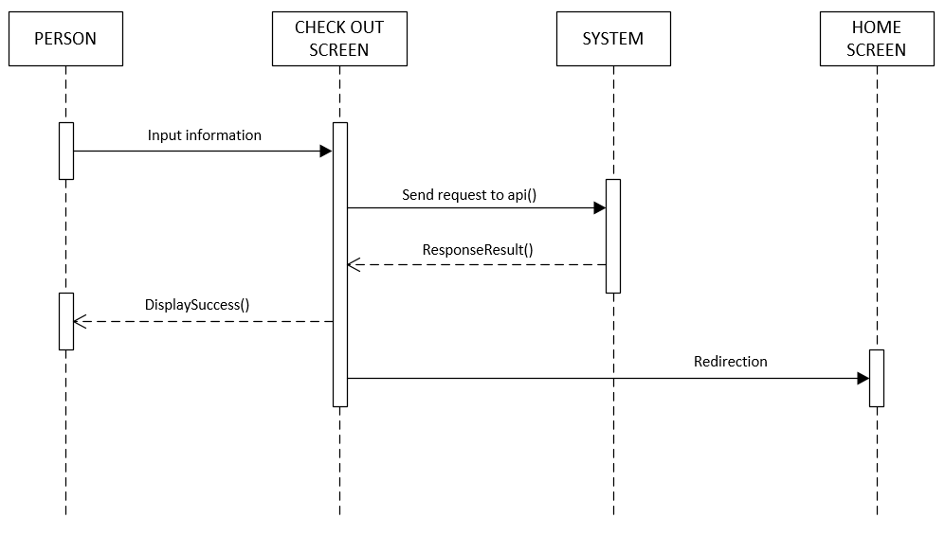

* 1. View orders list

|  |  |  |
| --- | --- | --- |
| **Author** | Le Ngoc Dang Khoa | |
| **Use Case Name** | View orders list | |
| **Actors** | Members (registered customers) | |
| **Description** | Customers want to see their order list to check status of an order | |
| **Requirements** |  | |
|  | **Actor Actions** | **System Responses** |
| **Basic flow** | 1. Clicks on Orders history in the navigation drawer | 2. System display all Orders of the customer in the orders screen |

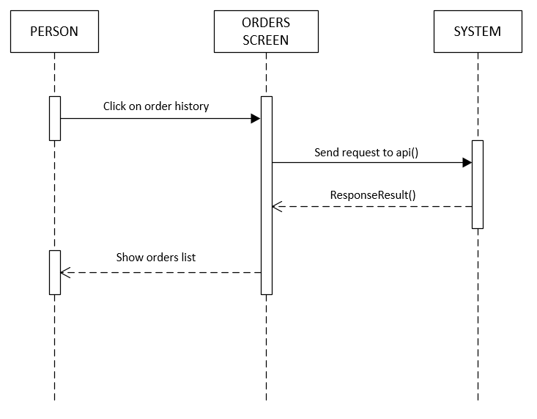

* 1. View order details

|  |  |  |
| --- | --- | --- |
| **Author** | Le Ngoc Dang Khoa | |
| **Use Case Name** | View order details | |
| **Actors** | Members (registered customers) | |
| **Description** | Customers want to see the details of an order | |
| **Requirements** |  | |
|  | **Actor Actions** | **System Responses** |
| **Basic flow** | 1. Actors click on an order to check it details | 2. System response with the details of an order base on OrderCode |

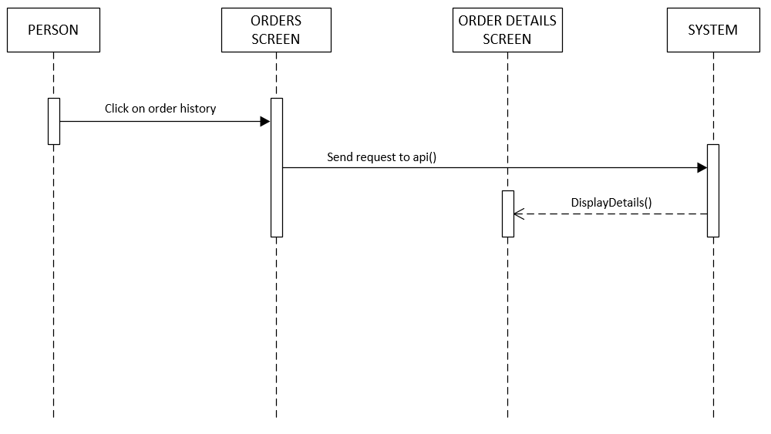

1. Admin

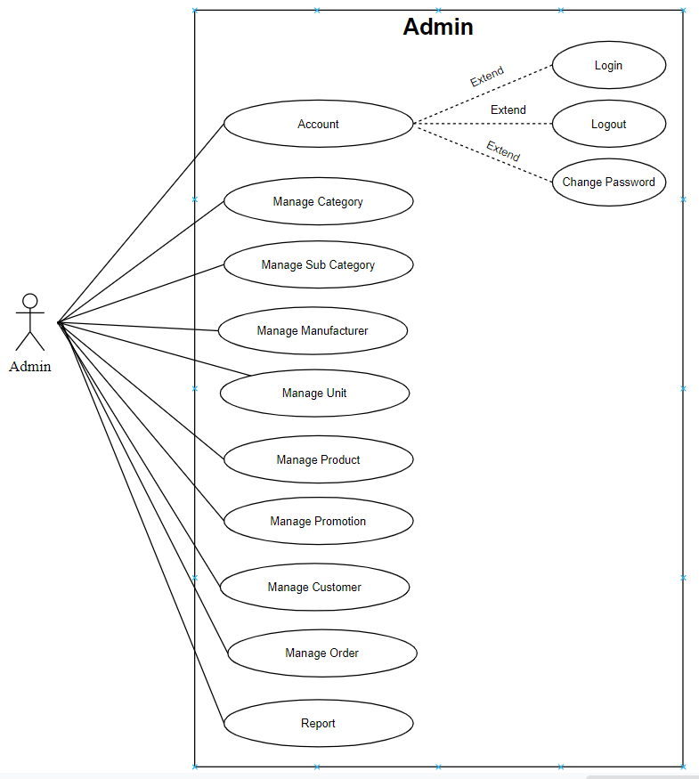

### 3.1. Admin can manage category

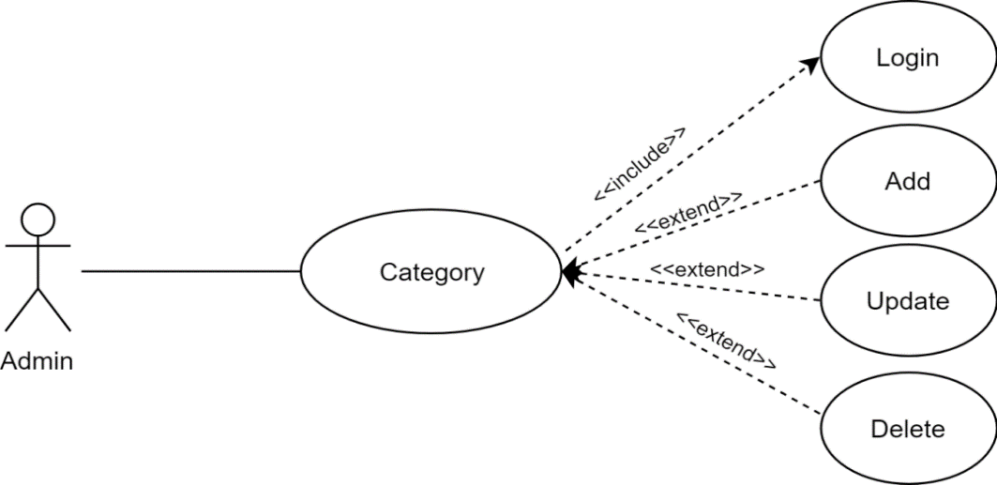

|  |  |  |
| --- | --- | --- |
| **Author** |  | |
| **Use Case Name** | Admin manage categories | |
| **Actors** | Admin | |
| **Description** | Admin can add, update category | |
| **Requirements** | Admin must log in successfully | |
| **Pre-conditions** |  | |
| **Post-conditions** | Success: Display Categories list | |
|  | **Actor Actions** | **System Responses** |
| **Basic flow** | 1. Actor chooses Category on menu.  3. Actor clicks ‘Add New Category’ button or select Category to update.  5. Actor inputs information to create/ update Category. | 2. System redirects to ' Category List' page and displays a list of Category.  4. System displays a form with the following fields:  - Category’s Name  6. System validates inputs.  7. System adds Category into the database.  8. System displays confirmation message or error message. |
| **Alternative Flow** |  |  |
| **Exception Flow** | 1. Actor left ‘Category’s Name’ field blank. | System displays messages: - ‘Category’s Name cannot be blank. |

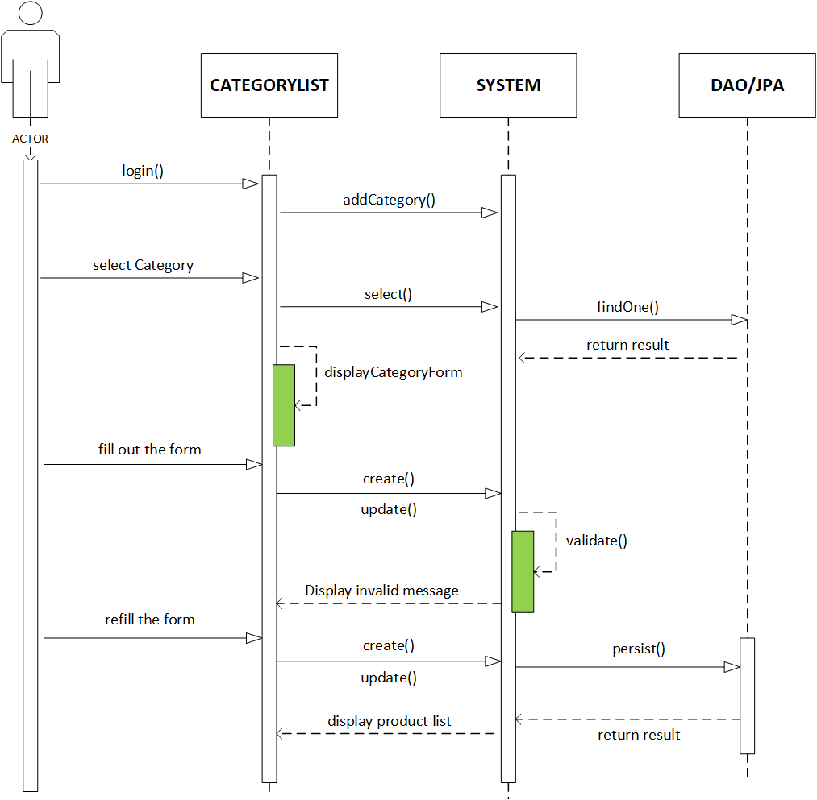

|  |  |  |
| --- | --- | --- |
| **Author** | Nguyen Thi Thuy Trang | |
| **Use Case Name** | Admin manage categories | |
| **Actors** | Admin | |
| **Description** | Admin can delete category | |
| **Requirements** | Admin must log in successfully | |
| **Pre-conditions** |  | |
| **Post-conditions** | Success: Category is deleted from the database | |
|  | **Actor Actions** | **System Responses** |
| **Basic flow** | 1. Actor chooses Category Tab on menu.  3. Actor clicks on ‘Delete’ button and confirm. | 2. System redirects to 'Category List' page and displays a list of existing Categorys.  4. System deletes Category from database.  5. System displays confirmation message or error message. |
| **Alternative Flow** |  |  |
| **Exception Flow** |  |  |

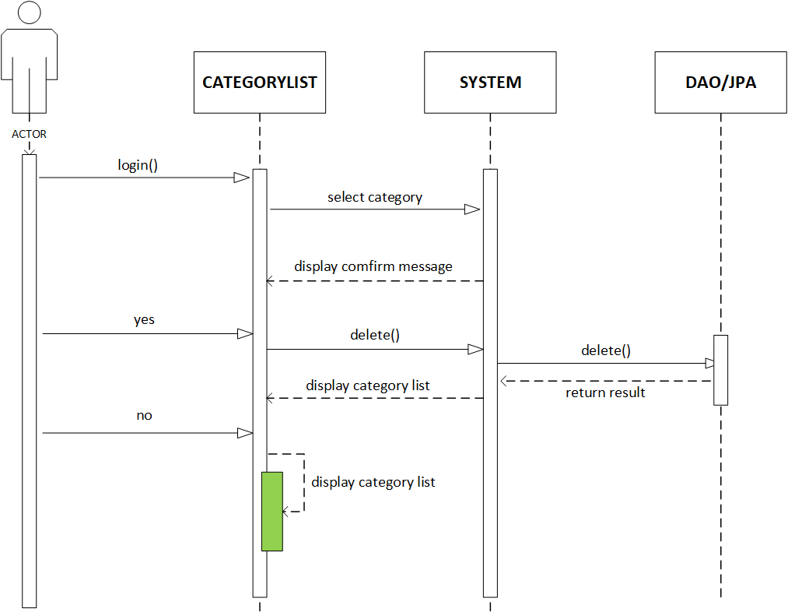

|  |  |  |
| --- | --- | --- |
| **Author** |  | |
| **Use Case Name** | Admin manage units | |
| **Actors** | Admin | |
| **Description** | Admin can delete unit | |
| **Requirements** | Admin must log in successfully | |
|  | **Actor Actions** | **System Responses** |
| **Basic flow** | 1. Actor chooses Unit Tab on menu.  3. Actor clicks on ‘Delete’ button and confirm. | 2. System redirects to ' Unit List' page and displays a list of existing Units.  4. System deletes Unit from database.  5. System displays confirmation message or error message. |

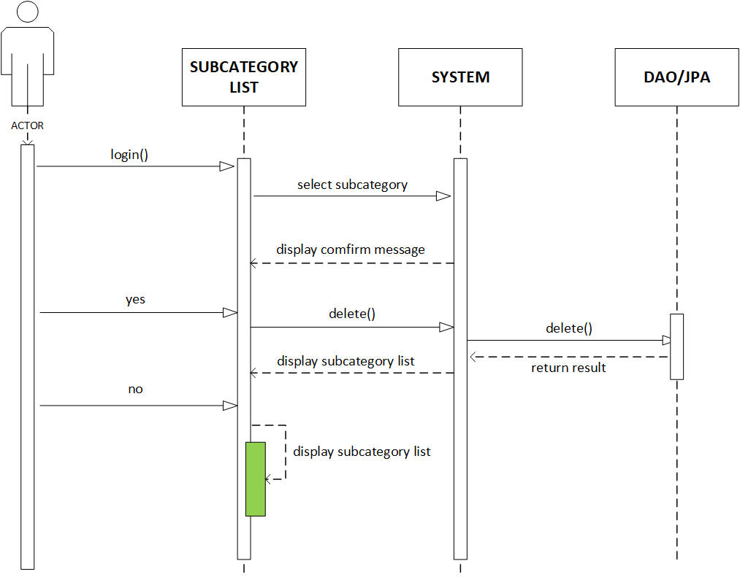

### 3.2. Admin can manage sub category

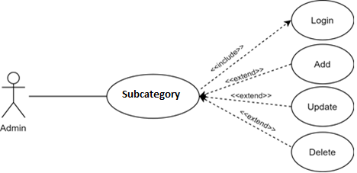

|  |  |  |
| --- | --- | --- |
| **Author** |  | |
| **Use Case Name** | Admin manage units | |
| **Actors** | Admin | |
| **Description** | Admin can add, update unit | |
| **Requirements** | Admin must log in successfully | |
| **Basic Flow** | 1. Actor chooses Unit on menu.  3. Actor clicks ‘Add New Unit ’ button or select Unit to update.  5. Actor inputs information to create/ update Unit . | 2. System redirects to ' Unit List' page and displays a list of Unit .  4. System displays a form with the following fields: - Unit ’s Name  6. System validates inputs.  7. System adds Unit into the database.  8. System displays confirmation message or error message. |
| **Alternative Flow** |  |  |
| **Exception Flow** | 1. Actor left input field field blank. | System displays messages: - Input field cannot be blank. |

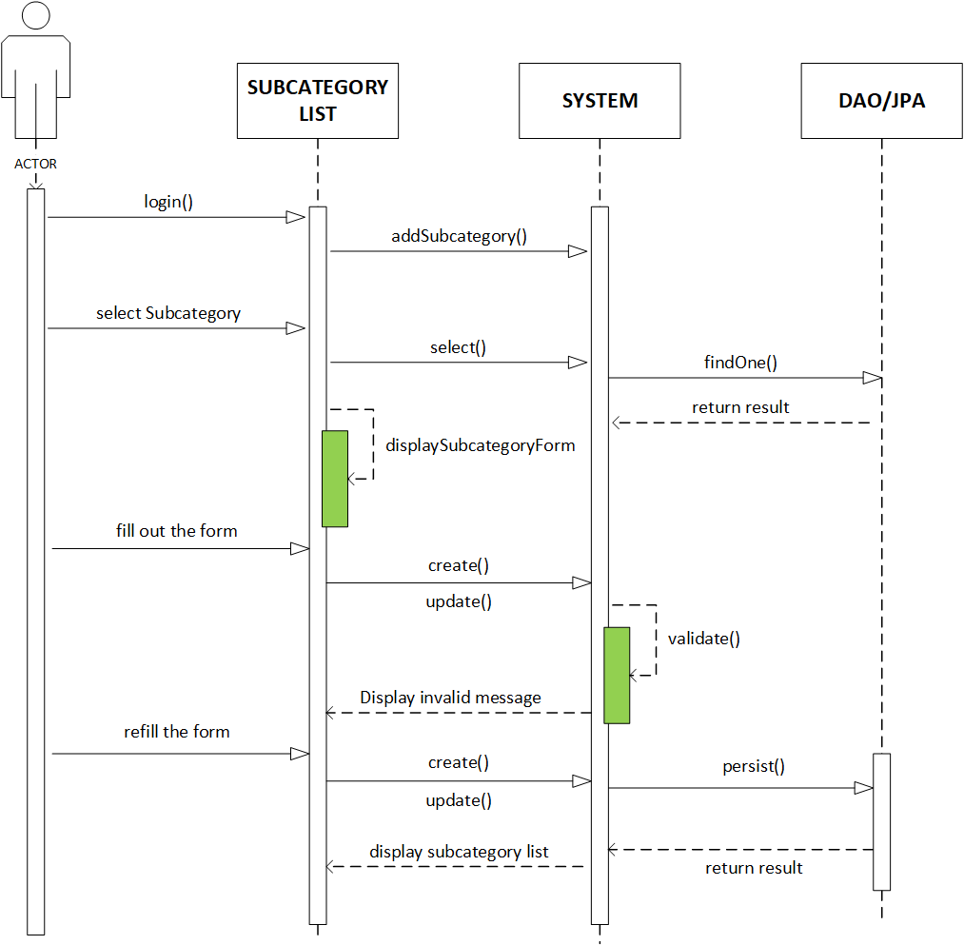

**3.3. Admin can manage manufacturer**

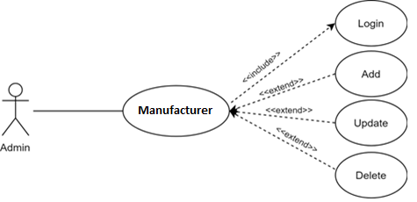

|  |  |  |
| --- | --- | --- |
| **Author** |  | |
| **Use Case Name** | Admin manage manufacturer | |
| **Actors** | Admin | |
| **Description** | Admin can add, manufacturer | |
| **Requirements** | Admin must log in successfully | |
| **Basic Flow** | 1. Actor chooses manufacturer on menu.  3. Actor clicks ‘Add New manufacturer ’ button or select Unit to update.  5. Actor inputs information to create/ update manufacturer . | 2. System redirects to ' manufacturer List' page and displays a list of Unit .  4. System displays a form with the following fields show  6. System validates inputs.  7. System adds manufacturer into the database.  8. System displays confirmation message or error message. |
| **Alternative Flow** |  |  |
| **Exception Flow** | 1. Actor left input field field blank. | System displays messages: - Input field cannot be blank. |

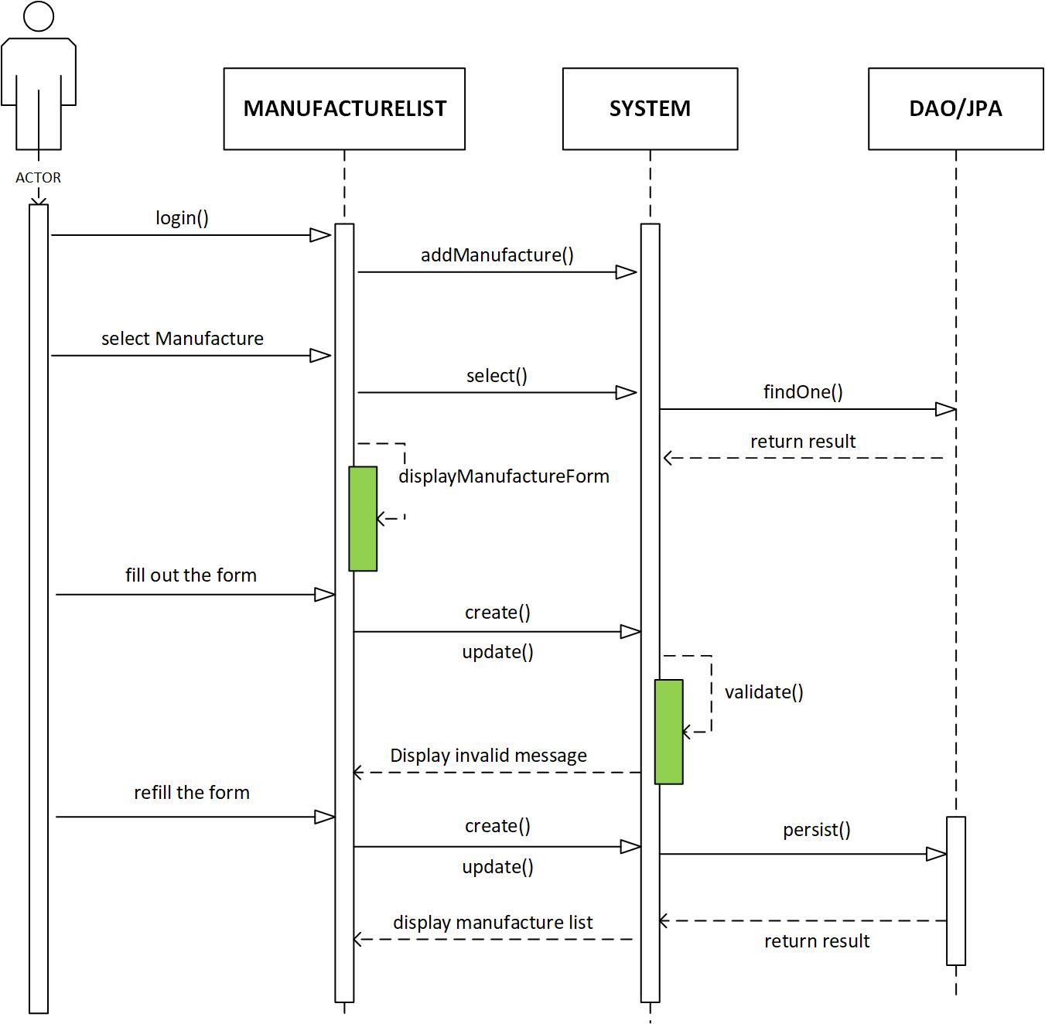

|  |  |  |
| --- | --- | --- |
| **Author** |  | |
| **Use Case Name** | Admin manage Manufacturers | |
| **Actors** | Admin | |
| **Description** | Admin can delete manufacturer | |
| **Requirements** | Admin must log in successfully | |
| **Basic Flow** | 1. Actor chooses manufacturer Tab on menu.  3. Actor clicks on ‘Delete’ button and confirm. | 2. System redirects to ' manufacturer List' page and displays a list of existing manufacturer .  4. System deletes manufacturer from database.  5. System displays confirmation message or error message. |
| **Alternative Flow** |  |  |
| **Exception Flow** |  |  |

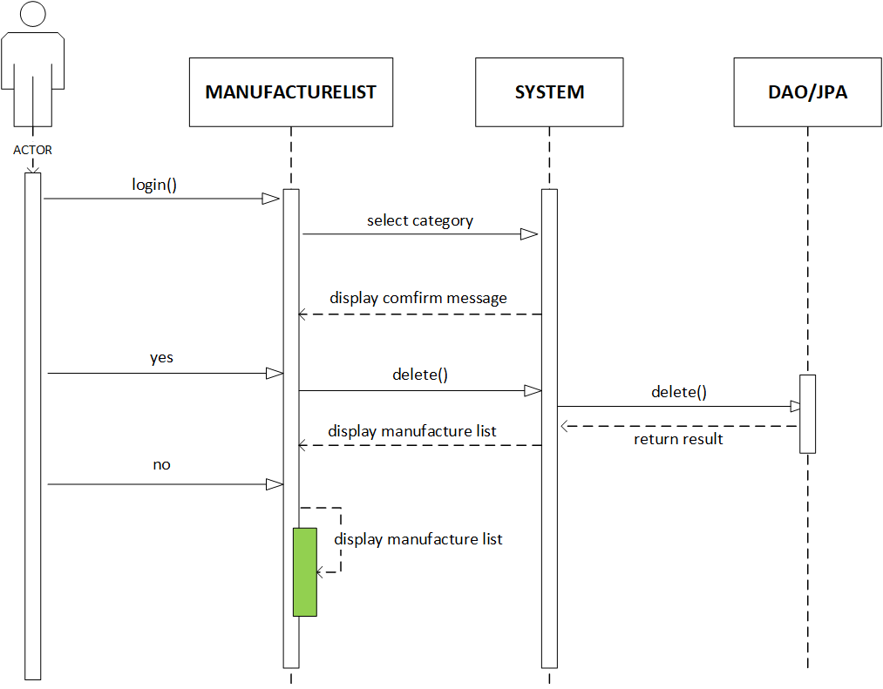

### 3.4. Admin can manage unit

|  |  |  |
| --- | --- | --- |
| **Author** |  | |
| **Use Case Name** | Admin manage units | |
| **Actors** | Admin | |
| **Description** | Admin can add, update unit | |
| **Requirements** | Admin must log in successfully | |
| **Basic Flow** | 1. Actor chooses Unit on menu.  3. Actor clicks ‘Add New Unit ’ button or select Unit to update.  5. Actor inputs information to create/ update Unit . | 2. System redirects to ' Unit List' page and displays a list of Unit .  4. System displays a form with the following fields: - Unit ’s Name  6. System validates inputs.  7. System adds Unit into the database.  8. System displays confirmation message or error message. |
| **Alternative Flow** |  |  |
| **Exception Flow** | 1. Actor left input field field blank. | System displays messages: - Input field cannot be blank. |

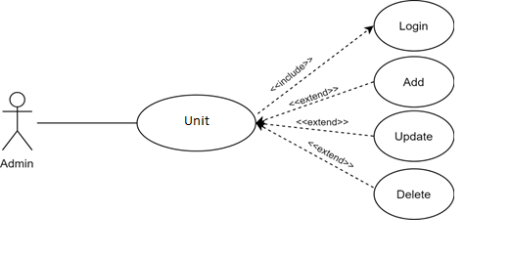

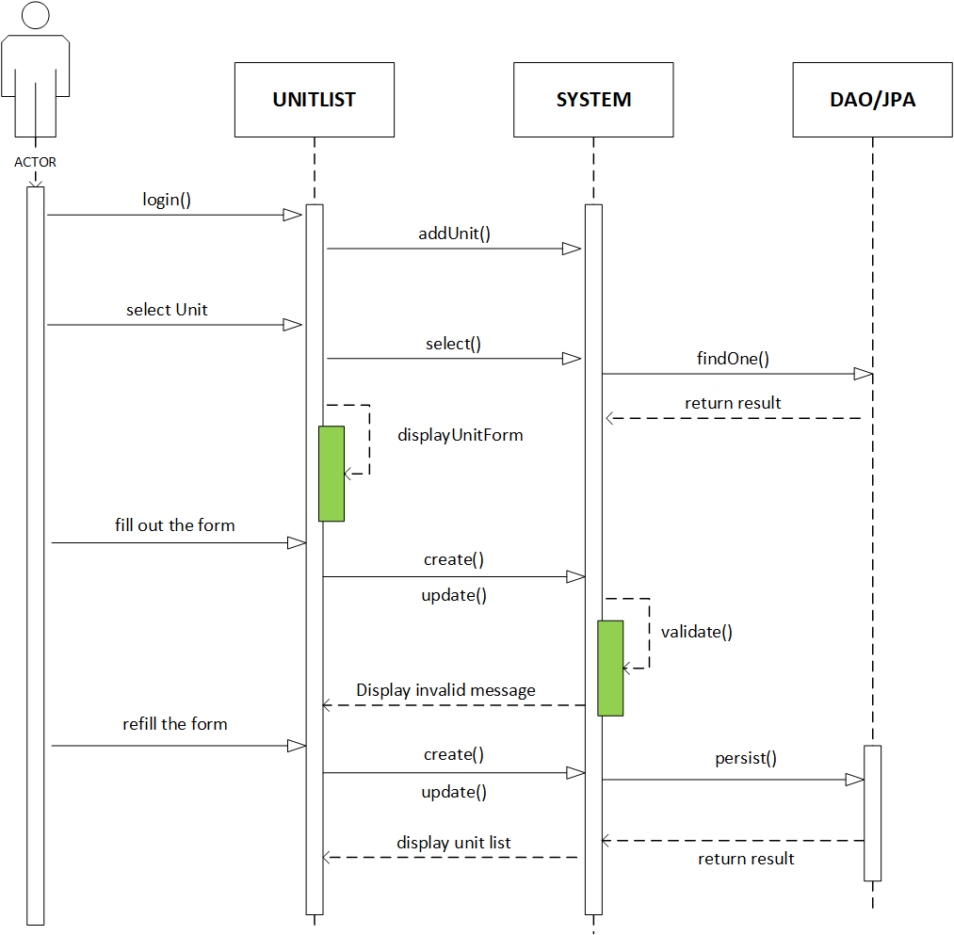

|  |  |  |
| --- | --- | --- |
| **Author** |  | |
| **Use Case Name** | Admin manage units | |
| **Actors** | Admin | |
| **Description** | Admin can delete unit | |
| **Requirements** | Admin must log in successfully | |
| **Basic Flow** | 1. Actor chooses Unit Tab on menu.  3. Actor clicks on ‘Delete’ button and confirm. | 2. System redirects to ' Unit List' page and displays a list of existing Units.  4. System deletes Unit from database.  5. System displays confirmation message or error message. |
| **Alternative Flow** |  |  |
| **Exception Flow** |  |  |

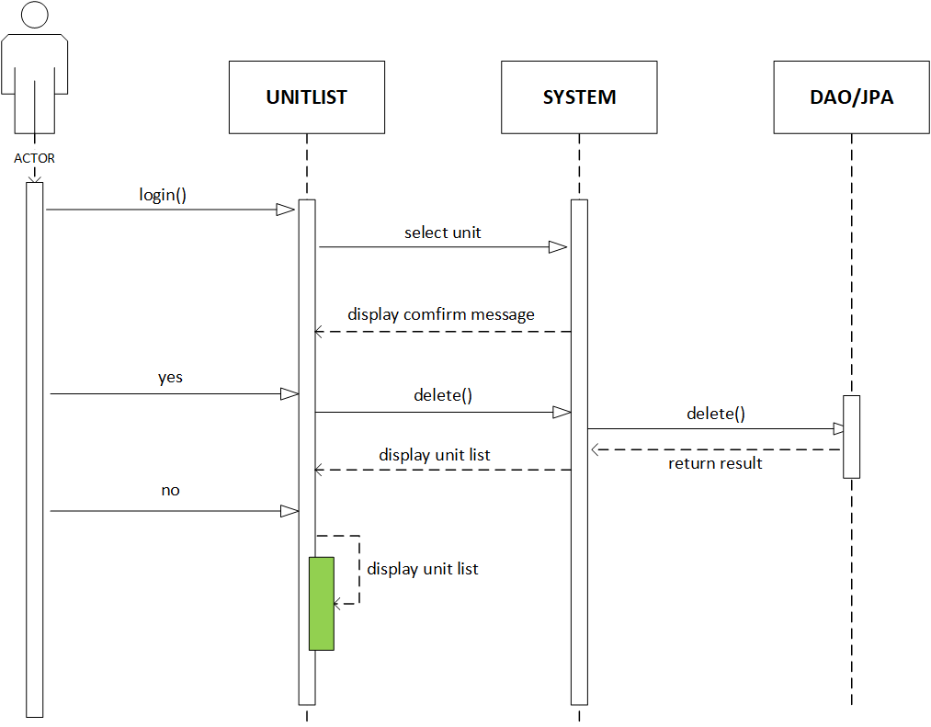

### 3.5. Admin can manage product

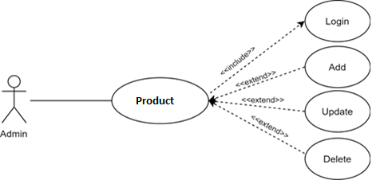

|  |  |  |
| --- | --- | --- |
| **Author** |  | |
| **Use Case Name** | Admin manage products | |
| **Actors** | Admin | |
| **Description** | Admin can add, update product | |
| **Requirements** | Admin must log in successfully | |
| **Basic Flow** | 1. Actor chooses Unit on menu.  3. Actor clicks ‘Add New product ’ button or select Unit to update.  5. Actor inputs information to create/ update product . | 2. System redirects to ' product List' page and displays a list of Unit .  4. System displays a form with the following fields show  6. System validates inputs.  7. System adds product into the database.  8. System displays confirmation message or error message. |
| **Alternative Flow** |  |  |
| **Exception Flow** | 1. Actor left input field field blank. | System displays messages: - Input field cannot be blank. |

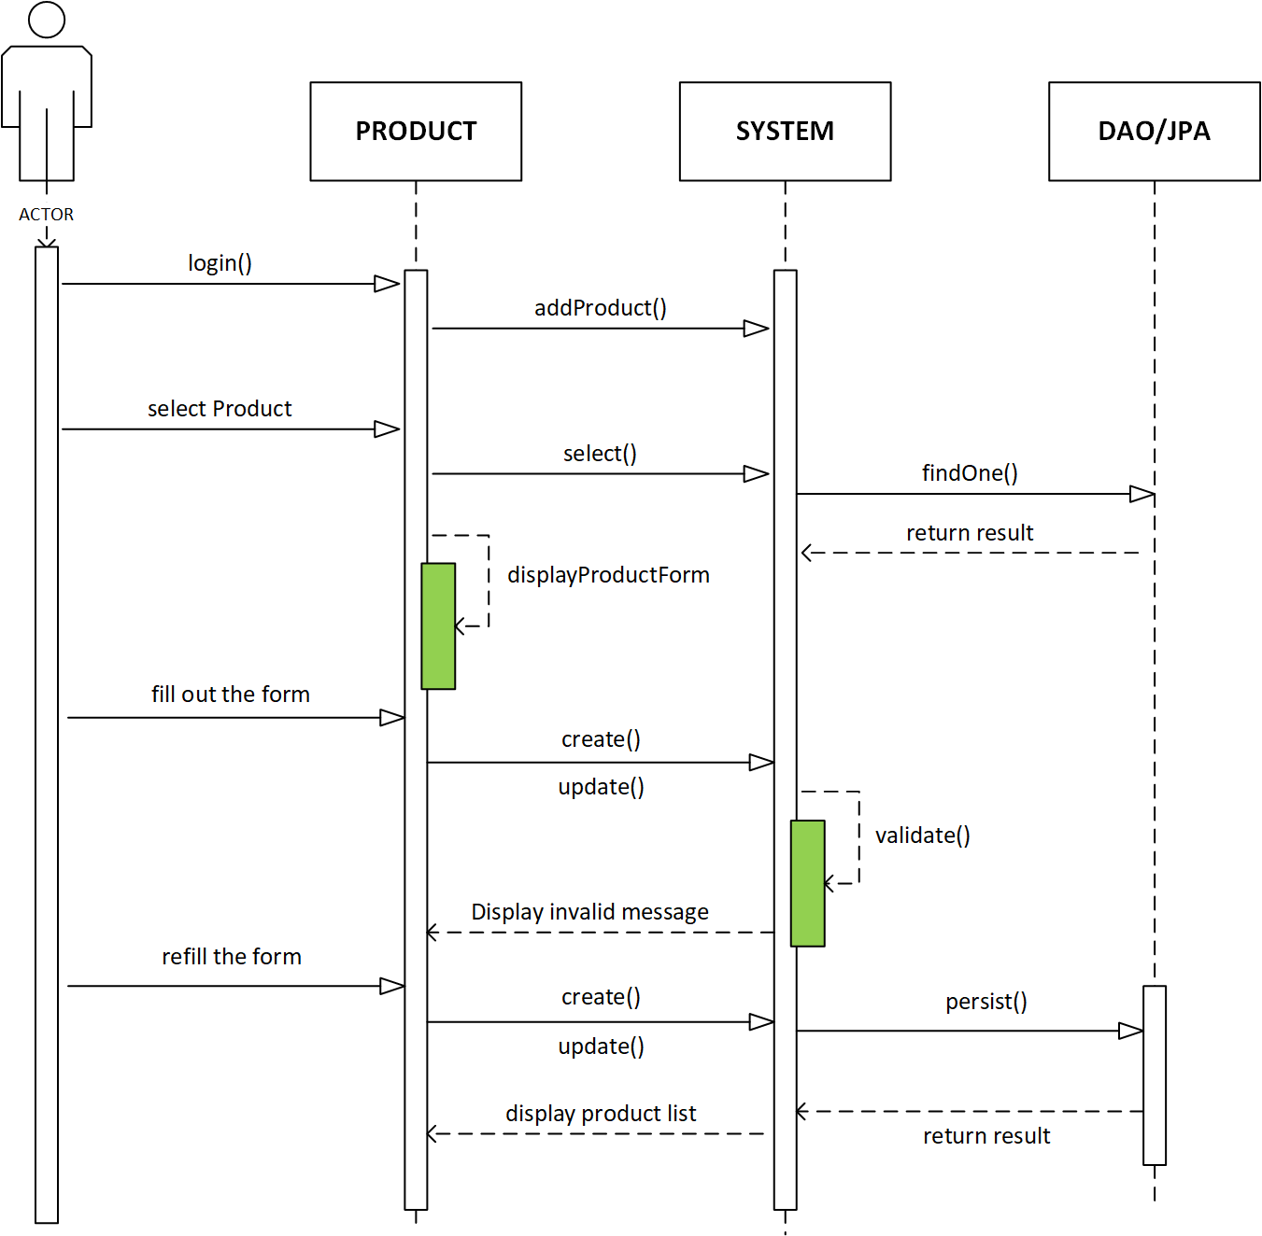

|  |  |  |
| --- | --- | --- |
| **Author** |  | |
| **Use Case Name** | Admin manage products | |
| **Actors** | Admin | |
| **Description** | Admin can delete product | |
| **Requirements** | Admin must log in successfully | |
| **Basic Flow** | 1. Actor chooses product Tab on menu.  3. Actor clicks on ‘Delete’ button and confirm. | 2. System redirects to ' product List' page and displays a list of existing product s.  4. System deletes product from database.  5. System displays confirmation message or error message. |
| **Alternative Flow** |  |  |
| **Exception Flow** |  |  |

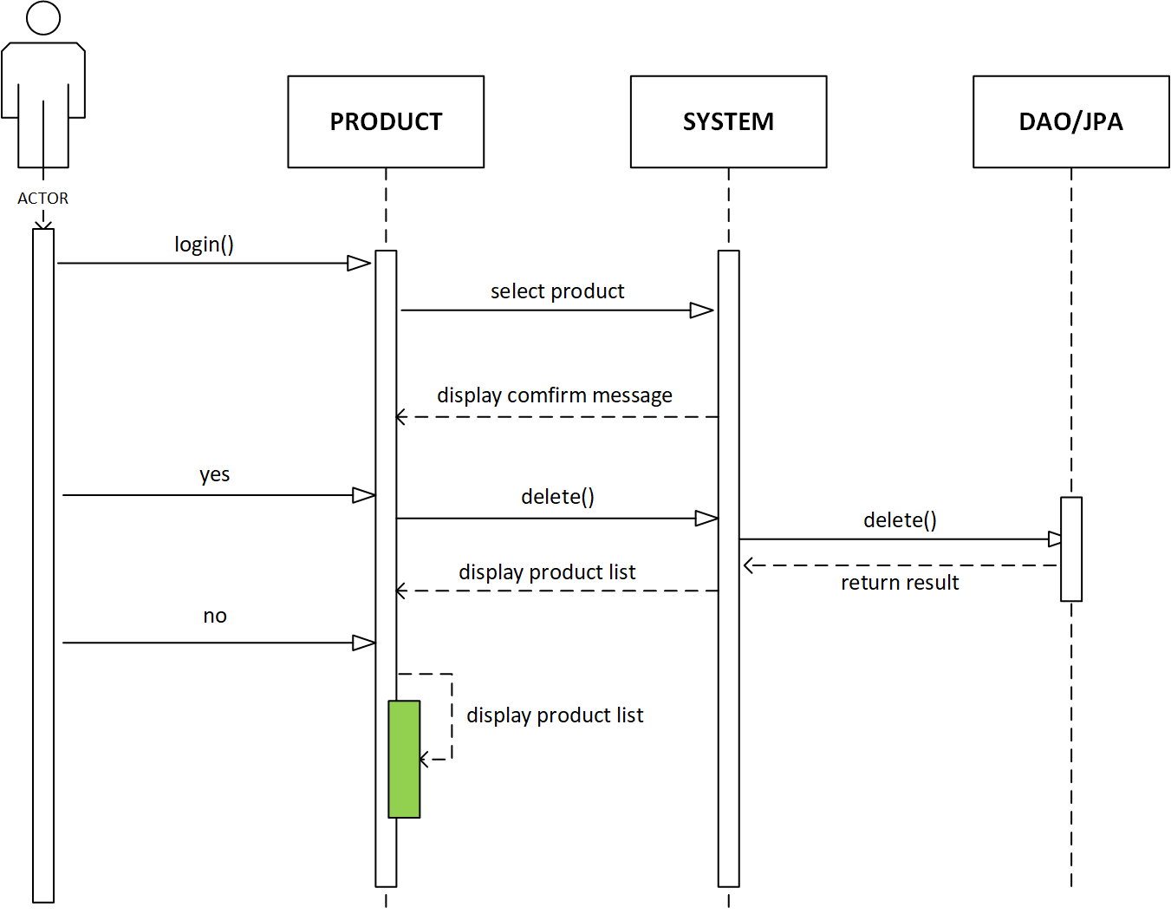

### 3.6. Admin can manage promotion

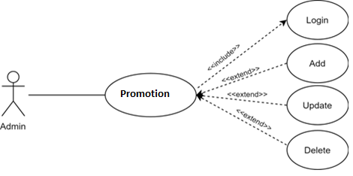

|  |  |  |
| --- | --- | --- |
| **Author** |  | |
| **Use Case Name** | Admin manage promotions | |
| **Actors** | Admin | |
| **Description** | Admin can add, update promotion | |
| **Requirements** | Admin must log in successfully | |
| **Basic Flow** | 1. Actor chooses promotion on menu.  3. Actor clicks ‘Add New promotion ’ button or select Unit to update.  5. Actor inputs information to create/ update promotion . | 2. System redirects to ' promotion List' page and displays a list of promotion .  4. System displays a form with the following fields show  6. System validates inputs.  7. System adds promotion into the database.  8. System displays confirmation message or error message. |
| **Alternative Flow** |  |  |
| **Exception Flow** | 1. Actor left chosse file field blank. | System displays messages: - Image cannot be blank. |

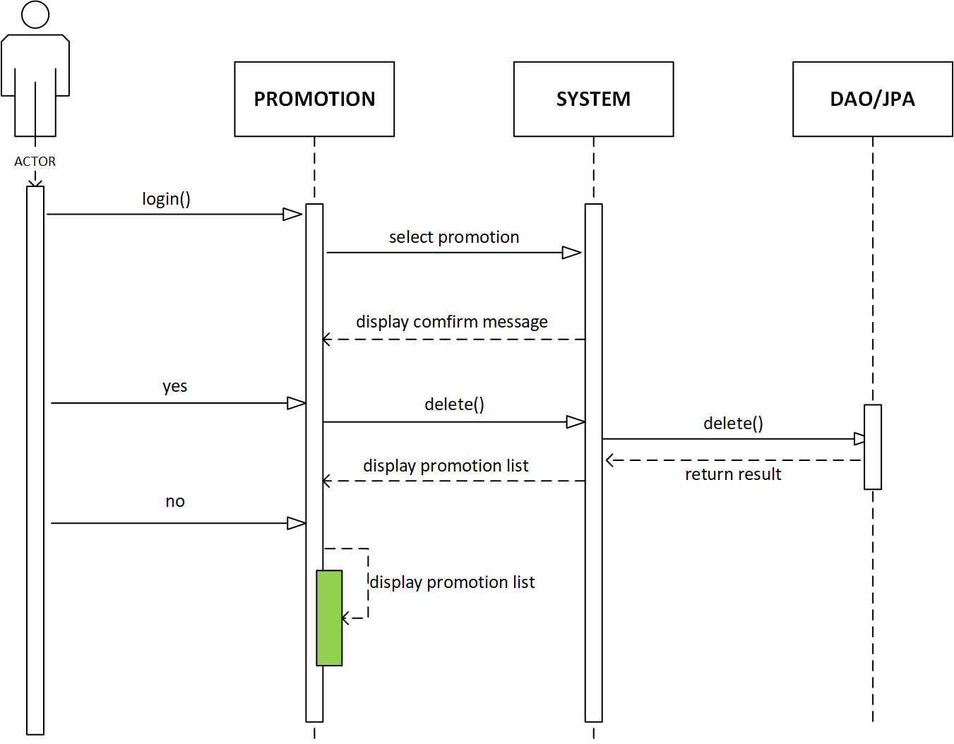

|  |  |  |
| --- | --- | --- |
| **Author** |  | |
| **Use Case Name** | Admin manage promotion s | |
| **Actors** | Admin | |
| **Description** | Admin can delete promotion | |
| **Requirements** | Admin must log in successfully | |
| **Basic Flow** | 1. Actor chooses promotion Tab on menu.  3. Actor clicks on ‘Delete’ button and confirm. | 2. System redirects to ' promotion List' page and displays a list of existing product s.  4. System deletes promotion from database.  5. System displays confirmation message or error message. |
| **Alternative Flow** |  |  |
| **Exception Flow** |  |  |

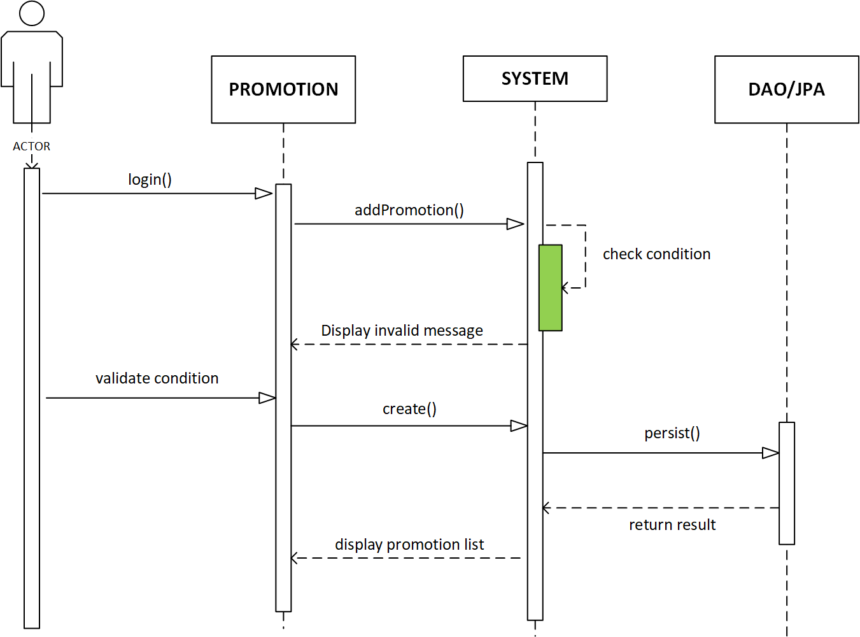

### 3.7. Admin can manage customer

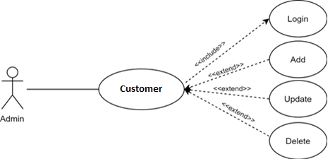

|  |  |  |
| --- | --- | --- |
| **Author** |  | |
| **Use Case Name** | Admin manage customers | |
| **Actors** | Admin | |
| **Description** | Admin can add, update customer | |
| **Requirements** | Admin must log in successfully | |
| **Basic Flow** | 1. Actor chooses customer on menu.  3. Actor clicks ‘Add New product ’ button or select customer to update.  5. Actor inputs information to create/ update customer . | 2. System redirects to ‘Customer List' page and displays a list of Unit .  4. System displays a form with the following fields show  6. System validates inputs.  7. System adds customer into the database.  8. System displays confirmation message or error message. |
| **Alternative Flow** |  |  |
| **Exception Flow** | 1. Actor left input field field blank. | System displays messages: - Input field cannot be blank. |

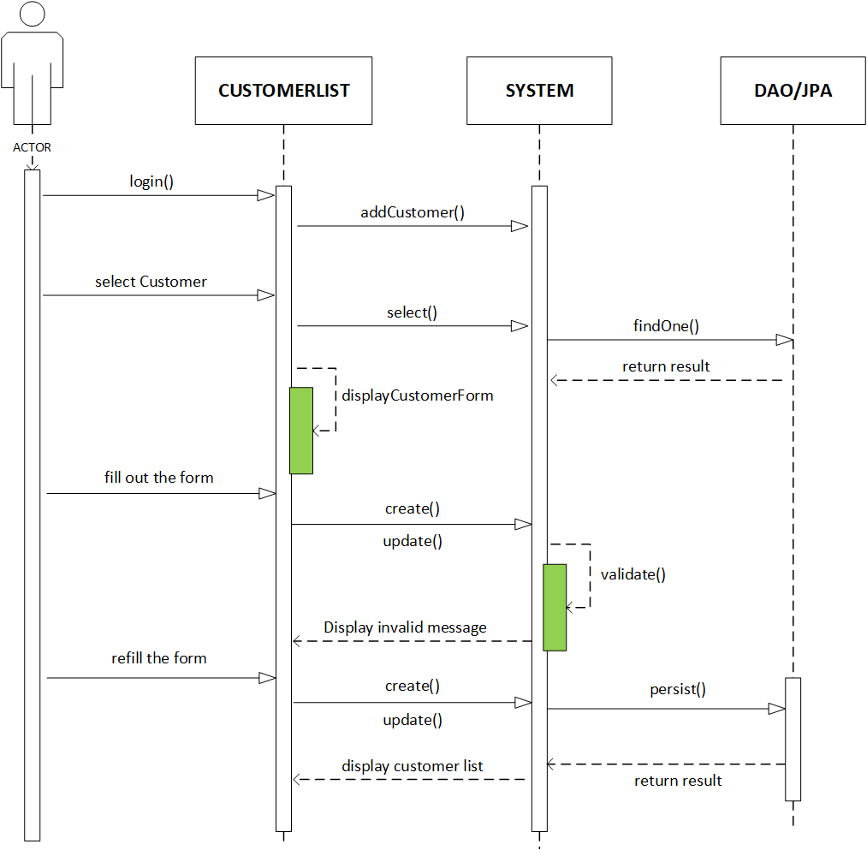

|  |  |  |
| --- | --- | --- |
| **Author** |  | |
| **Use Case Name** | Admin manage customers | |
| **Actors** | Admin | |
| **Description** | Admin can delete customer | |
| **Requirements** | Admin must log in successfully | |
| **Basic Flow** | 1. Actor chooses Custome Tab on menu.  3. Actor clicks on ‘Delete’ button and confirm. | 2. System redirects to ‘Customer List' page and displays a list of existing Units.  4. System deletes Customer from database.  5. System displays confirmation message or error message. |
| **Alternative Flow** |  |  |
| **Exception Flow** |  |  |

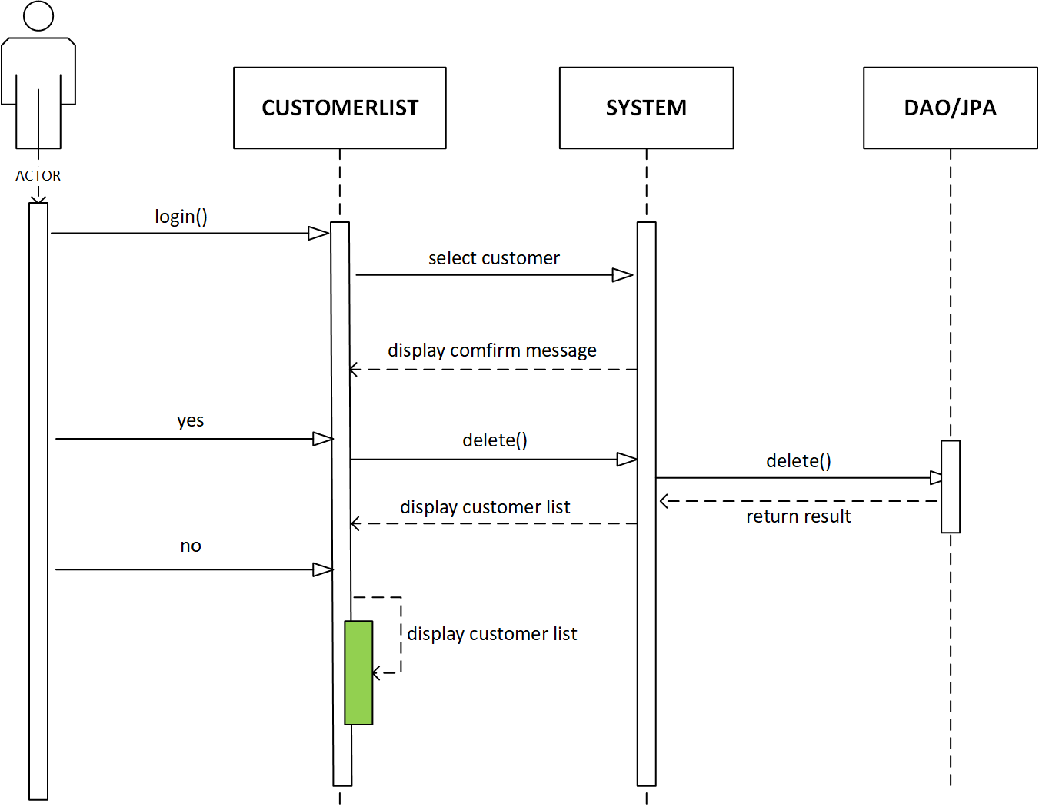

### 3.8. Admin can manage order

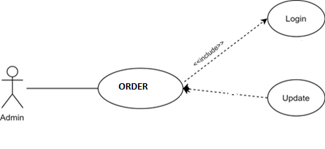

|  |  |  |
| --- | --- | --- |
| **Author** |  | |
| **Use Case Name** | Admin manage customers | |
| **Actors** | Admin | |
| **Description** | Admin can add, update customer | |
| **Requirements** | Admin must log in successfully | |
| **Basic Flow** | 1. Actor chooses customer on menu.  3. Actor clicks ‘Add New product ’ button or select customer to update.  5. Actor inputs information to create/ update customer . | 2. System redirects to ‘Customer List' page and displays a list of Unit .  4. System displays a form with the following fields show  6. System validates inputs.  7. System adds customer into the database.  8. System displays confirmation message or error message. |
| **Alternative Flow** |  |  |
| **Exception Flow** | 1. Actor left input field field blank. | System displays messages: - Input field cannot be blank. |

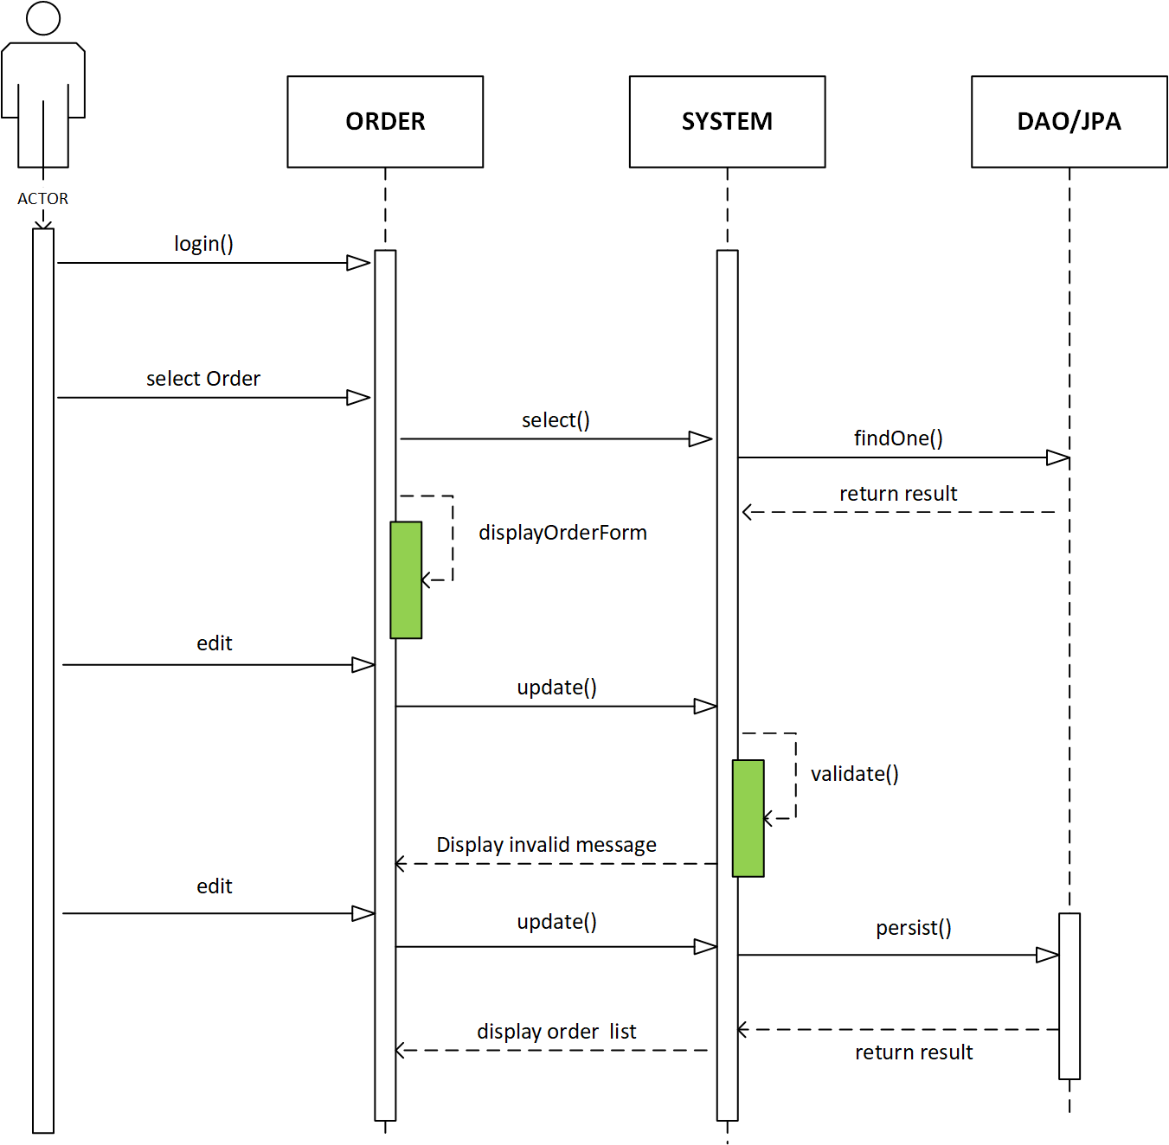

### 3.9. Admin view report

1. Entity Relationship Diagram (ERD):
2. Logical

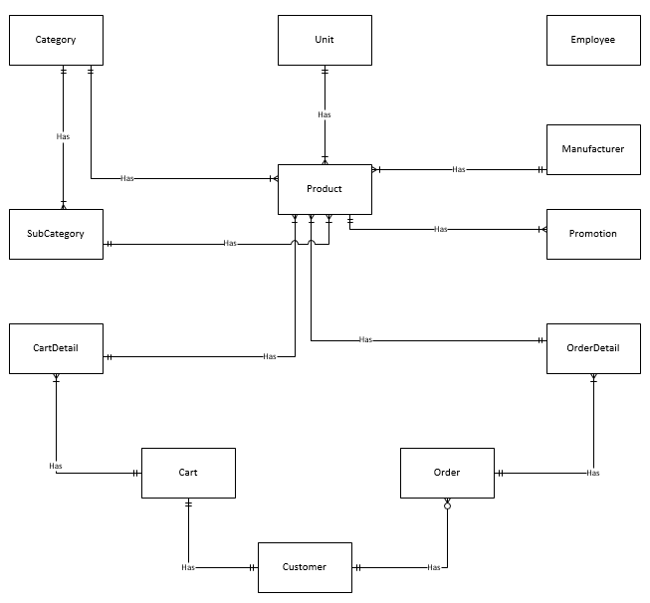

1. Entity Properties
   1. Category

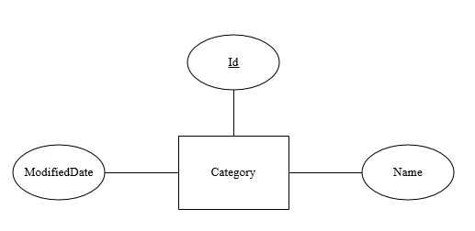

* 1. SubCategory

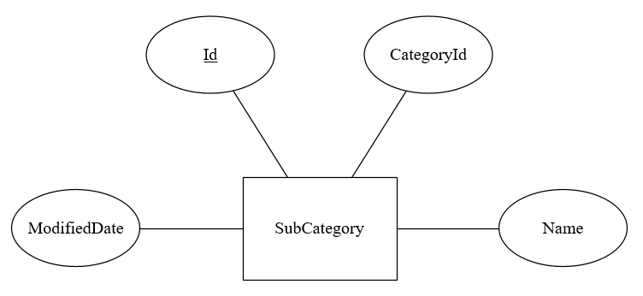

* 1. Manufacturer

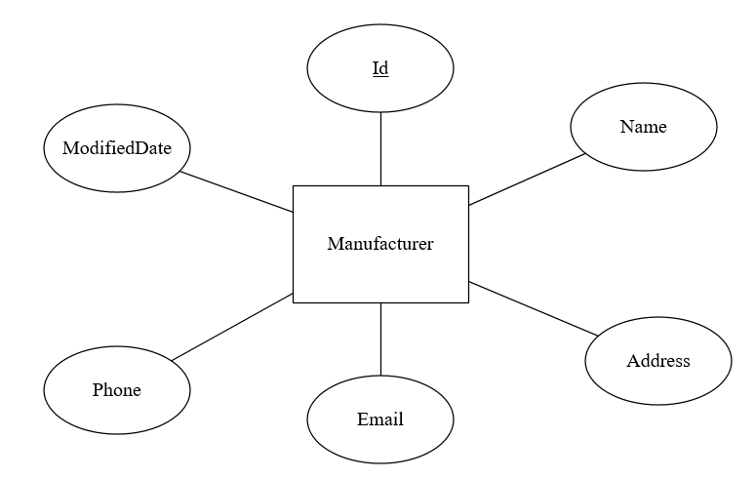

* 1. Unit

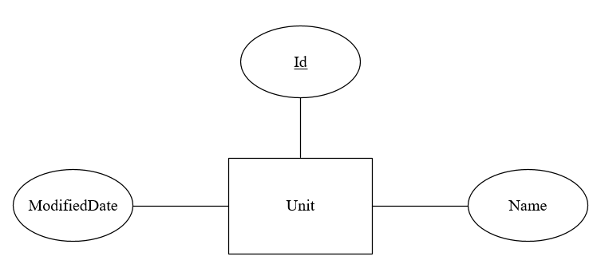

* 1. Product

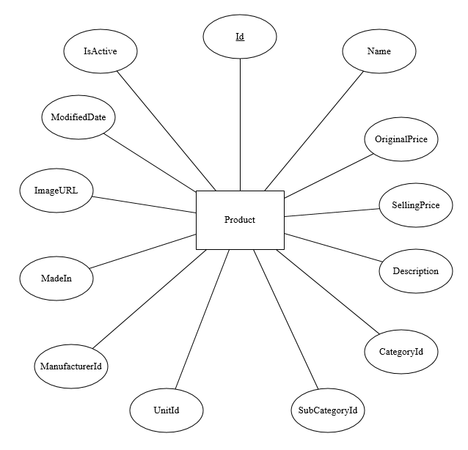

* 1. Promotion

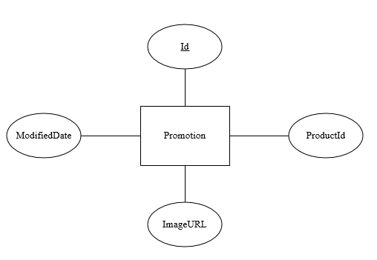

* 1. Customer

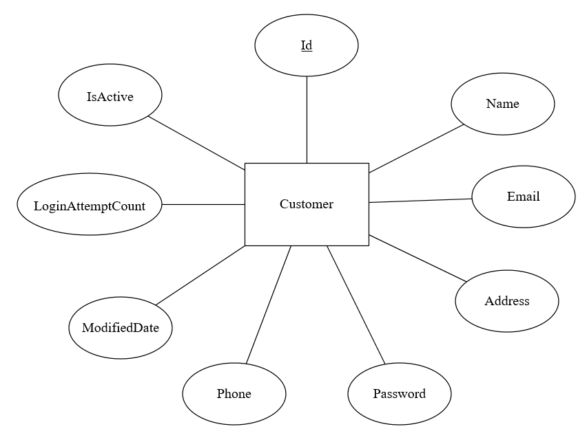

* 1. Order

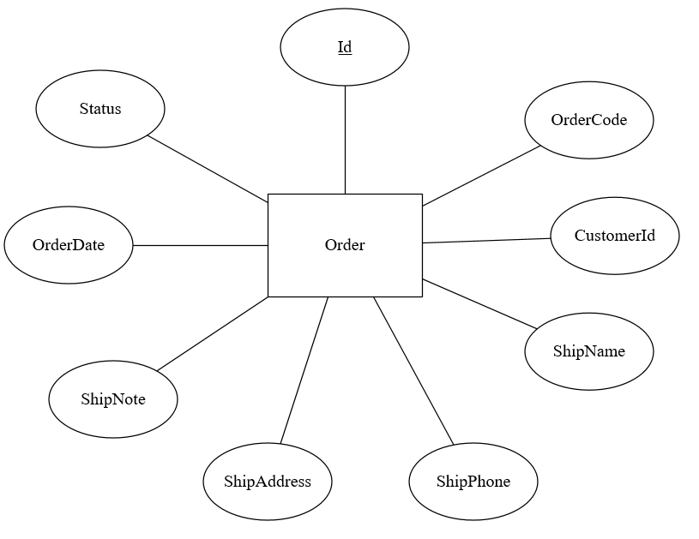

* 1. OrderDetail

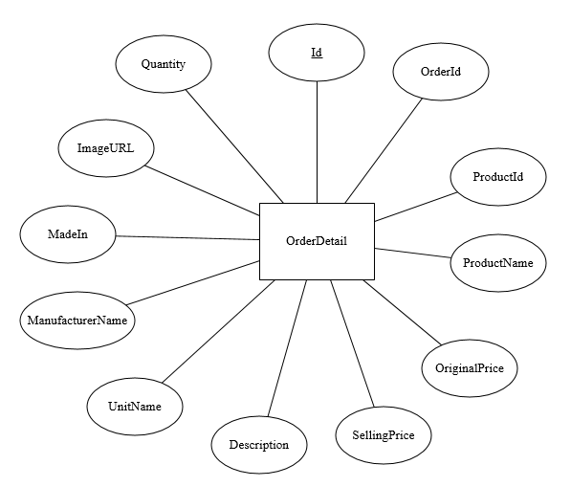

* 1. Cart

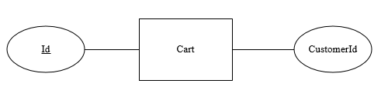

* 1. CartDetail

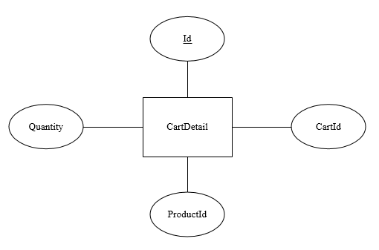

* 1. Employee

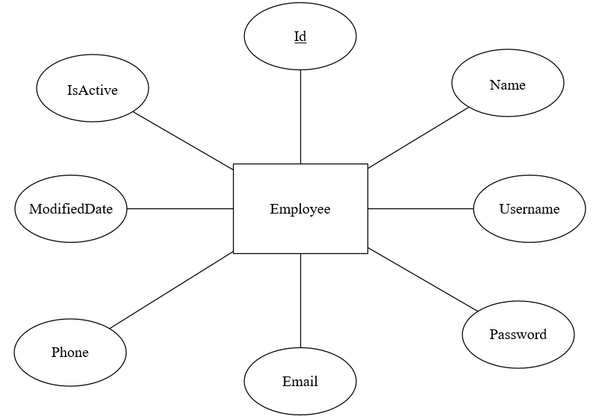

1. Task sheet Review 2

|  |  |  |  |  |  |  |
| --- | --- | --- | --- | --- | --- | --- |
| Project Ref. No: | | Project Title:  HKTT Store | Date of Preparation of Activity Plan | | | |
| No. | Task | Description | Start Date | Complete Date | Team Member Names | Status |
| 01 | Review 2 | User case and sequence diagram for guest | 27/05/2020 | 02/06/2020 | Hoang Thanh Tai | Completed |
| 02 | User case and sequence diagram for member | Le Ngoc Dang Khoa | Completed |
| 03 | Entity Relationship Diagram |
| 04 | User case and sequence diagram for Admin  - Category  - Manufacturer  - Unit  - Report | Ha Minh Tan | Completed |
| 05 | User case and sequence diagram for Admin  - SubCategory  - Product  - Promotion  - Customer  - Order | Pham Huynh | Completed |

|  |  |  |
| --- | --- | --- |
|  | Prepare By: Group 1 | Approved By: |
| Date: 01/06/2020 | Team Leader  Le Ngoc Dang Khoa | Mr. Ngô Phước Nguyên |

# REVIEW III

# I. Database Relationship Diagram

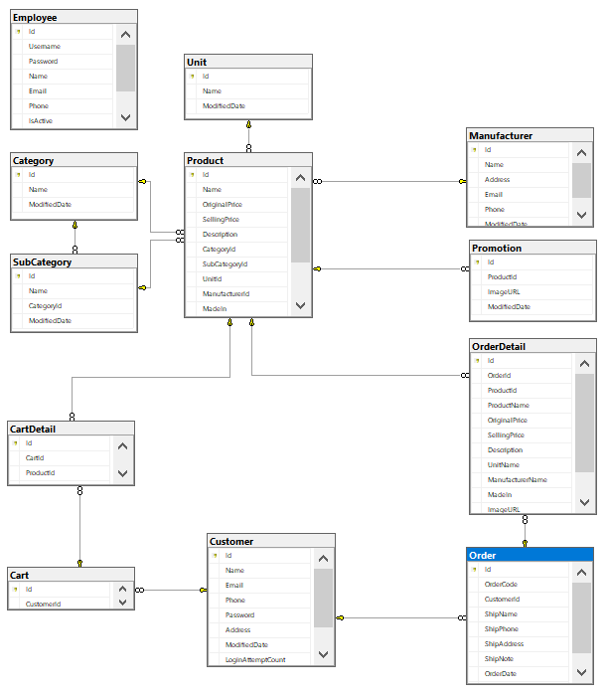

# II. Table Definition

1. Category

|  |  |  |  |  |  |  |
| --- | --- | --- | --- | --- | --- | --- |
| **Key** | **Field Name** | **Data Type** | **Null** | **Default** | **Table-Field-Ref** | **Description** |
| PK | Id | Int | No |  |  | Category Id |
|  | Name | nvarchar(250) | No |  |  | Category Name |
|  | ModifiedDate | Datetime | No |  |  | Lastest time the object was modified. |

1. SubCategory

|  |  |  |  |  |  |  |
| --- | --- | --- | --- | --- | --- | --- |
| **Key** | **Field Name** | **Data Type** | **Null** | **Default** | **Table-Field-Ref** | **Description** |
| PK | Id | Int | No |  |  | SubCategory Id |
|  | Name | nvarchar(250) | No |  |  | SubCategory Name |
| FK | CategoryId | Int | No |  | Category(Id) | CategoryId that the SubCategory belong to. |
|  | ModifiedDate | Datetime | No |  |  | Lastest time the object was modified. |

1. Manufacturer

|  |  |  |  |  |  |  |
| --- | --- | --- | --- | --- | --- | --- |
| **Key** | **Field Name** | **Data Type** | **Null** | **Default** | **Table-Field-Ref** | **Description** |
| PK | Id | Int | No |  |  | Manufacturer Id |
|  | Name | nvarchar(250) | No |  |  | Manufacturer Name |
|  | ModifiedDate | Datetime | No |  |  | Lastest time the object was modified. |

1. Unit

|  |  |  |  |  |  |  |
| --- | --- | --- | --- | --- | --- | --- |
| **Key** | **Field Name** | **Data Type** | **Null** | **Default** | **Table-Field-Ref** | **Description** |
| PK | Id | Int | No |  |  | Unit Id |
|  | Name | nvarchar(250) | No |  |  | Unit Name |
|  | ModifiedDate | Datetime | No |  |  | Lastest time the object was modified. |

1. Product

|  |  |  |  |  |  |  |
| --- | --- | --- | --- | --- | --- | --- |
| **Key** | **Field Name** | **Data Type** | **Null** | **Default** | **Table-Field-Ref** | **Description** |
| PK | Id | Int | No |  |  | Product Id |
|  | Name | nvarchar(250) | No |  |  | Product Name |
|  | OriginalPrice | float | No |  |  | Orginal price of product |
|  | SellingPrice | float | No |  |  | Selling price of product |
|  | Description | nvarchar(250) | No |  |  | Product’s description |
| FK | CategoryId | Int | No |  | Category(Id) | CategoryId that the Product belong to. |
| FK | SubCategoryId | Int | No |  | SubCategory(Id) | SubCategoryId that the Product belong to. |
| FK | UnitId | Int | No |  | Unit(Id) | UnitId that the Product belong to. |
| FK | ManufacturerId | Int | No |  | Manufacturer(Id) | ManufacturerId that the Product belong to. |
|  | MadeIn | nvarchar(250) | No |  |  | Where the product is made |
|  | ImageURL | nvarchar(250) | No |  |  | Image link of product |
|  | ModifiedDate | Datetime | No |  |  | Lastest time the object was modified. |
|  | IsActive | Int | No |  |  | Define if the product is active for the customer to buy or not  (1: Active, 0: Inactive) |

1. Promotion

|  |  |  |  |  |  |  |
| --- | --- | --- | --- | --- | --- | --- |
| **Key** | **Field Name** | **Data Type** | **Null** | **Default** | **Table-Field-Ref** | **Description** |
| PK | Id | Int | No |  |  | Promotion Id |
| FK | ProductId | Int | No |  | Product(Id) | ProductId that need promotion |
|  | ImageURL | nvarchar(250) | No |  |  | The image link of the promotion |
|  | ModifiedDate | Datetime | No |  |  | Lastest time the object was modified. |

1. Customer

|  |  |  |  |  |  |  |
| --- | --- | --- | --- | --- | --- | --- |
| **Key** | **Field Name** | **Data Type** | **Null** | **Default** | **Table-Field-Ref** | **Description** |
| PK | Id | Int | No |  |  | Customer Id |
|  | Name | nvarchar(250) | No |  |  | Customer Name |
|  | Email | varchar(250) | No |  |  | Customer Email |
|  | Phone | varchar(20) | No |  |  | Customer phone |
|  | Password | varchar(250) | No |  |  | Customer password |
|  | Address | nvarchar(250) | No |  |  | Customer address |
|  | ModifiedDate | Datetime | No |  |  | Lastest time the object was modified. |
|  | LoginAttemptCount | Int | No |  |  | Count how many time the customer had enter the password wrong. If the count = 3, the next time the customer enter the password wrong, system will lock the account by changing IsActive = 0 |
|  | IsActive | Int | No |  |  | Define if the customer is active or not  (1: Active, 0: Inactive) |

1. Order

|  |  |  |  |  |  |  |
| --- | --- | --- | --- | --- | --- | --- |
| **Key** | **Field Name** | **Data Type** | **Null** | **Default** | **Table-Field-Ref** | **Description** |
| PK | Id | Int | No |  |  | Order’s Id |
|  | OrderCode | varchar(50) | No |  |  | Order’s Code that show to the customer |
| FK | CustomerId | Int | No |  | Customer(Id) | CustomerId |
|  | ShipName | nvarchar(250) | No |  |  | Name of the receiver |
|  | ShipPhone | nvarchar(250) | No |  |  | Phone of the receiver |
|  | ShipAddress | nvarchar(250) | No |  |  | Address of the receiver |
|  | ShipNote | nvarchar(250) | No | “” |  | Order’s note |
|  | OrderDate | Datetime | No |  |  | Order date of the order created |
|  | Status | Int | No |  |  | Status of the order  1: New  2: Processing  3: Done |

1. OrderDetail

|  |  |  |  |  |  |  |
| --- | --- | --- | --- | --- | --- | --- |
| **Key** | **Field Name** | **Data Type** | **Null** | **Default** | **Table-Field-Ref** | **Description** |
| PK | Id | Int | No |  |  | OrderDetail Id |
| FK | OrderId | Int | No |  | Order(Id) | OrderId that the OrderDetail belong to |
| FK | ProductId | Int | No |  | Product(Id) | ProductId |
|  | ProductName |  | No |  |  | Product’s Name at the moment the product is ordered |
|  | OriginalPrice |  | No |  |  | Product’s OriginalPrice at the moment the product is ordered |
|  | SellingPrice |  | No |  |  | Product’s SellingPrice at the moment the product is ordered |
|  | Description |  | No |  |  | Product’s Description at the moment the product is ordered |
|  | UnitName |  | No |  |  | Product’s UnitName at the moment the product is ordered |
|  | ManufacturerName |  | No |  |  | Product’s ManufacturerName at the moment the product is ordered |
|  | MadeIn |  | No |  |  | Product’s MadeIn at the moment the product is ordered |
|  | ImageURL |  | No |  |  | Product’s ImageURL at the moment the product is ordered |
|  | Quantity | Int | No |  |  | Order quantity |

1. Cart

|  |  |  |  |  |  |  |
| --- | --- | --- | --- | --- | --- | --- |
| **Key** | **Field Name** | **Data Type** | **Null** | **Default** | **Table-Field-Ref** | **Description** |
| PK | Id | Int | No |  |  | Cart’s Id |
| FK | CustomerId | Int | No |  | Customer(Id) | CustomerId |

1. CartDetail

|  |  |  |  |  |  |  |
| --- | --- | --- | --- | --- | --- | --- |
| **Key** | **Field Name** | **Data Type** | **Null** | **Default** | **Table-Field-Ref** | **Description** |
| PK | Id | Int | No |  |  | OrderDetail Id |
| FK | CartId | Int | No |  | Cart(Id) | CartId that the CartDetail belong to |
| FK | ProductId | Int | No |  | Product(Id) | ProductId |
|  | Quantity | Int | No |  |  | Order quantity |

1. Employee

|  |  |  |  |  |  |  |
| --- | --- | --- | --- | --- | --- | --- |
| **Key** | **Field Name** | **Data Type** | **Null** | **Default** | **Table-Field-Ref** | **Description** |
| PK | Id | Int | No |  |  | Employee Id |
|  | Username | varchar(50) | No |  |  | Employee username |
|  | Password | varchar(250) | No |  |  | Customer password |
|  | Name | nvarchar(250) | No |  |  | Customer Name |
|  | Email | varchar(250) | No |  |  | Customer Email |
|  | Phone | varchar(20) | No |  |  | Customer phone |
|  | IsActive | Int | No |  |  | Define if the Employee is active or not  (1: Active, 0: Inactive) |
|  | ModifiedDate | Datetime | No |  |  | Lastest time the object was modified. |

# III. Site map

## 1. Customer’s android application

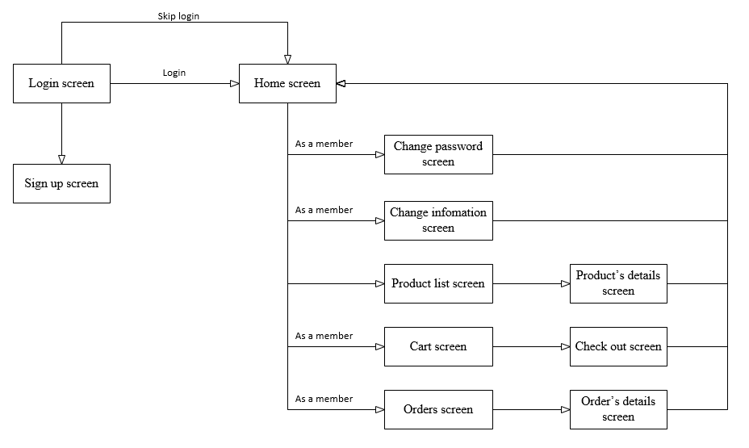

## 2. Admin’s web site

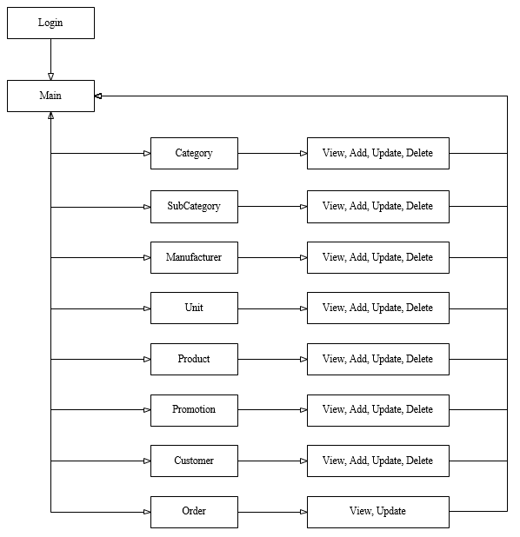

# IV. Customer GUI design

## 1. Splash screen



When the user open the application, a splash screen will show.

- If the user had login, after the animation the application will redirect to home screen.

- If the user enter as a new customer, after the animation the application will redirect to login screen.

## 2. Login screen

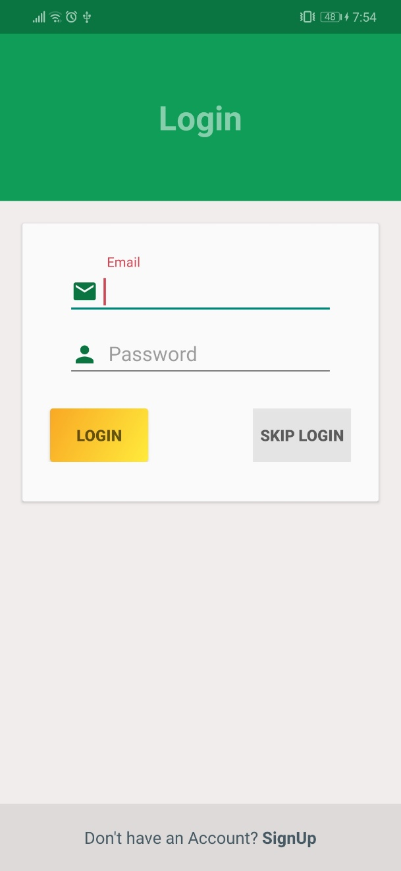

|  |  |  |  |  |  |
| --- | --- | --- | --- | --- | --- |
| **No.** | **Name** | **Type** | **Validation** | **Event** | **Description** |
| 1 | Email | EditText | Not null, email pattern |  | Customer’s email to login |
| 2 | Password | EditText | Not null |  | Customer’s password to login |
| 3 | Login | Button |  | Click | Check login and redirect to home screen |
| 4 | Skip login | Button |  | Click | The user can skip login and go to home screen, but they won’t be able to add product to cart |
| 5 | Sign up | Button |  | Click | Go to sign up screen to register new account |

## 3. Sign up

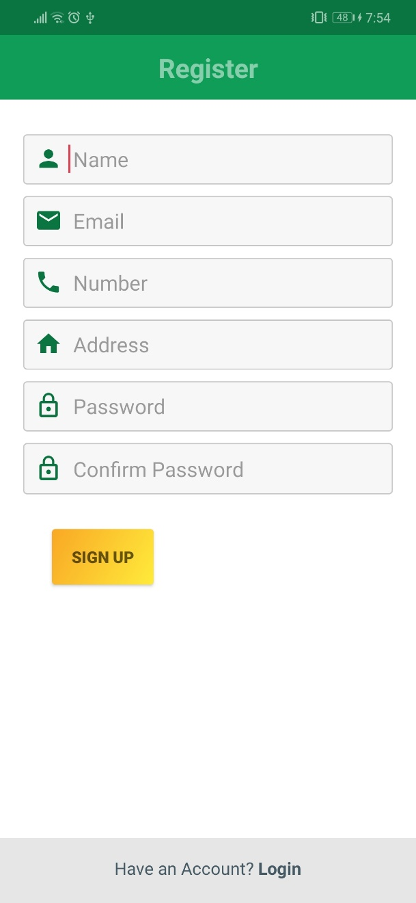

|  |  |  |  |  |  |
| --- | --- | --- | --- | --- | --- |
| **No.** | **Name** | **Type** | **Validation** | **Event** | **Description** |
| 1 | Name | EditText | Not null |  | Customer’s name |
| 2 | Email | EditText | Not null, email pattern |  | Customer’s email, email is unique, can’t be register with more than 1 customer |
| 3 | Phone | EditText | Not null, phone number pattern |  | Customer’s phone number, phone is unique, can’t be register with more than 1 customer |
| 4 | Address | EditText | Not null |  | Customer’s address |
| 5 | Password | EditText | Not null |  | Customer’s password |
| 6 | Confirm password | EditText | Not null |  | Confirm password must be the same as password |
| 7 | Sign up | Button |  | Click | Check input and create new account if the input is valid |
| 8 | Login | Button |  | Click | Go back to login screen to login |

## 4. Home screen

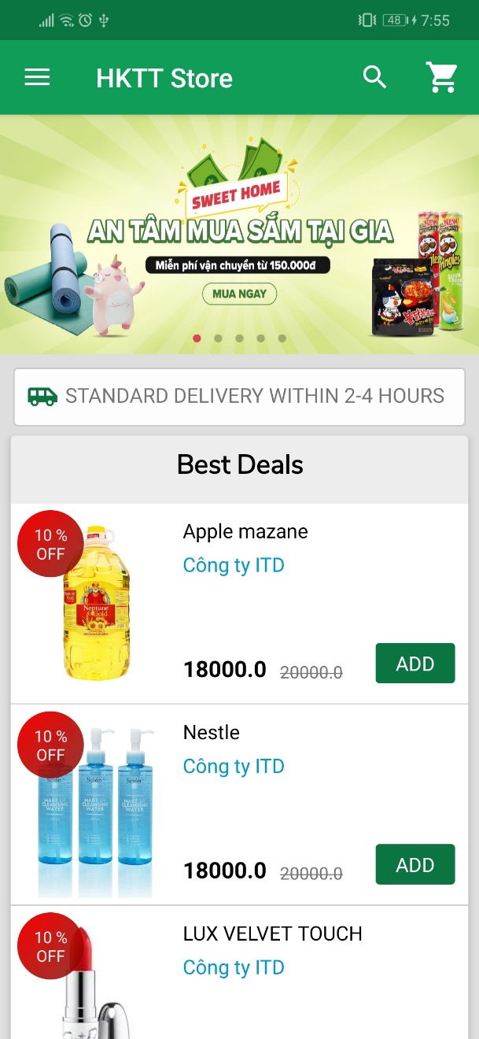 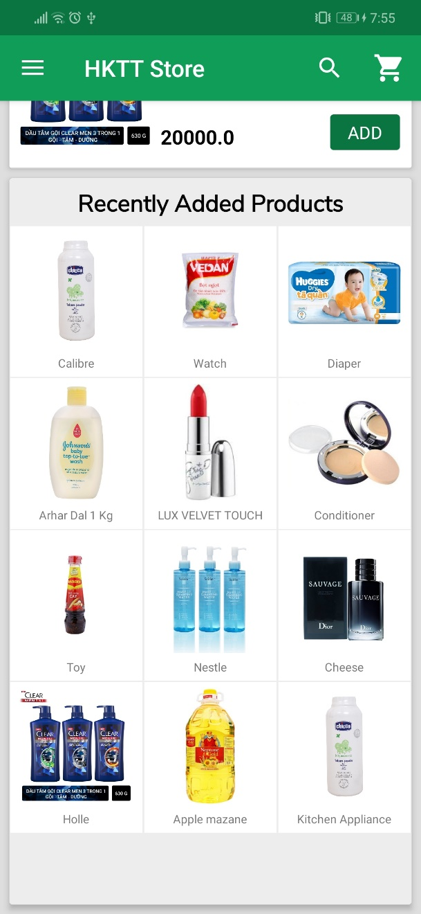

|  |  |  |  |  |  |
| --- | --- | --- | --- | --- | --- |
| **No.** | **Name** | **Type** | **Validation** | **Event** | **Description** |
| 1 | Hamberger icon | Navigation drawer |  | Click | Click to open the navigation drawer |
| 2 | Search icon | Button |  | Click | Click to open search bar |
| 3 | Cart icon | Button |  | Click | Click to open customer cart. If the customer enter home as a member and there are items in cart, an badge with cart count will show. |
| 4 | Promotion slider | Slider |  | Click | Slider with image of current promotion for a product. Click on an image with show details of product that the promotion belong to |
| 5 | Best deals | RecyclerView |  | Click | List of products having the most discount order by decending. When the user click on an item, product details screen will show. |
| 6 | Recently Added Product | GridView |  | Click | List of products that are recently added. When the user click on an item, product details screen will show. |
| 7 | Add | Button |  | Click | Add product to cart, update badge of cart icon |

## 5. Navigation Drawer when login as a guest

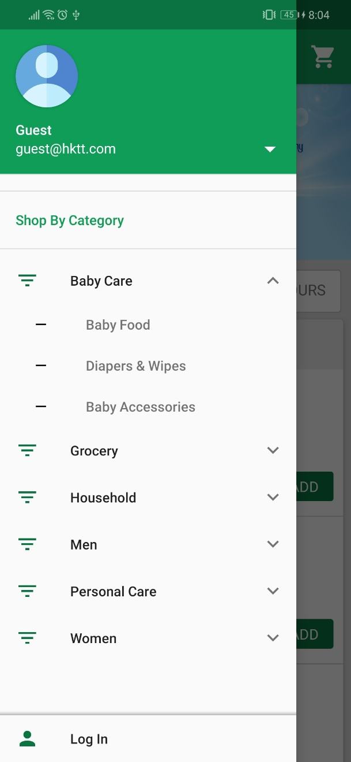

|  |  |  |  |  |  |
| --- | --- | --- | --- | --- | --- |
| **No.** | **Name** | **Type** | **Validation** | **Event** | **Description** |
| 1 | Customer information | Profile |  | Click | Customer’s information, click to see profile |
| 2 | Category list | ExpandableDrawerItem |  | Click | Click on a category will show sub category belong to that category |
| 3 | Sub category | SecondaryDrawerItem |  | Click | Click to go to result page with list of product belong to the sub category selected |
| 4 | Login | Button |  | Click | Go to login screen |

## 6. Navigation Drawer when login as a member

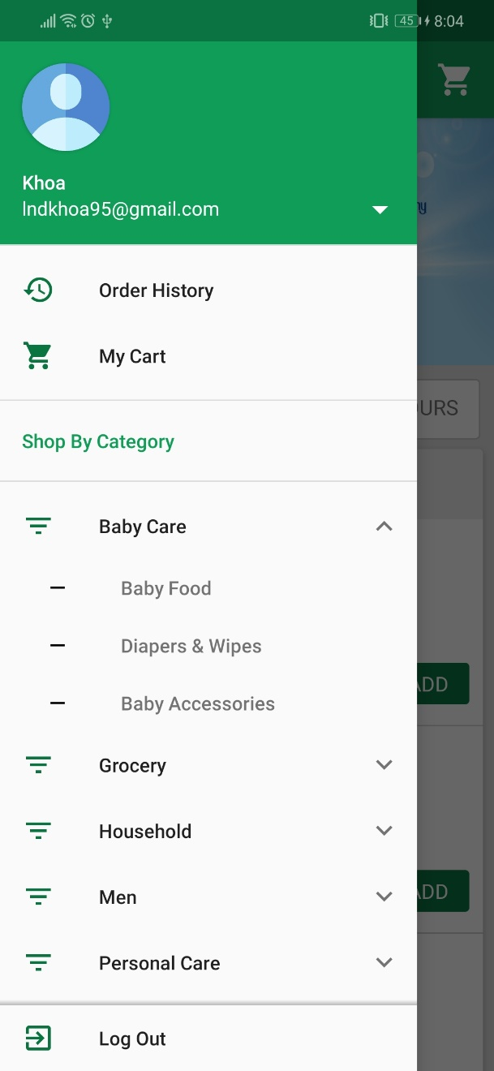

|  |  |  |  |  |  |
| --- | --- | --- | --- | --- | --- |
| **No.** | **Name** | **Type** | **Validation** | **Event** | **Description** |
| 1 | Customer information | Profile |  | Click | Customer’s information, click to see profile |
| 2 | Order history | PrimaryDrawerItem |  | Click | If the user enter home as a member, order history will show. Click to check order history. |
| 3 | My Cart | PrimaryDrawerItem |  | Click | If the user enter home as a member, My cart will show. Click to check cart list |
| 4 | Category list | ExpandableDrawerItem |  | Click | Click on a category will show sub category belong to that category |
| 5 | Sub category | SecondaryDrawerItem |  | Click | Click to go to result page with list of product belong to the sub category selected |
| 6 | Logout | Button |  | Click | Go to logout and back to login screen |

## 7. Profile

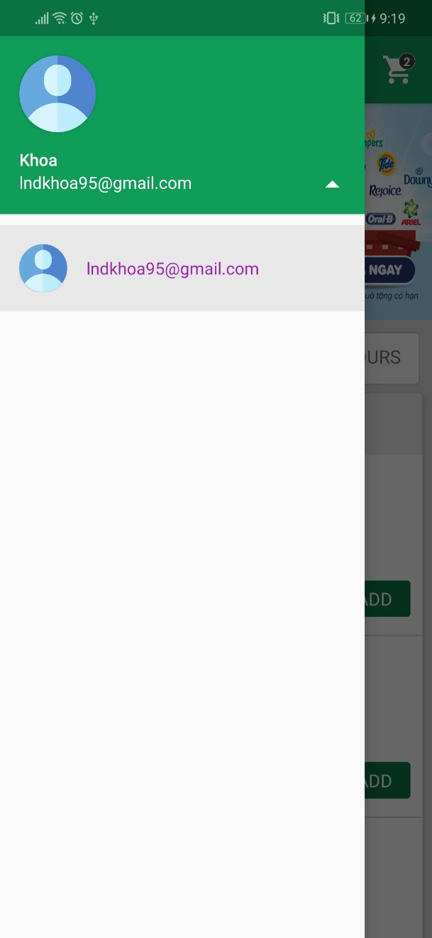

|  |  |  |  |  |  |
| --- | --- | --- | --- | --- | --- |
| **No.** | **Name** | **Type** | **Validation** | **Event** | **Description** |
| 1 | Customer information | Profile |  | Click | Customer’s profile, click to see account’s options |

## 8. Account options

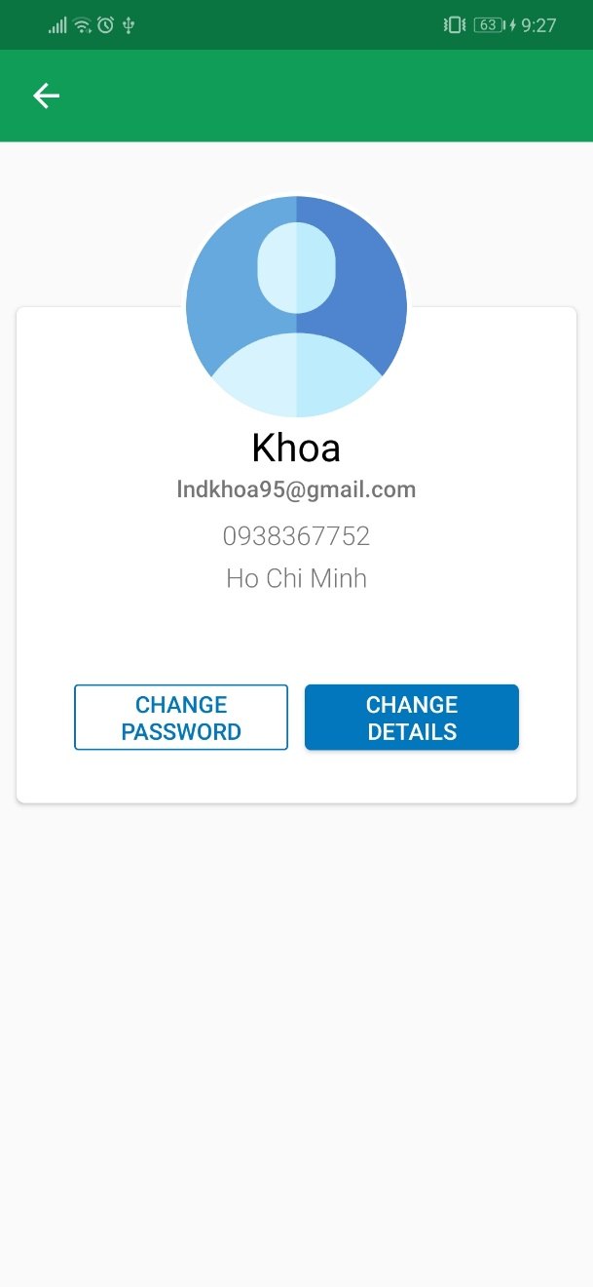

|  |  |  |  |  |  |
| --- | --- | --- | --- | --- | --- |
| **No.** | **Name** | **Type** | **Validation** | **Event** | **Description** |
| 1 | Customer information | TextView |  |  | Customer’s information |
| 2 | Change password | Button |  | Click | Click to go to change password screen |
| 3 | Change details | Button |  | Click | Click to go to change update information screen |

## 9. Change password

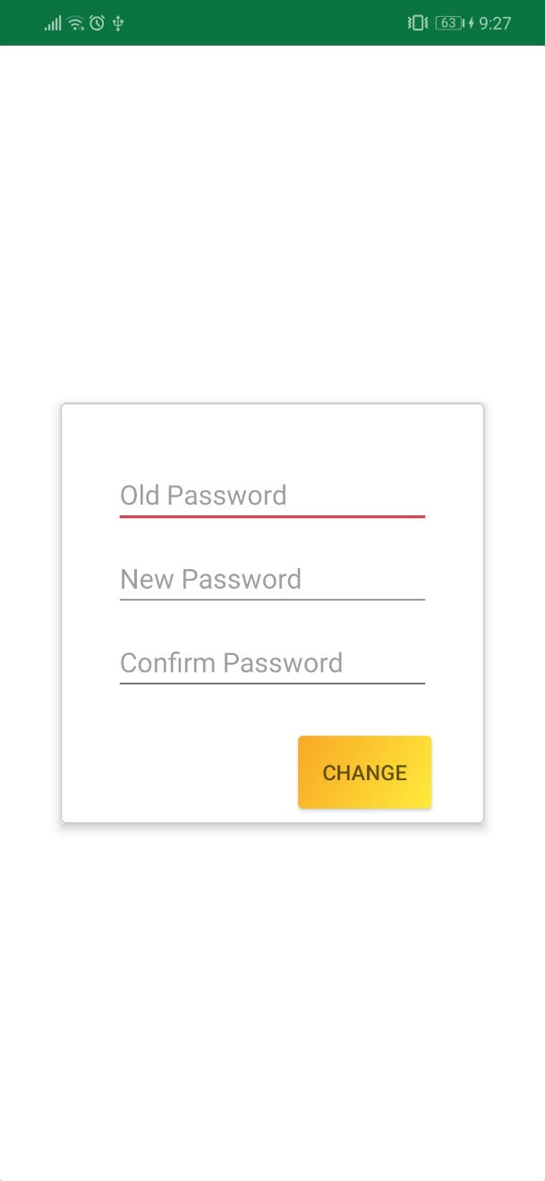

|  |  |  |  |  |  |
| --- | --- | --- | --- | --- | --- |
| **No.** | **Name** | **Type** | **Validation** | **Event** | **Description** |
| 1 | Old password | EditText | Not null |  | Customer’s password |
| 2 | New password | EditText | Not null |  | Customer’s new password |
| 3 | Confirm password | EditText | Not null, phone number pattern |  | Confirm password must be the same as new password |
| 4 | Change | Button |  | Click | Check input and update customer’s password |

## 10. Update information

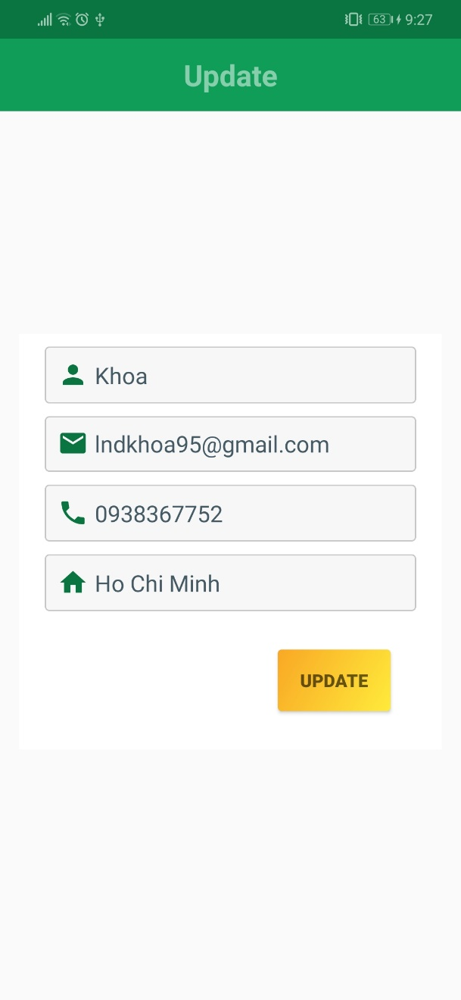

|  |  |  |  |  |  |
| --- | --- | --- | --- | --- | --- |
| **No.** | **Name** | **Type** | **Validation** | **Event** | **Description** |
| 1 | Name | EditText | Not null |  | Customer’s name |
| 2 | Email | EditText | Not null, email pattern |  | Customer’s email, email is unique, can’t be register with more than 1 customer |
| 3 | Phone | EditText | Not null, phone number pattern |  | Customer’s phone number, phone is unique, can’t be register with more than 1 customer |
| 4 | Address | EditText | Not null |  | Customer’s address |
| 5 | Update | Button |  | Click | Check input and update customer’s information |

## 11. Product list filtered by sub category

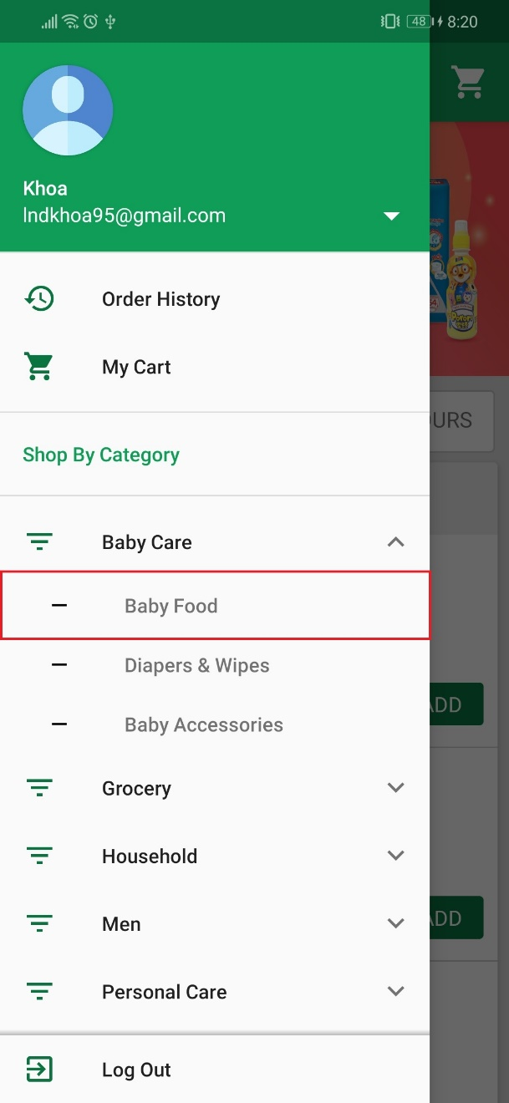 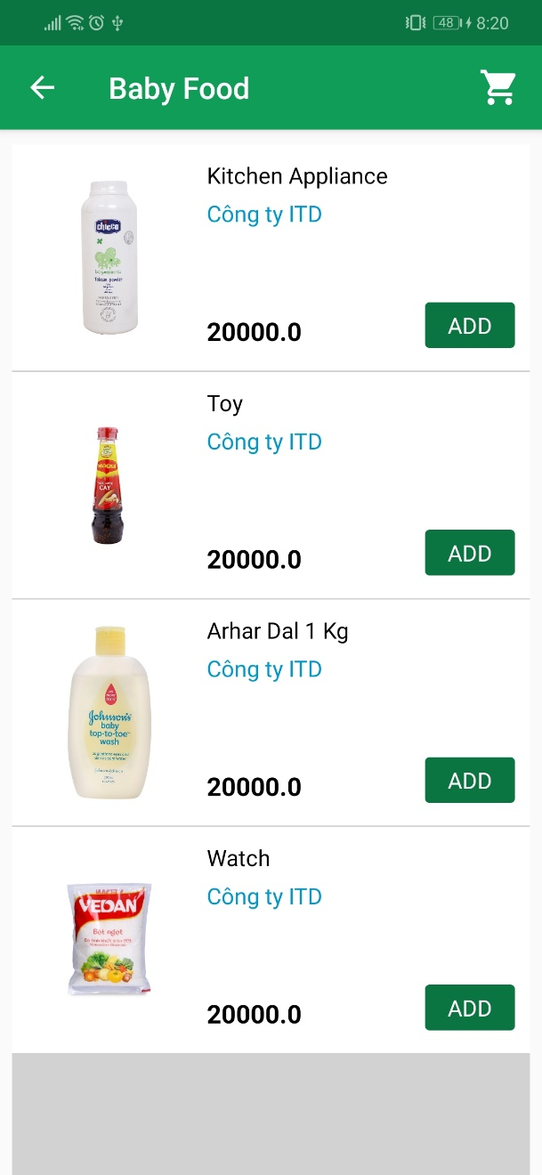

|  |  |  |  |  |  |
| --- | --- | --- | --- | --- | --- |
| **No.** | **Name** | **Type** | **Validation** | **Event** | **Description** |
| 1 | Sub category | SecondaryDrawerItem |  | Click | Sub category’s name. Click to see all products of that sub category |
| 2 | Product list | RecyclerView |  | Click | List of products belong to selected sub category. Click on any product will show product details screen |
| 3 | Add | Button |  | Click | Add product to cart |

## 12. Search by product name

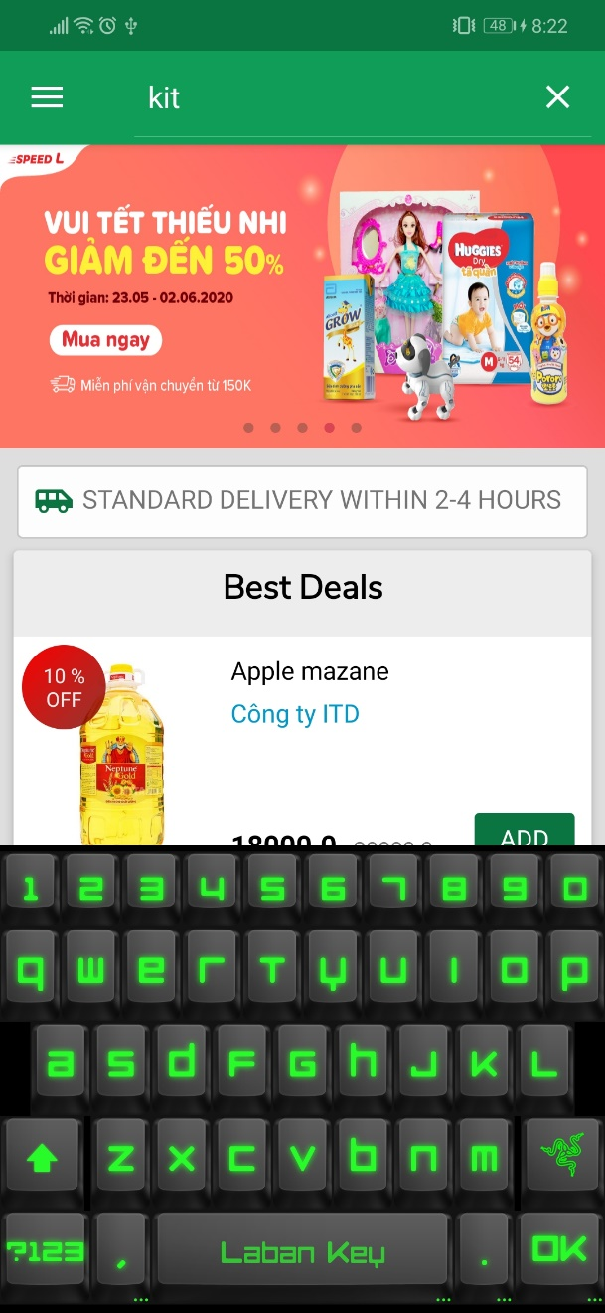 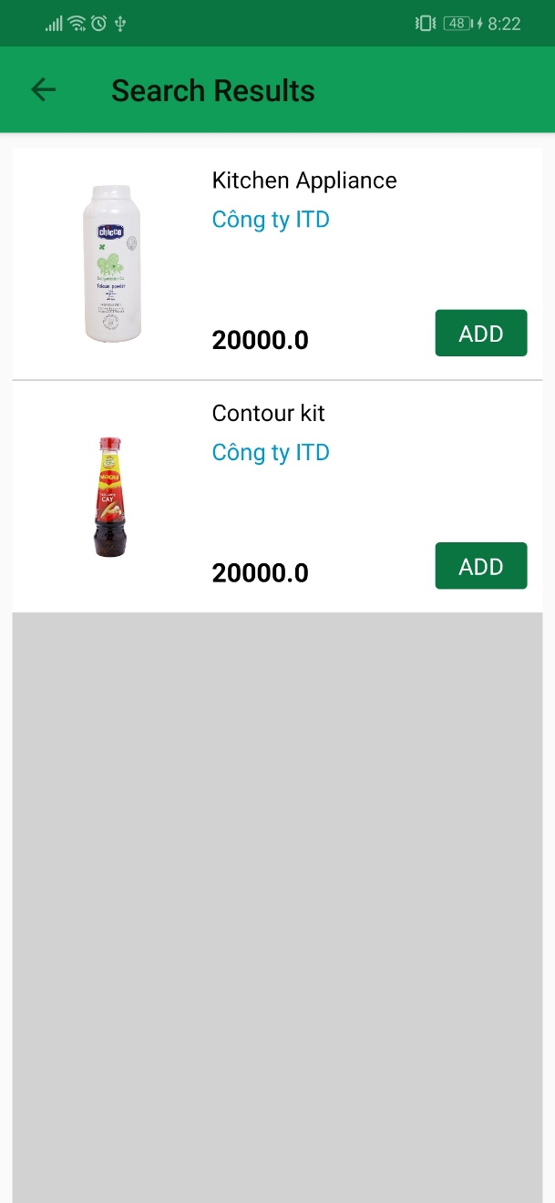

|  |  |  |  |  |  |
| --- | --- | --- | --- | --- | --- |
| **No.** | **Name** | **Type** | **Validation** | **Event** | **Description** |
| 1 | Search | Search bar |  | Click | Enter text to search and click ok. |
| 2 | Product list | RecyclerView |  | Click | List of products has name contains search text. Click on any product will show product details screen |
| 3 | Add | Button |  | Click | Add product to cart |

## 13. Product’s details

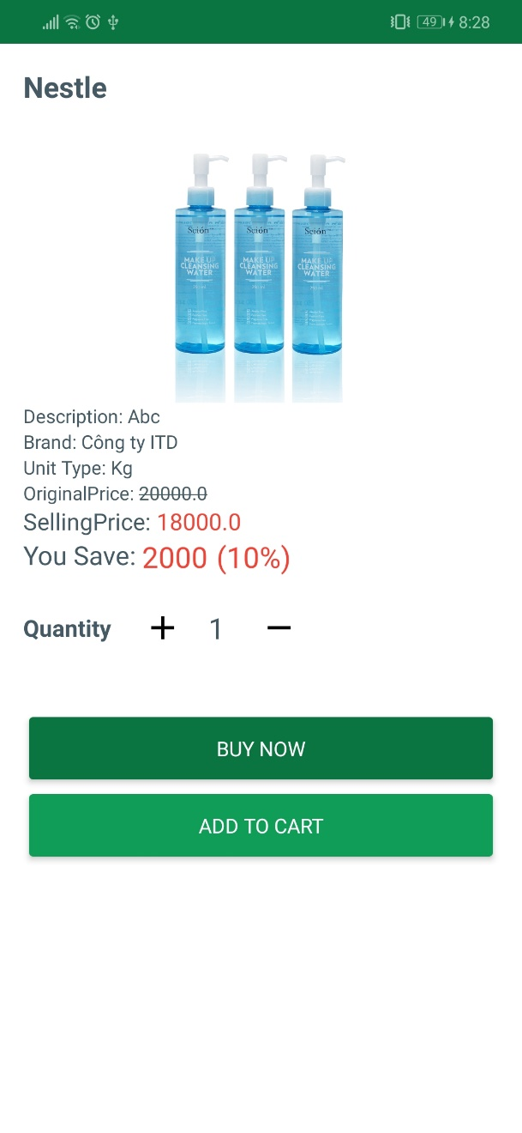

|  |  |  |  |  |  |
| --- | --- | --- | --- | --- | --- |
| **No.** | **Name** | **Type** | **Validation** | **Event** | **Description** |
| 1 | Product info | TextView |  |  | Product’s details |
| 2 | Buy now | Button |  | Click | Add product to cart with selected quantity and redirect to cart screen |
| 3 | Add to cart | Button |  | Click | Add product to cart with selected quantity |

## 14. My cart

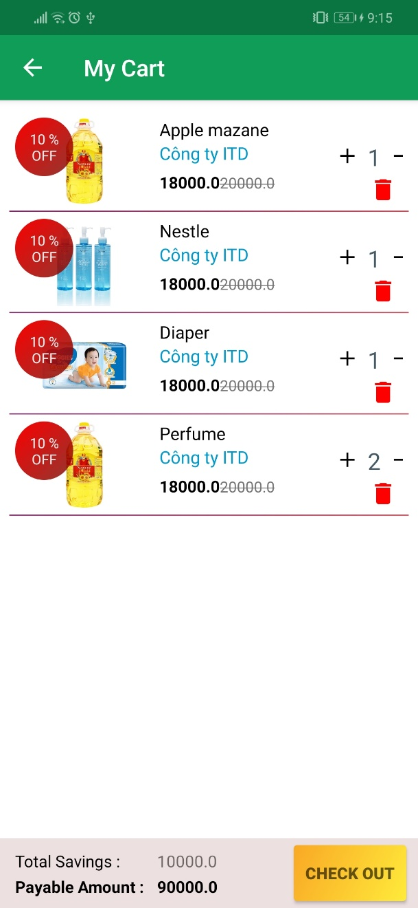

|  |  |  |  |  |  |
| --- | --- | --- | --- | --- | --- |
| **No.** | **Name** | **Type** | **Validation** | **Event** | **Description** |
| 1 | Product list | RecylcerView |  |  | List of product in cart |
| 2 | Plus icon | Button |  | Click | Increase product’s quantity by 1 |
| 3 | Minus icon | Button |  | Click | Decrease product’s quantity by 1 |
| 4 | Trash can icon | Button |  | Click | Remove product from cart |
| 5 | Check out | Button |  | Click | Go to check out screen |

## 15. Check out

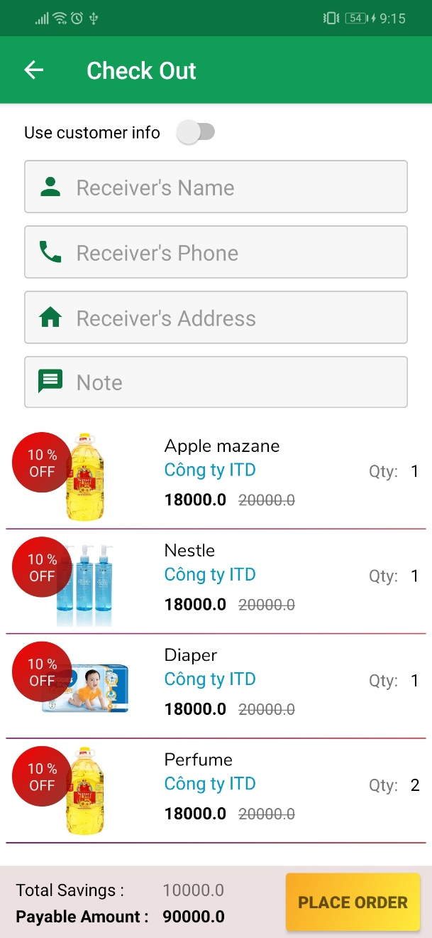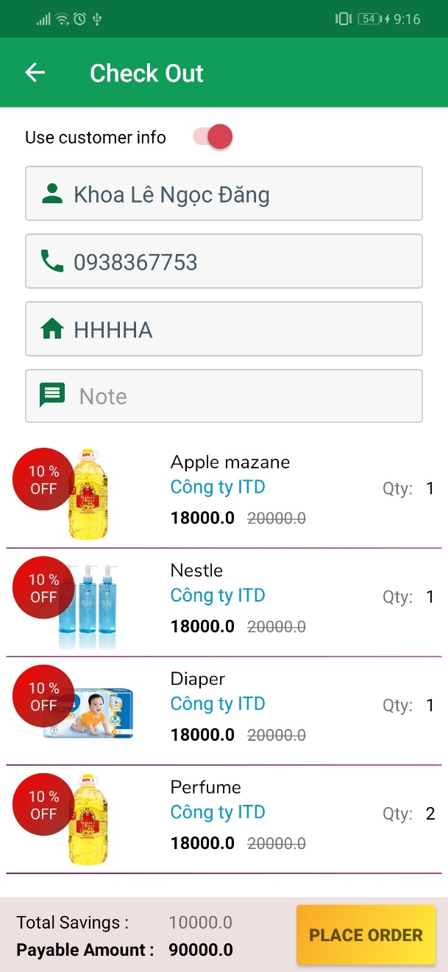

|  |  |  |  |  |  |
| --- | --- | --- | --- | --- | --- |
| **No.** | **Name** | **Type** | **Validation** | **Event** | **Description** |
| 1 | Use customer info | Switch |  | OnChecked | Checked switch to use customer’s information when sign up as the receiver infomation |
| 2 | Receiver’s name | EditText | Not null |  | Receiver’s name |
| 3 | Receiver’s phone | EditText | Not null |  | Receiver’s phone |
| 4 | Receiver’s address | EditText | Not null |  | Receiver’s address |
| 5 | Note | EditText | Not null |  | Order’s note |
| 6 | Product list | RecylcerView |  |  | List of product in cart |
| 7 | Place order | Button |  | Click | Send order request and redirect to home screen |

## 16. Order history

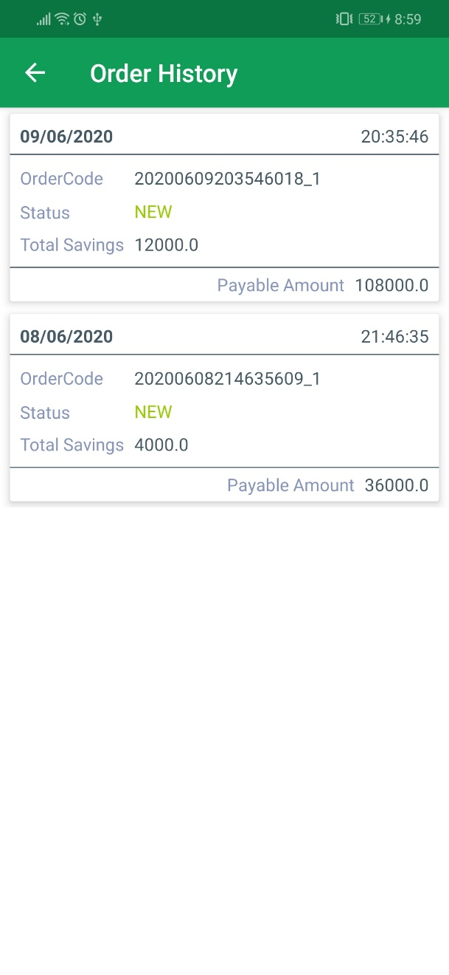

|  |  |  |  |  |  |
| --- | --- | --- | --- | --- | --- |
| **No.** | **Name** | **Type** | **Validation** | **Event** | **Description** |
| 1 | Order list | RecylcerView |  | Click | List of order of member. Click to see order’s details |

## 17. Order’s details

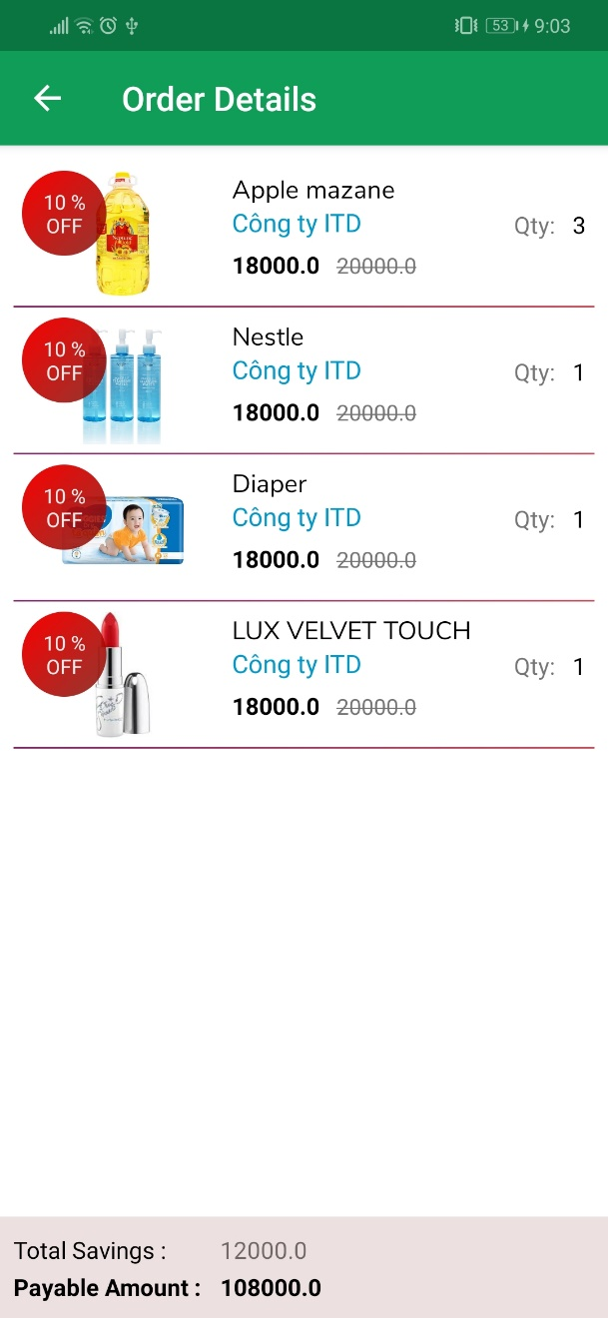

|  |  |  |  |  |  |
| --- | --- | --- | --- | --- | --- |
| **No.** | **Name** | **Type** | **Validation** | **Event** | **Description** |
| 1 | Product list | RecylcerView |  |  | List of product of order |

# V. Admin GUI design

## 1. Login page

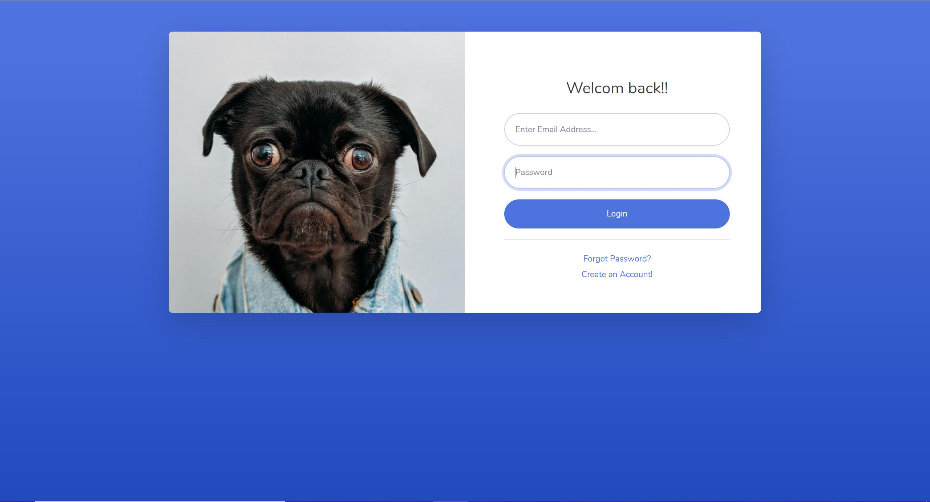

|  |  |  |  |  |  |
| --- | --- | --- | --- | --- | --- |
| **No.** | **Name** | **Type** | **Validation** | **Event** | **Description** |
| 1 | Email address | EditText | Not null |  | Email to login |
| 2 | Password | EditText | Not null |  | Password to login |
| 3 | Login | Button |  | Click | If success, go to Dashboard page else show error |

## 2. Dashboard

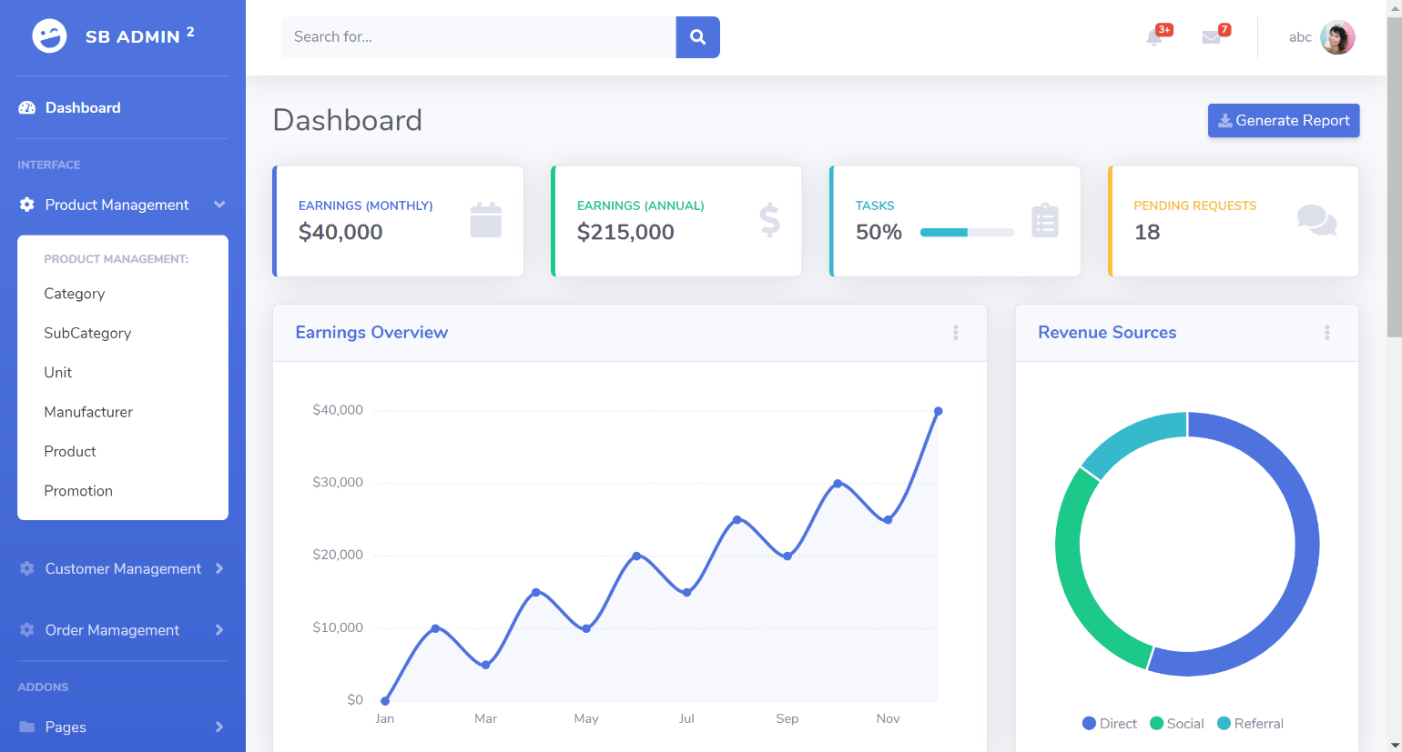

|  |  |  |  |  |  |
| --- | --- | --- | --- | --- | --- |
| **No.** | **Name** | **Type** | **Validation** | **Event** | **Description** |
| 1 | Menu tab |  |  | Click | Admin choose to manage |
| 2 | Search | Button | Not null | Click | Admin click to search |

## 3. Category page

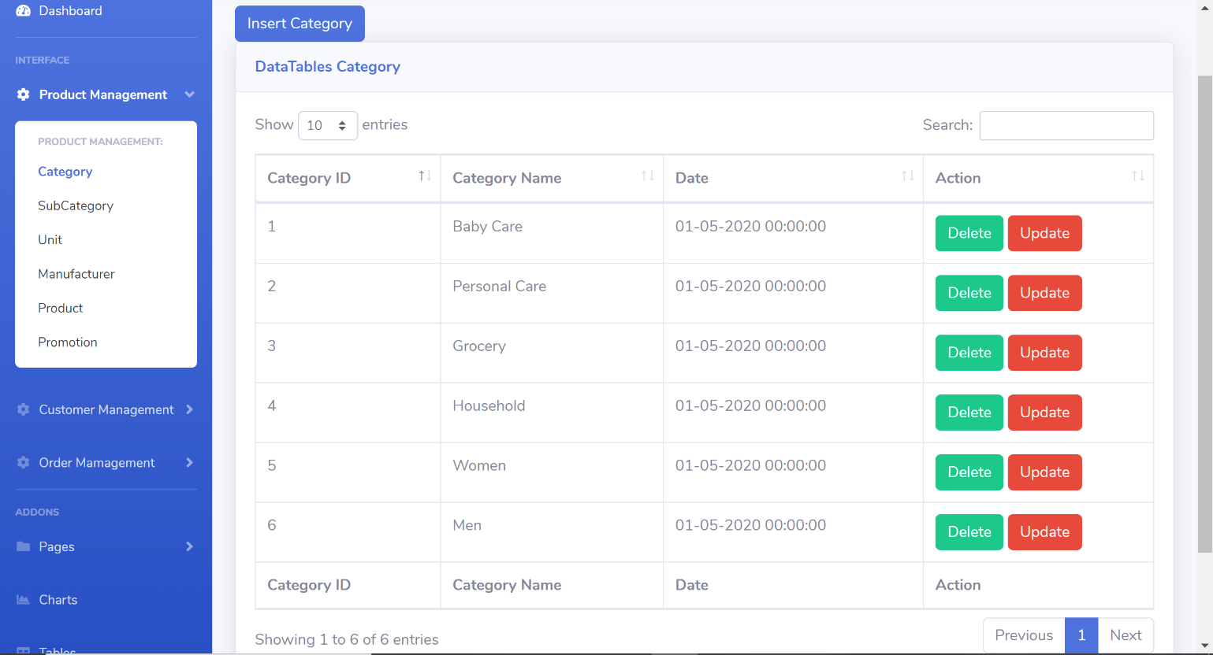

|  |  |  |  |  |  |
| --- | --- | --- | --- | --- | --- |
| **No.** | **Name** | **Type** | **Validation** | **Event** | **Description** |
| 1 | Category List | Table |  |  | Category list |
| 2 | Search | EditText |  |  | Admin type to search |
| 3 | Delete | Button |  | Click | Admin click to delete category ( after confirm dialog ) |
| 4 | Update | Button |  | Click | Admin click to go to Update category page |
| 5 | Previous | Button |  | Click | Go before entries |
| 6 | Next | Button |  | Click | Go next entries |

## 4. Category insert page

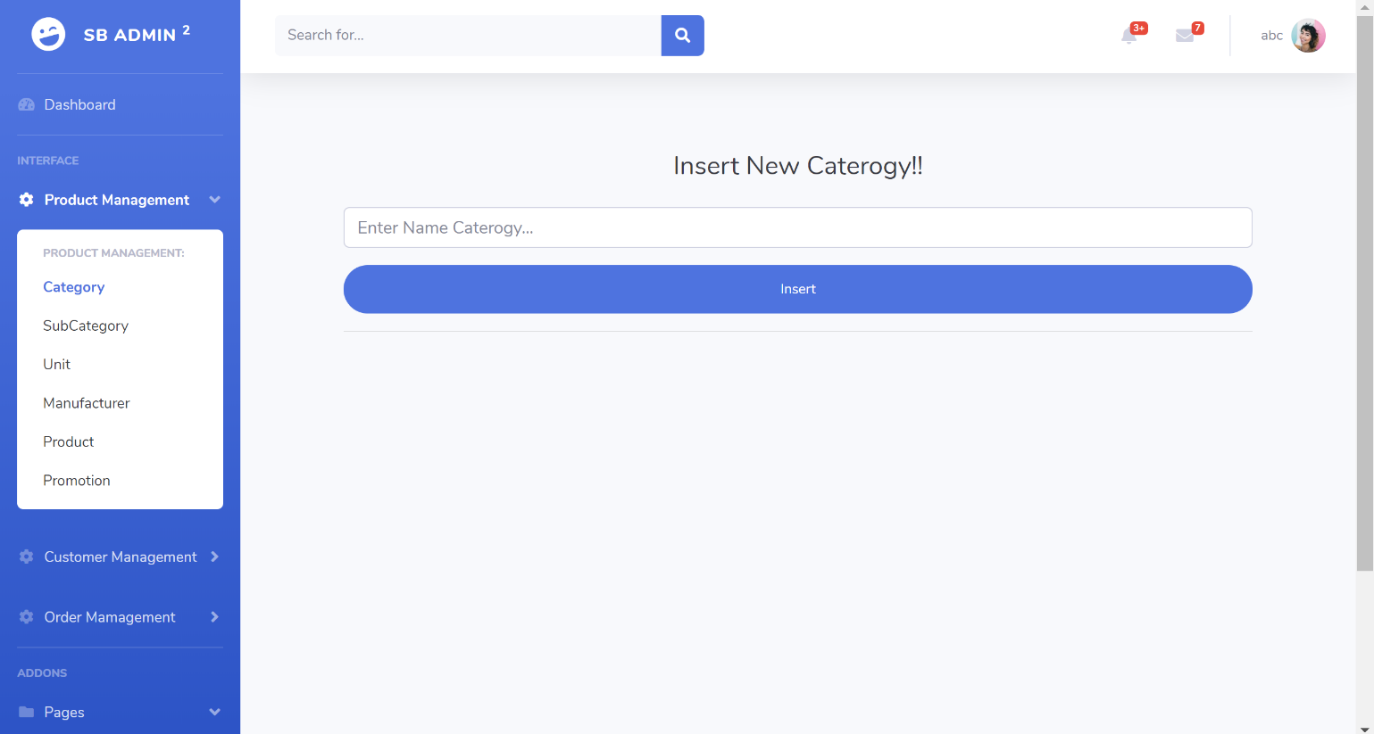

|  |  |  |  |  |  |
| --- | --- | --- | --- | --- | --- |
| **No.** | **Name** | **Type** | **Validation** | **Event** | **Description** |
| 1 | Category name | EditText | Not null |  | Admin input category name to insert |
| 2 | Insert | Button |  | Click | After validate category name admin click this button to insert |

## 4. Category update page

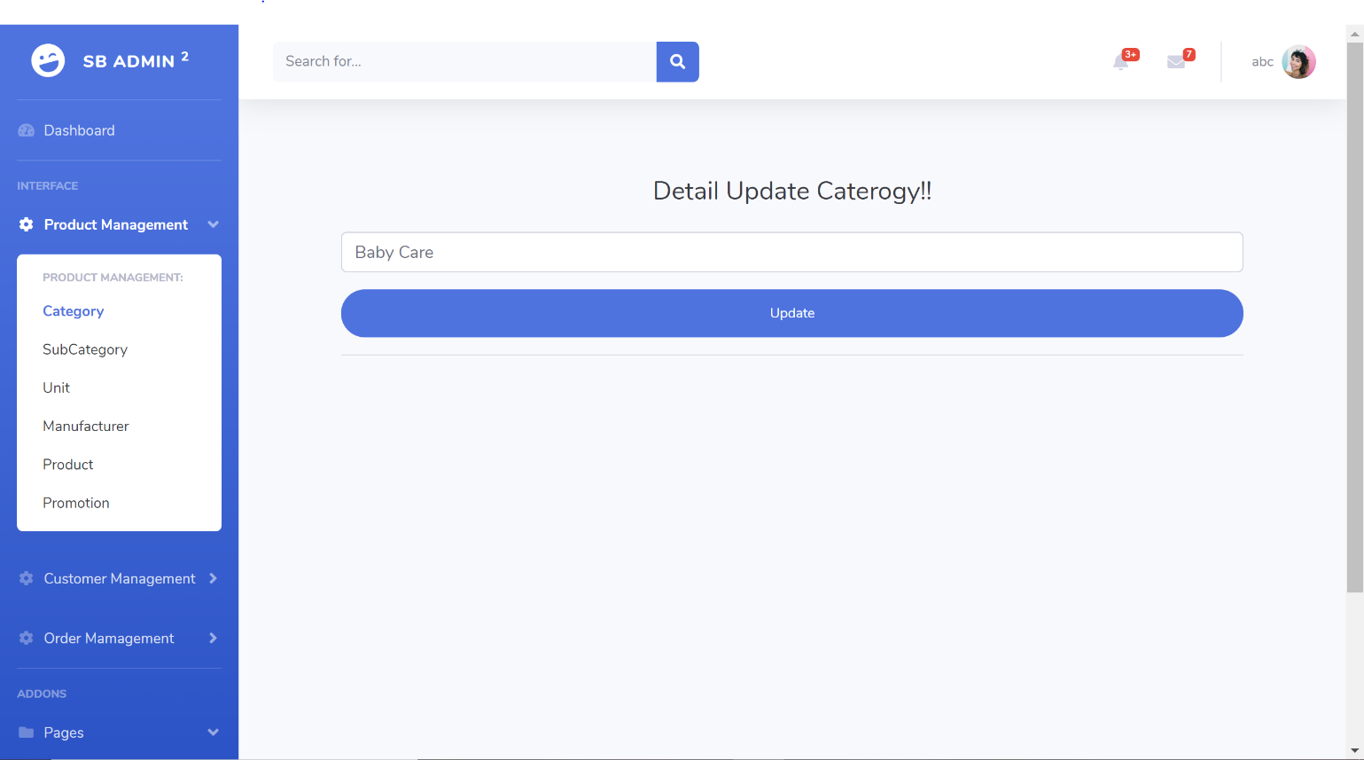

|  |  |  |  |  |  |
| --- | --- | --- | --- | --- | --- |
| **No.** | **Name** | **Type** | **Validation** | **Event** | **Description** |
| 1 | Category name | EditText | Not null |  | Admin input category name to update |
| 2 | Update | Button |  | Click | After validate category name admin click this button to update |

## 5. Subcategory page

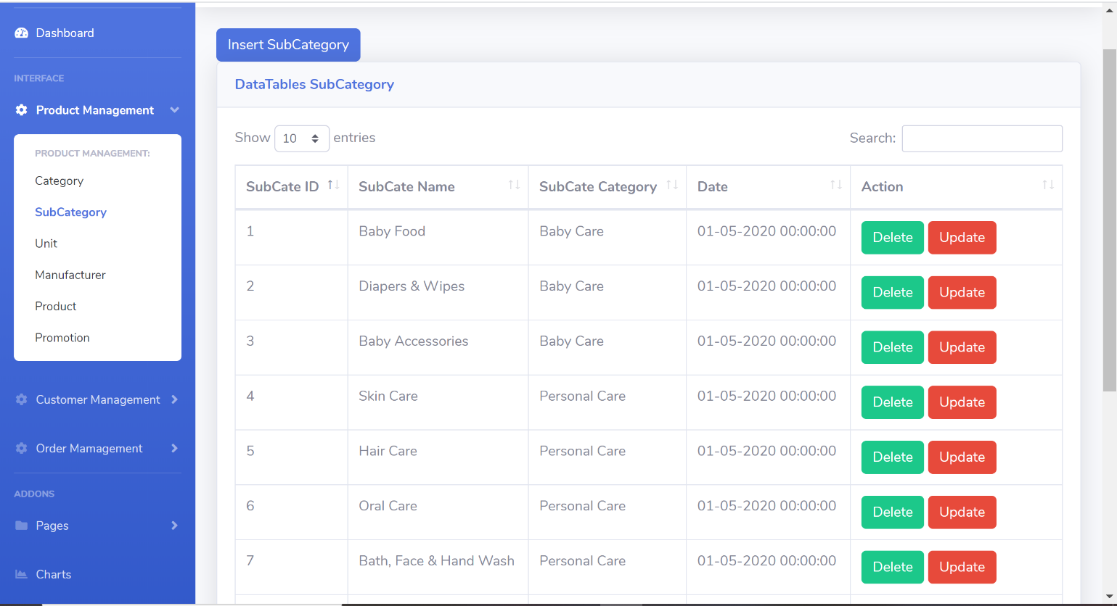

|  |  |  |  |  |  |
| --- | --- | --- | --- | --- | --- |
| **No.** | **Name** | **Type** | **Validation** | **Event** | **Description** |
| 1 | Subategory List | Table |  |  | Subategory list |
| 2 | Search | EditText |  |  | Admin type to search |
| 3 | Insert SubCategory | Button |  | Click | Admin click to go to insert page |
| 4 | Delete | Button |  | Click | Admin click to delete subcategory ( after confirm dialog ) |
| 5 | Update | Button |  | Click | Admin click to go to Update subcategory page |

## 6. Subcategory insert page

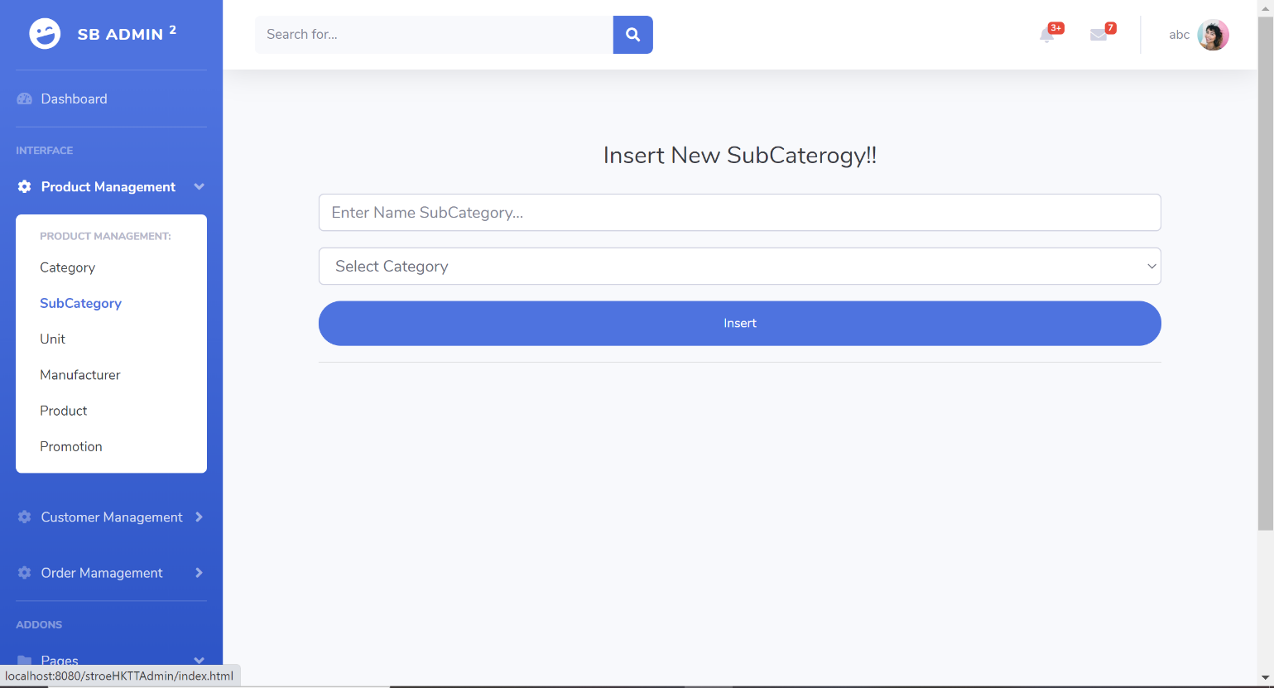

|  |  |  |  |  |  |
| --- | --- | --- | --- | --- | --- |
| **No.** | **Name** | **Type** | **Validation** | **Event** | **Description** |
| 1 | Subcategory name | EditText | Not null |  | Admin input category name to insert |
| 2 | Category name | Combobox | Not null |  | Admin must insert category before insert subcategory |
| 3 | Insert | Button |  | Click | After validate input, admin click this button to insert |

## 7. Subcategory update page

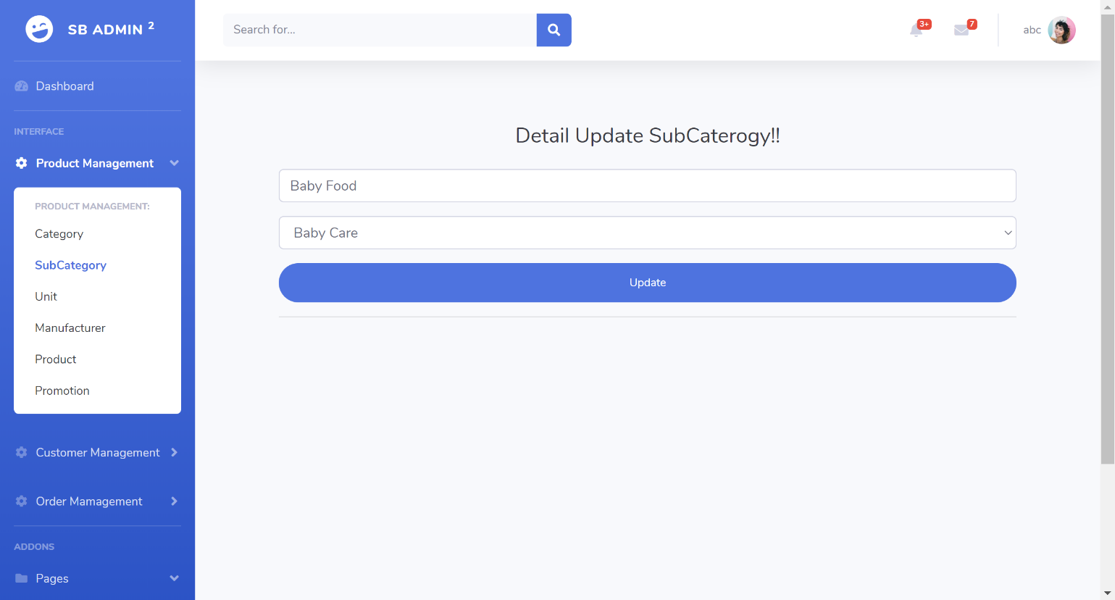

|  |  |  |  |  |  |
| --- | --- | --- | --- | --- | --- |
| **No.** | **Name** | **Type** | **Validation** | **Event** | **Description** |
| 1 | Subcategory | EditText | Not null |  | Admin input category name to update |
| 2 | Category name | Combobox | Not null |  | Category name |
| 3 | Update | Button |  | Click | After validate category name admin click this button to update |

## 8. Unit page

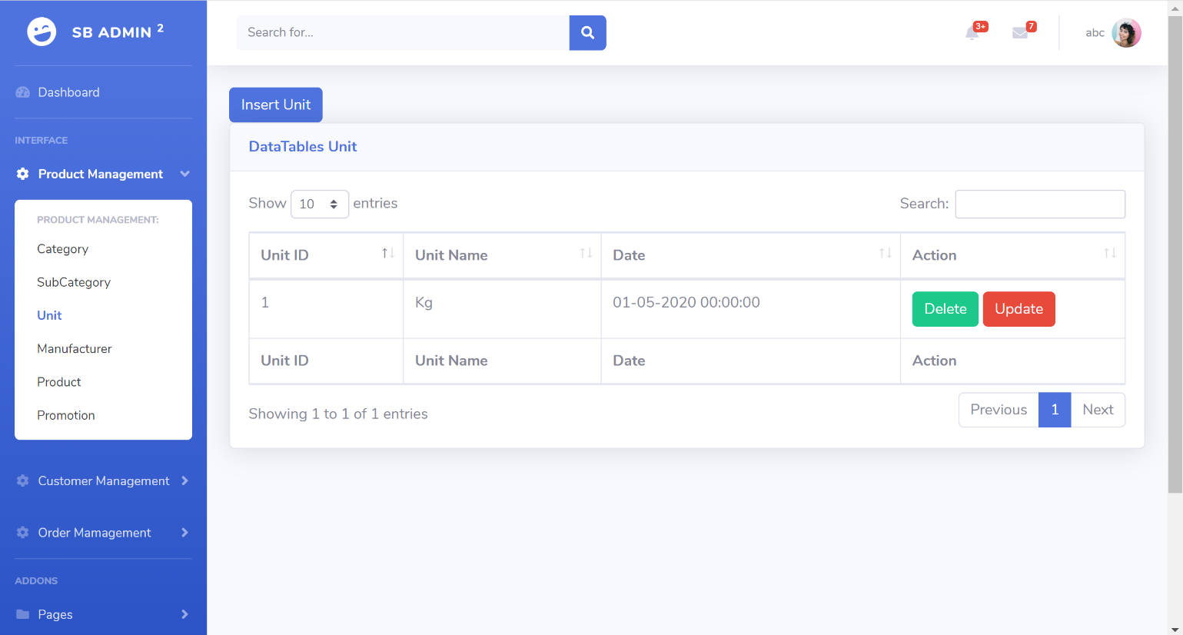

|  |  |  |  |  |  |
| --- | --- | --- | --- | --- | --- |
| **No.** | **Name** | **Type** | **Validation** | **Event** | **Description** |
| 1 | Unit List | Table |  |  | Unit list |
| 2 | Search | EditText |  |  | Admin type to search |
| 3 | Insert Unit | Button |  | Click | Admin click to go to insert page |
| 4 | Delete | Button |  | Click | Admin click to delete unit ( after confirm dialog ) |
| 5 | Update | Button |  | Click | Admin click to go to Update unit page |

## 9. Unit insert page

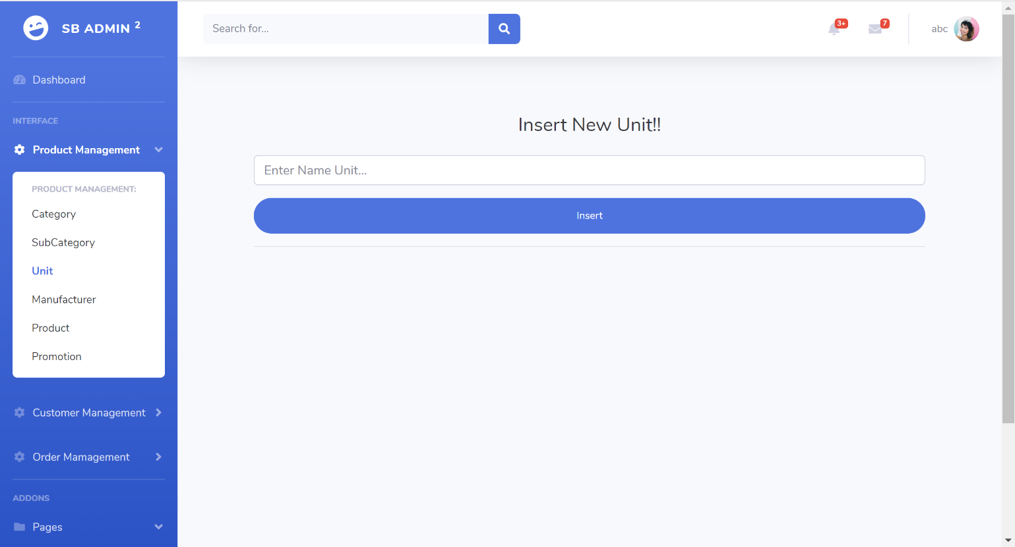

|  |  |  |  |  |  |
| --- | --- | --- | --- | --- | --- |
| **No.** | **Name** | **Type** | **Validation** | **Event** | **Description** |
| 1 | Unit name | EditText | Not null |  | Admin input unit name to insert |
| 2 | Insert | Button |  | Click | After validate unit name admin click this button to insert |

## 10. Unit update page

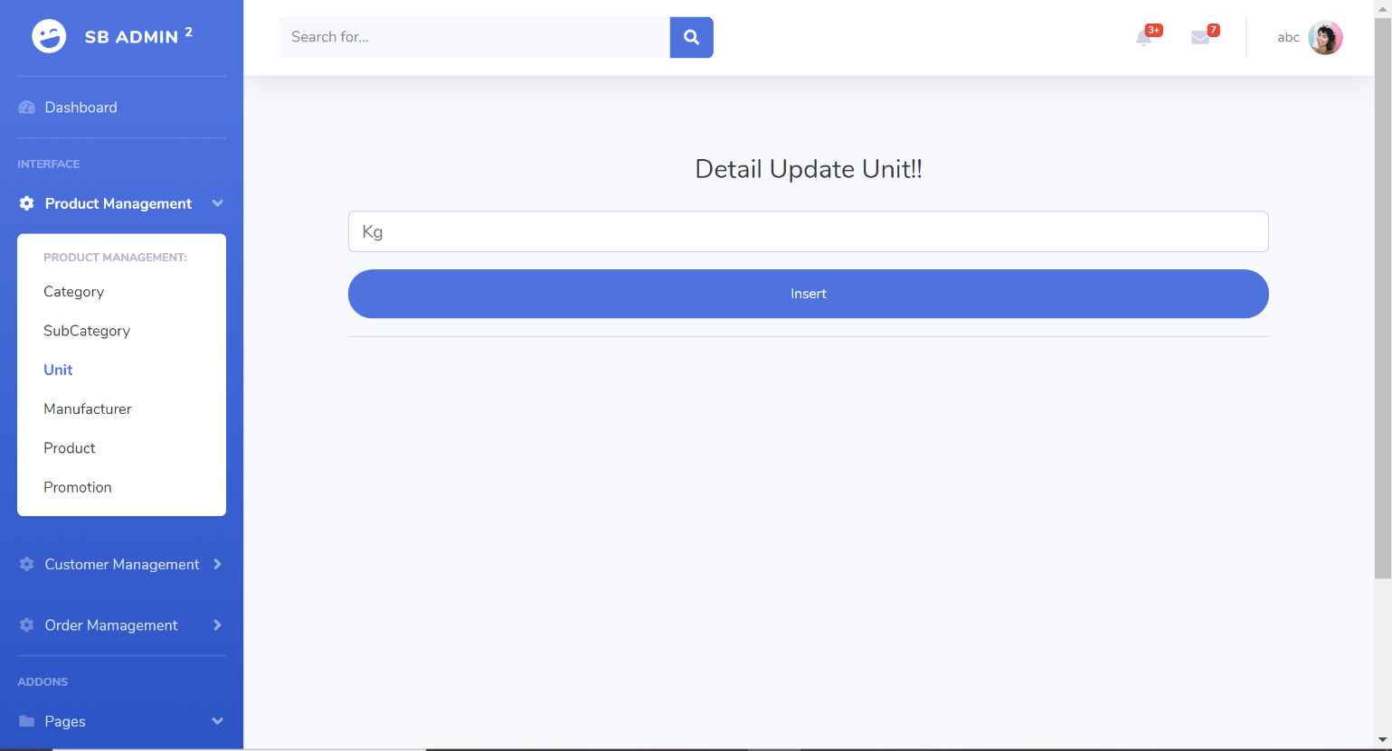

|  |  |  |  |  |  |
| --- | --- | --- | --- | --- | --- |
| **No.** | **Name** | **Type** | **Validation** | **Event** | **Description** |
| 1 | Unit name | EditText | Not null |  | Admin input unit name to update |
| 2 | Update | Button |  | Click | After validate unit name admin click this button to update |

## 11. Manufacturer page

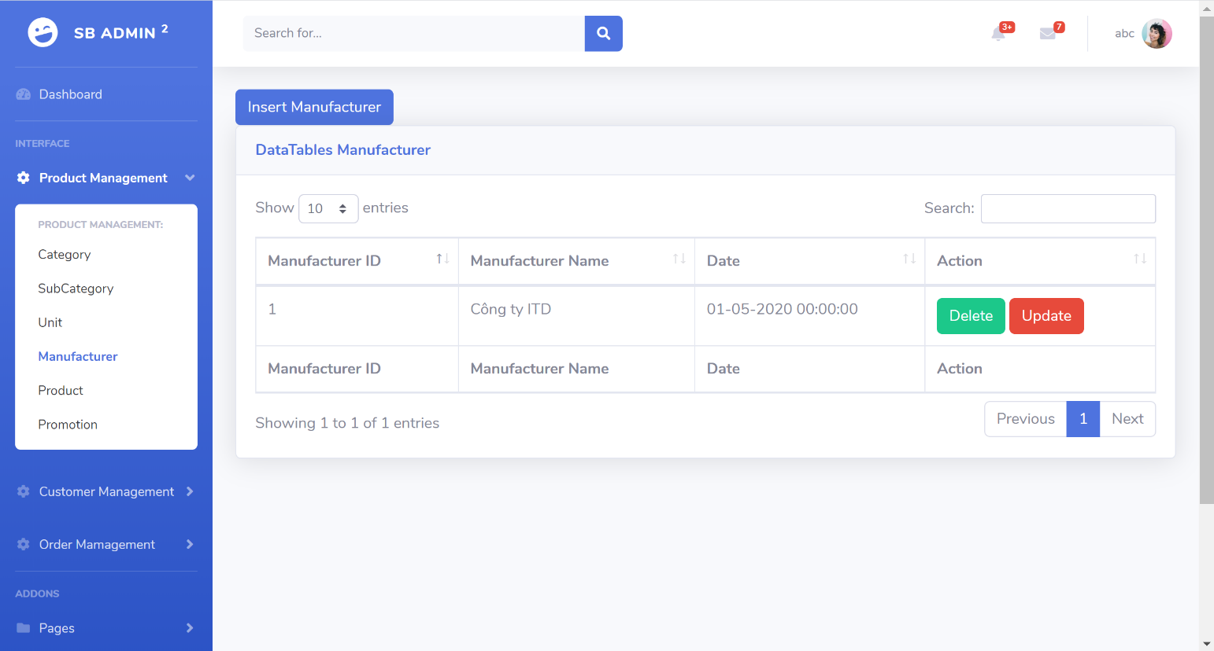

|  |  |  |  |  |  |
| --- | --- | --- | --- | --- | --- |
| **No.** | **Name** | **Type** | **Validation** | **Event** | **Description** |
| 1 | Manufacturer List | Table |  |  | Manufacturer list |
| 2 | Search | EditText |  |  | Admin type to search |
| 3 | Insert Manufacturer | Button |  | Click | Admin click to go to insert page |
| 4 | Delete | Button |  | Click | Admin click to delete manufacturer ( after confirm dialog ) |
| 5 | Update | Button |  | Click | Admin click to go to Update manufacturer page |

## 12. Manufacturer insert page

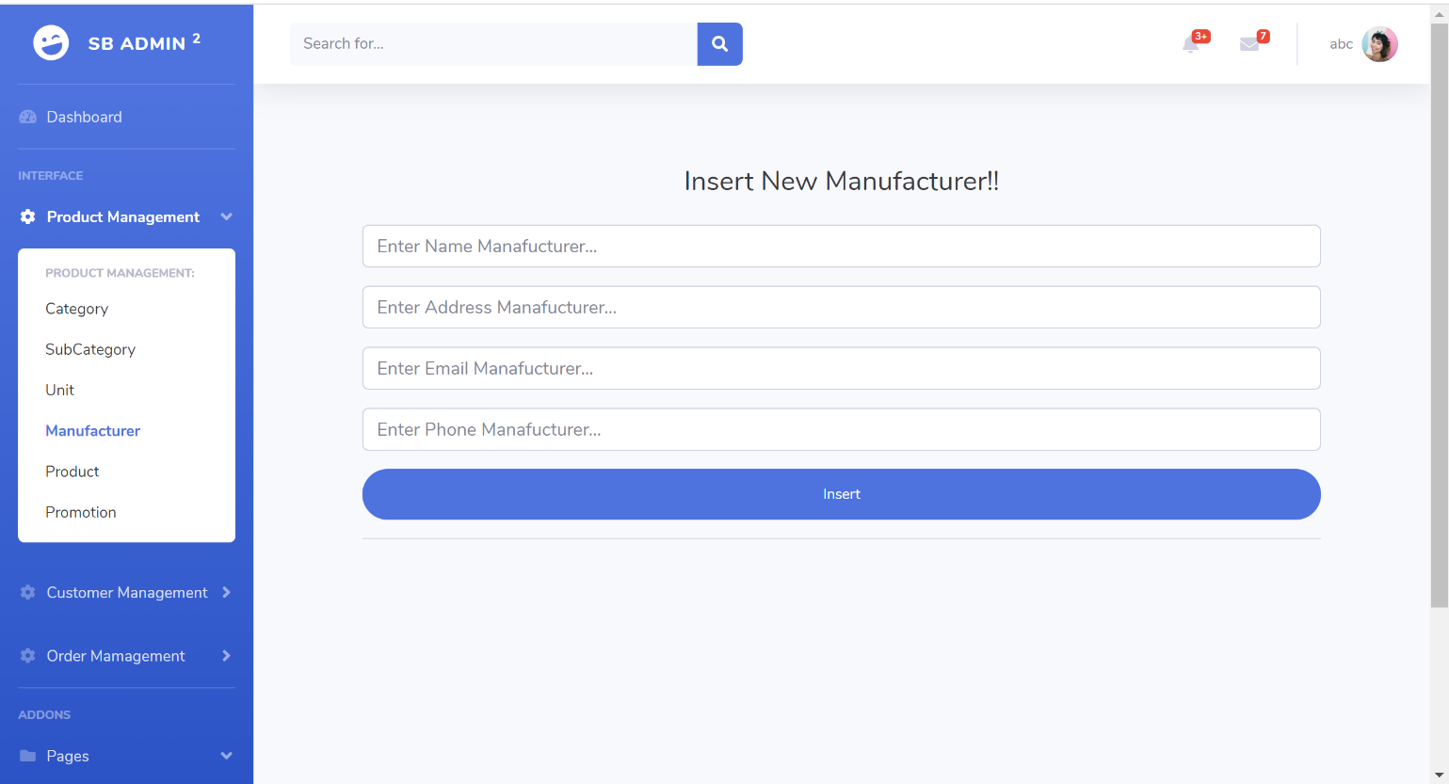

|  |  |  |  |  |  |
| --- | --- | --- | --- | --- | --- |
| **No.** | **Name** | **Type** | **Validation** | **Event** | **Description** |
| 1 | Manufacturer name | EditText | Not null |  | Manufacturer name |
| 2 | Manufacturer address | EditText | Not null |  | Manufacturer’s address, address is unique, can’t be register with more than 1 customer |
| 3 | Manufacturer email | EditText | Not null |  | Manufacturer’s email, email is unique, can’t be register with more than 1 customer |
| 4 | Manufacturer phone | EditText | Not null |  | Manufacturer’s phone number, phone is unique, can’t be register with more than 1 customer |
| 5 | Insert | Button |  | Click | After validate input, admin click this button to insert |

## 13. Manufacturer update page

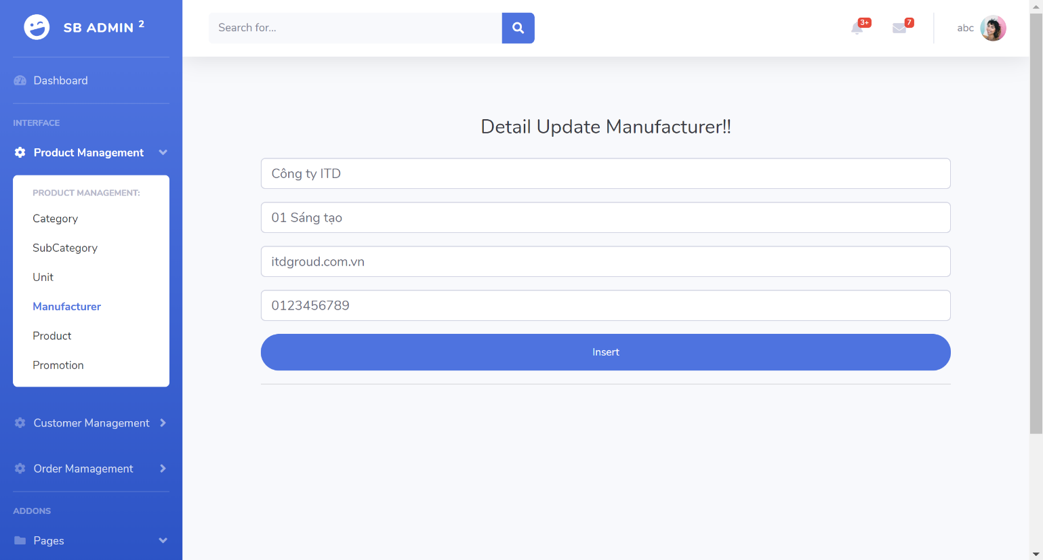

|  |  |  |  |  |  |
| --- | --- | --- | --- | --- | --- |
| **No.** | **Name** | **Type** | **Validation** | **Event** | **Description** |
| 1 | Manufacturer name | EditText | Not null |  | Manufacturer name |
| 2 | Manufacturer address | EditText | Not null |  | Manufacturer’s address, address is unique, can’t be register with more than 1 customer |
| 3 | Manufacturer email | EditText | Not null |  | Manufacturer’s email, email is unique, can’t be register with more than 1 customer |
| 4 | Manufacturer phone | EditText | Not null |  | Manufacturer’s phone number, phone is unique, can’t be register with more than 1 customer |
| 5 | Insert | Button |  | Click | After validate input, admin click this button to update |

## 14. Product page

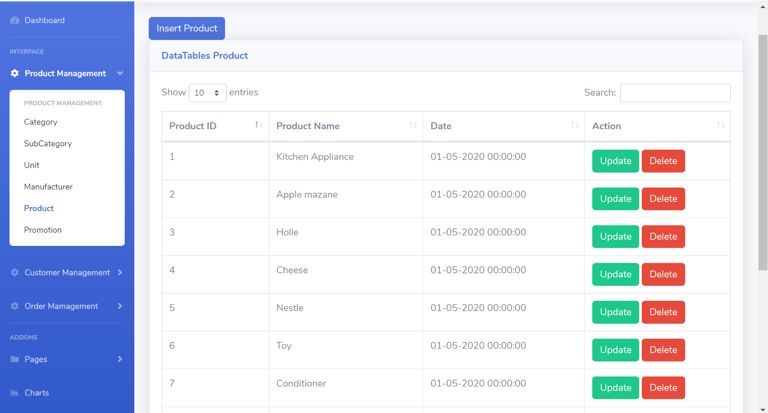

|  |  |  |  |  |  |
| --- | --- | --- | --- | --- | --- |
| **No.** | **Name** | **Type** | **Validation** | **Event** | **Description** |
| 1 | Product List | Table |  |  | Product list |
| 2 | Search | EditText |  |  | Admin type to search |
| 3 | Insert Product | Button |  | Click | Admin click to go to insert page |
| 4 | Delete | Button |  | Click | Admin click to delete product ( after confirm dialog ) |
| 5 | Update | Button |  | Click | Admin click to go to Update product page |

## 15. Product insert page

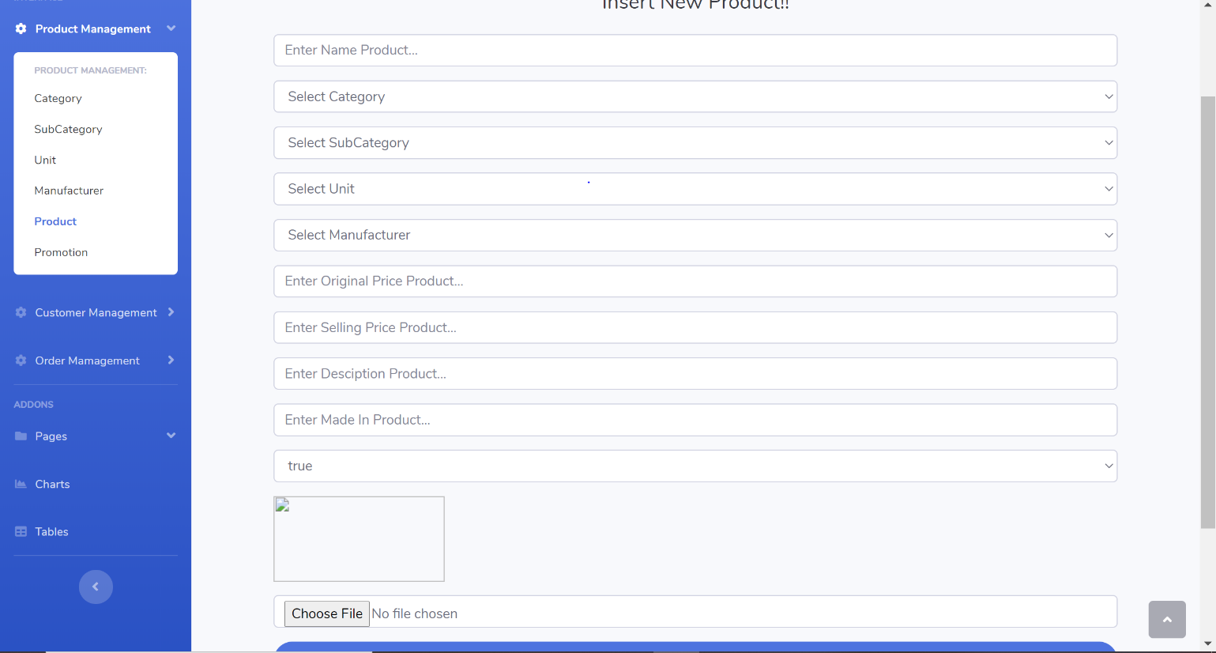

|  |  |  |  |  |  |
| --- | --- | --- | --- | --- | --- |
| **No.** | **Name** | **Type** | **Validation** | **Event** | **Description** |
| 1 | Product’s name | EditText | Not null |  | Product’s name |
| 2 | Product’s category | EditText | Not null |  | Product’s category |
| 3 | Product’s subcategory | EditText | Not null |  | Product’s subcategory |
| 4 | Product’s unit | EditText | Not null |  | Product’s unit |
| 5 | Product’s manufacturer | EditText | Not null |  | Product’s manufacturer |
| 6 | Product’s original price | EditText | Not null |  | Product’s original price |
| 7 | Product’s selling price | EditText | Not null |  | Product’s selling price |
| 8 | Product’s description | EditText | Not null |  | Product’s description |
| 9 | Product’s made in | EditText | Not null |  | Product’s made in |
| 10 | Active product | EditText | Not null |  | If value = true, this product will be show in product page, if false this product willl don’t show in product page |
| 11 | Choose file | EditText |  | Click | After click this button ,admin choose image for this product |
| 12 | Insert | Button |  | Click | After validate input, admin click this button to insert |

## 16. Product update page

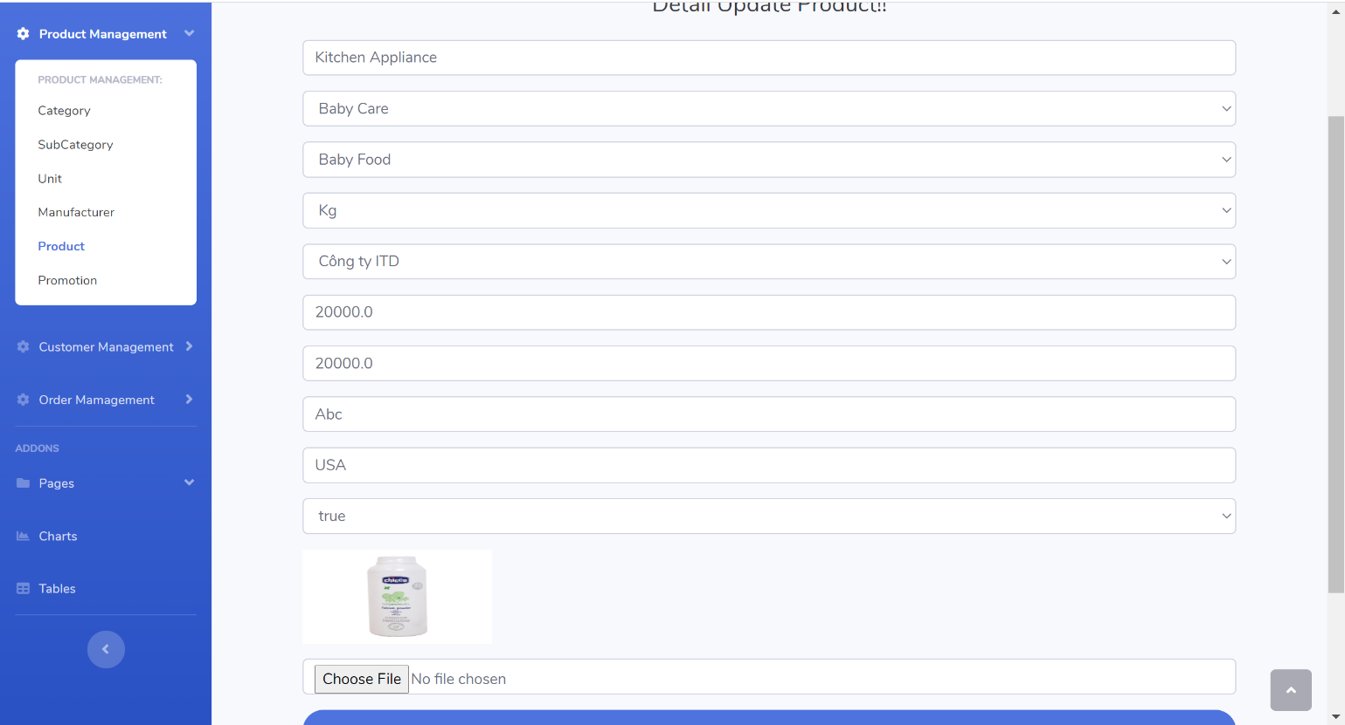

|  |  |  |  |  |  |
| --- | --- | --- | --- | --- | --- |
| **No.** | **Name** | **Type** | **Validation** | **Event** | **Description** |
| 1 | Product’s name | EditText | Not null |  | Product’s name |
| 2 | Product’s category | EditText | Not null |  | Product’s category |
| 3 | Product’s subcategory | EditText | Not null |  | Product’s subcategory |
| 4 | Product’s unit | EditText | Not null |  | Product’s unit |
| 5 | Product’s manufacturer | EditText | Not null |  | Product’s manufacturer |
| 6 | Product’s original price | EditText | Not null |  | Product’s original price |
| 7 | Product’s selling price | EditText | Not null |  | Product’s selling price |
| 8 | Product’s description | EditText | Not null |  | Product’s description |
| 9 | Product’s made in | EditText | Not null |  | Product’s made in |
| 10 | Active product | EditText | Not null |  | If value = true, this product will be show in product page, if false this product willl don’t show in product page |
| 11 | Choose file | EditText |  | Click | After click this button ,admin choose image for this product |
| 12 | Insert | Button |  | Click | After validate input, admin click this button to upate |

## 17. Promotion page

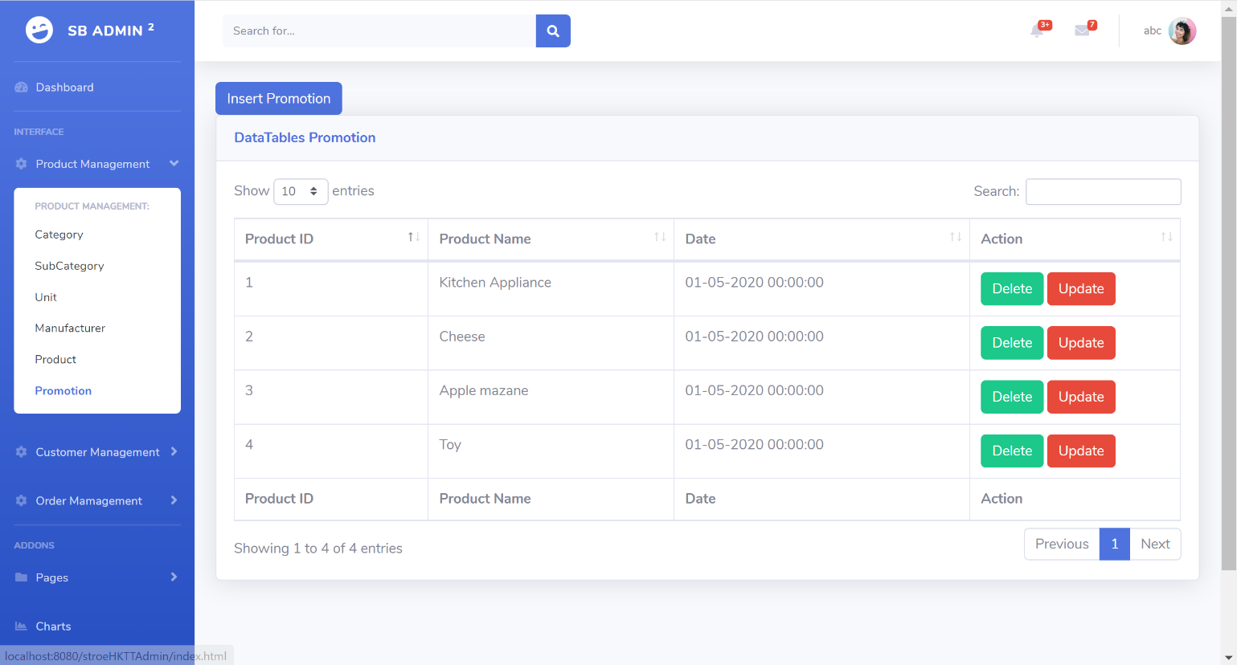

|  |  |  |  |  |  |
| --- | --- | --- | --- | --- | --- |
| **No.** | **Name** | **Type** | **Validation** | **Event** | **Description** |
| 1 | Promotion List | Table |  |  | Promotion list |
| 2 | Search | EditText |  |  | Admin type to search |
| 3 | Insert promotion | Button |  | Click | Admin click to go to Select promotion page if less than 5 products, show error if more than 5 products |
| 3 | Delete | Button |  | Click | Admin click to delete promotion ( after confirm dialog ) |
| 4 | Update | Button |  | Click | Admin click to go to Update promotion page |

## 18. Promotion select product page

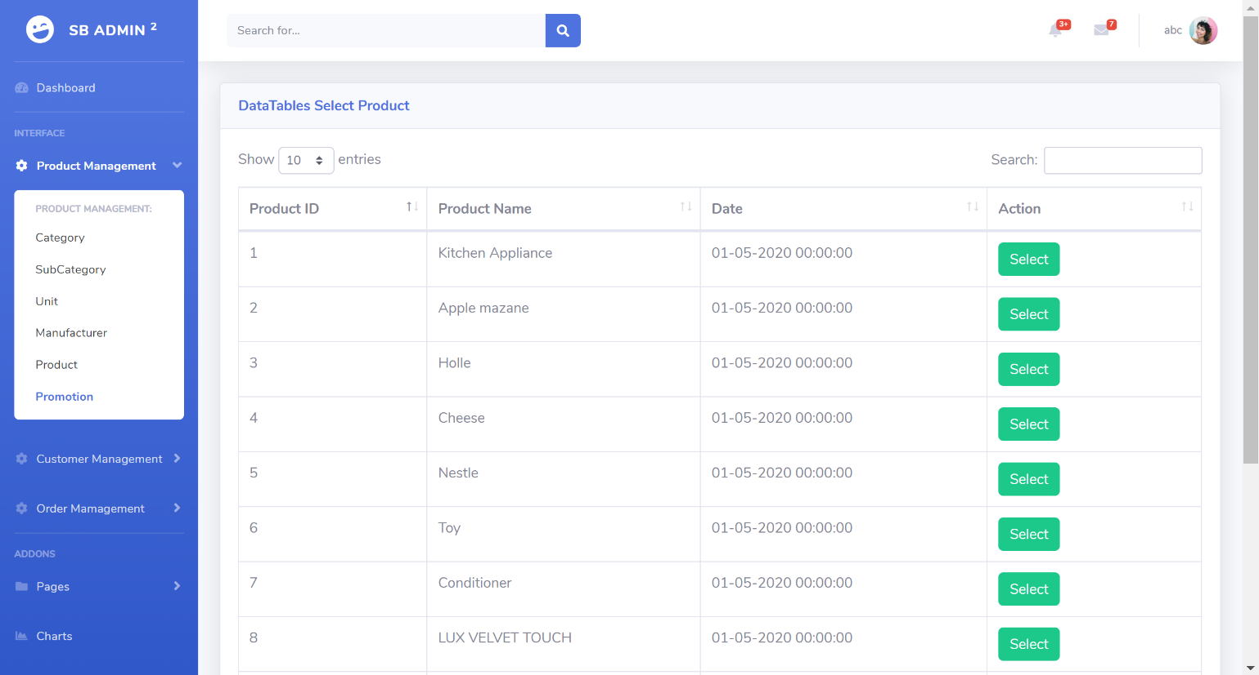

|  |  |  |  |  |  |
| --- | --- | --- | --- | --- | --- |
| **No.** | **Name** | **Type** | **Validation** | **Event** | **Description** |
| 1 | Select | Button |  | Click | Go to insert promotion page with item selected |

## 19. Promotion insert page

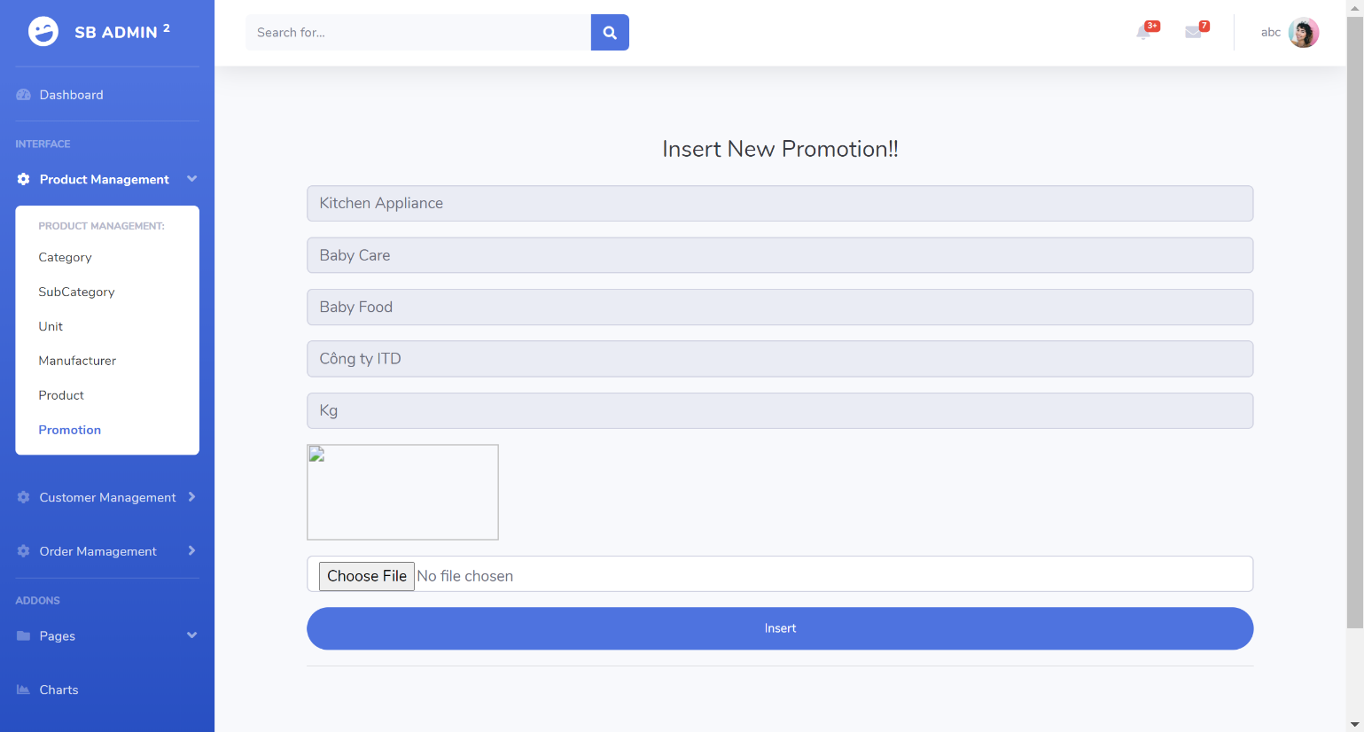

|  |  |  |  |  |  |
| --- | --- | --- | --- | --- | --- |
| **No.** | **Name** | **Type** | **Validation** | **Event** | **Description** |
| 1 | Choose file | Button | Not null | Click | Admin must choose image to insert |
| 2 | Update | Button |  | Click | After choose image admin click this button to insert |

## 20. Promotion update page

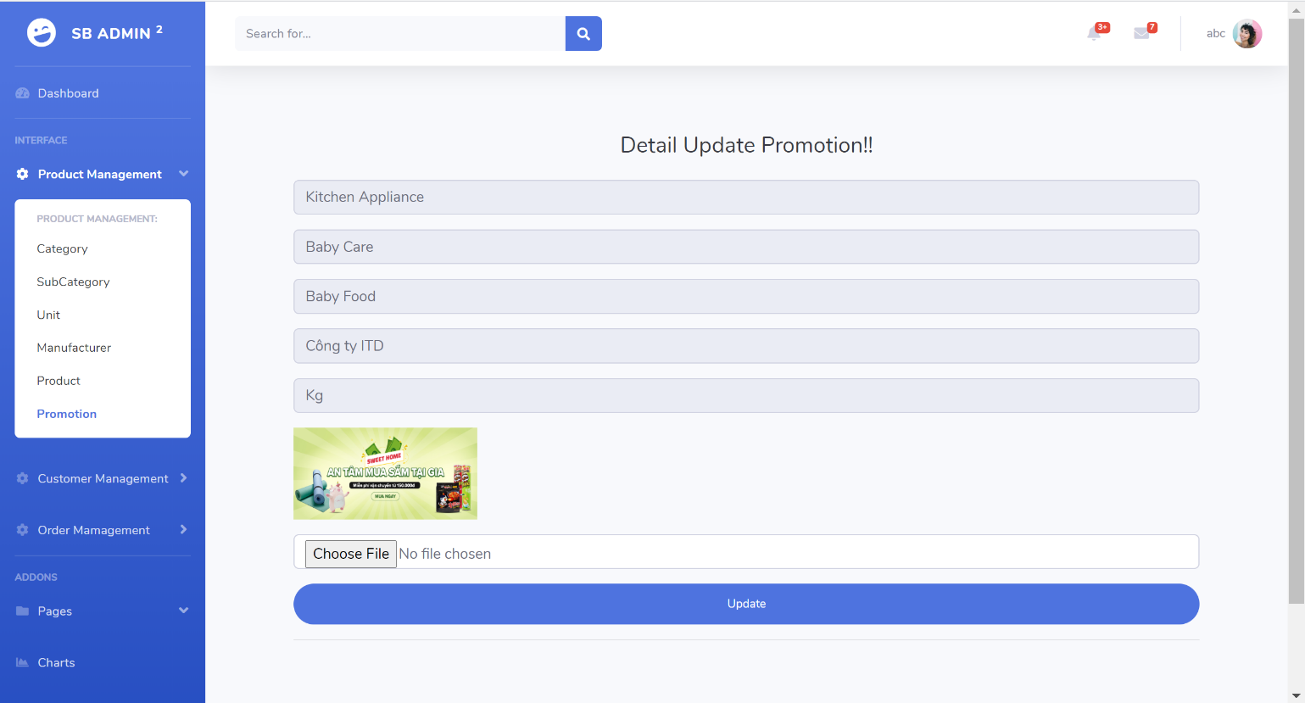

|  |  |  |  |  |  |
| --- | --- | --- | --- | --- | --- |
| **No.** | **Name** | **Type** | **Validation** | **Event** | **Description** |
| 1 | Choose file | Button |  | Click | Admin choose image to update |
| 2 | Update | Button |  | Click | After choose image admin click this button to update |

## 21. Customer page

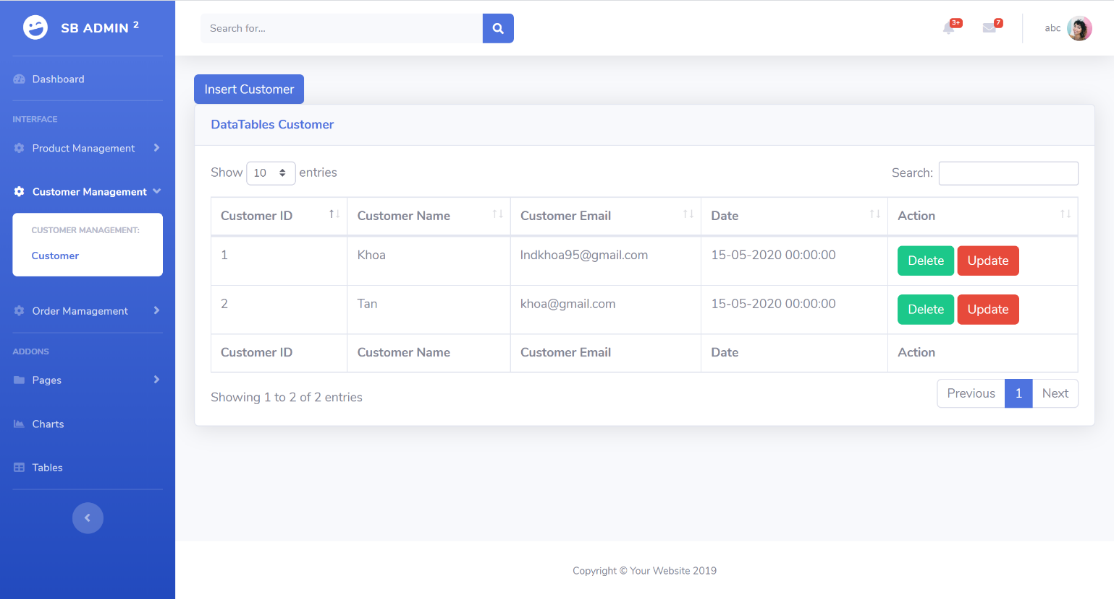

|  |  |  |  |  |  |
| --- | --- | --- | --- | --- | --- |
| **No.** | **Name** | **Type** | **Validation** | **Event** | **Description** |
| 1 | Customer List | Table |  |  | Customer list |
| 2 | Search | EditText |  |  | Admin type to search |
| 3 | Insert | Button |  | Click | Admin click to go to insert page |
| 4 | Delete | Button |  | Click | Admin click to delete customer ( after confirm dialog ) |
| 5 | Update | Button |  | Click | Admin click to go to Update subcategory page |

## 22. Customer page

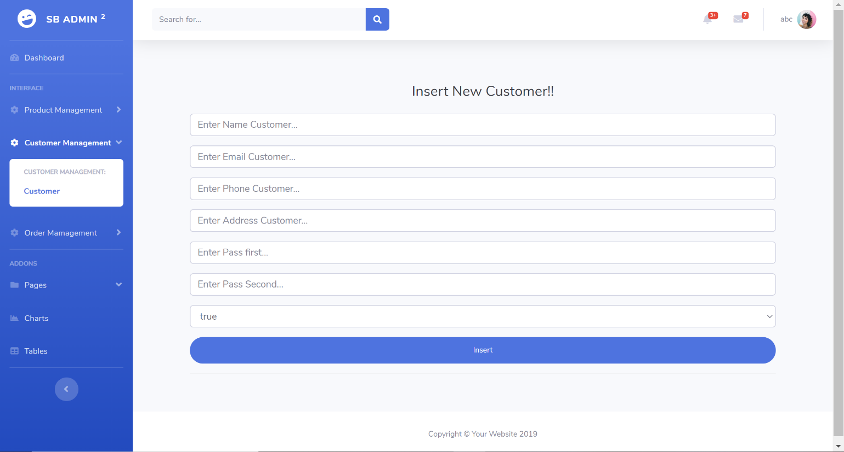

|  |  |  |  |  |  |
| --- | --- | --- | --- | --- | --- |
| **No.** | **Name** | **Type** | **Validation** | **Event** | **Description** |
| 1 | Customer’s name | EditText | Not null |  | Customer’s name |
| 1 | Customer’s email | EditText | Not null |  | Customer’s email, email is unique, can’t be register with more than 1 customer |
| 1 | Customer’s phone | EditText | Not null |  | Customer’s phone number, phone is unique, can’t be register with more than 1 customer |
| 1 | Customer’s address | EditText | Not null |  | Customer’s address, address is unique, can’t be register with more than 1 customer |
| 1 | Pass 1st | EditText | Not null |  | Password 1 |
| 1 | Pass 2nd | EditText | Not null |  | Password 2 |
| 2 | Insert | Button |  | Click | After validate input, admin click this button to insert |

## 23. Customer update page

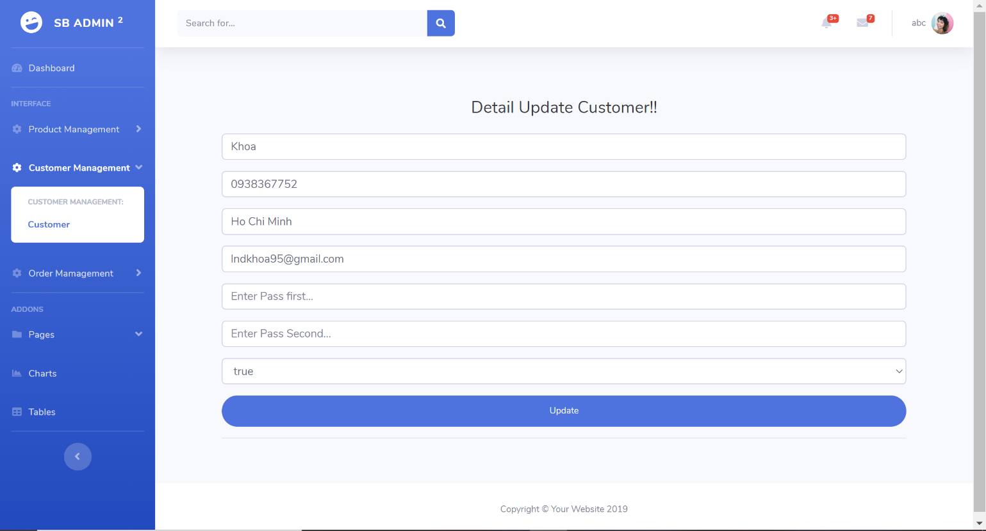

|  |  |  |  |  |  |
| --- | --- | --- | --- | --- | --- |
| **No.** | **Name** | **Type** | **Validation** | **Event** | **Description** |
| 1 | Customer’s name | EditText | Not null |  | Customer’s name |
| 1 | Customer’s email | EditText | Not null |  | Customer’s email, email is unique, can’t be register with more than 1 customer |
| 1 | Customer’s phone | EditText | Not null |  | Customer’s phone number, phone is unique, can’t be register with more than 1 customer |
| 1 | Customer’s address | EditText | Not null |  | Customer’s address, address is unique, can’t be register with more than 1 customer |
| 1 | Pass 1st | EditText | Not null |  | Password 1 |
| 1 | Pass 2nd | EditText | Not null |  | Password 2 |
| 2 | Insert | Button |  | Click | After validate input, admin click this button to update |

## 24. Order page

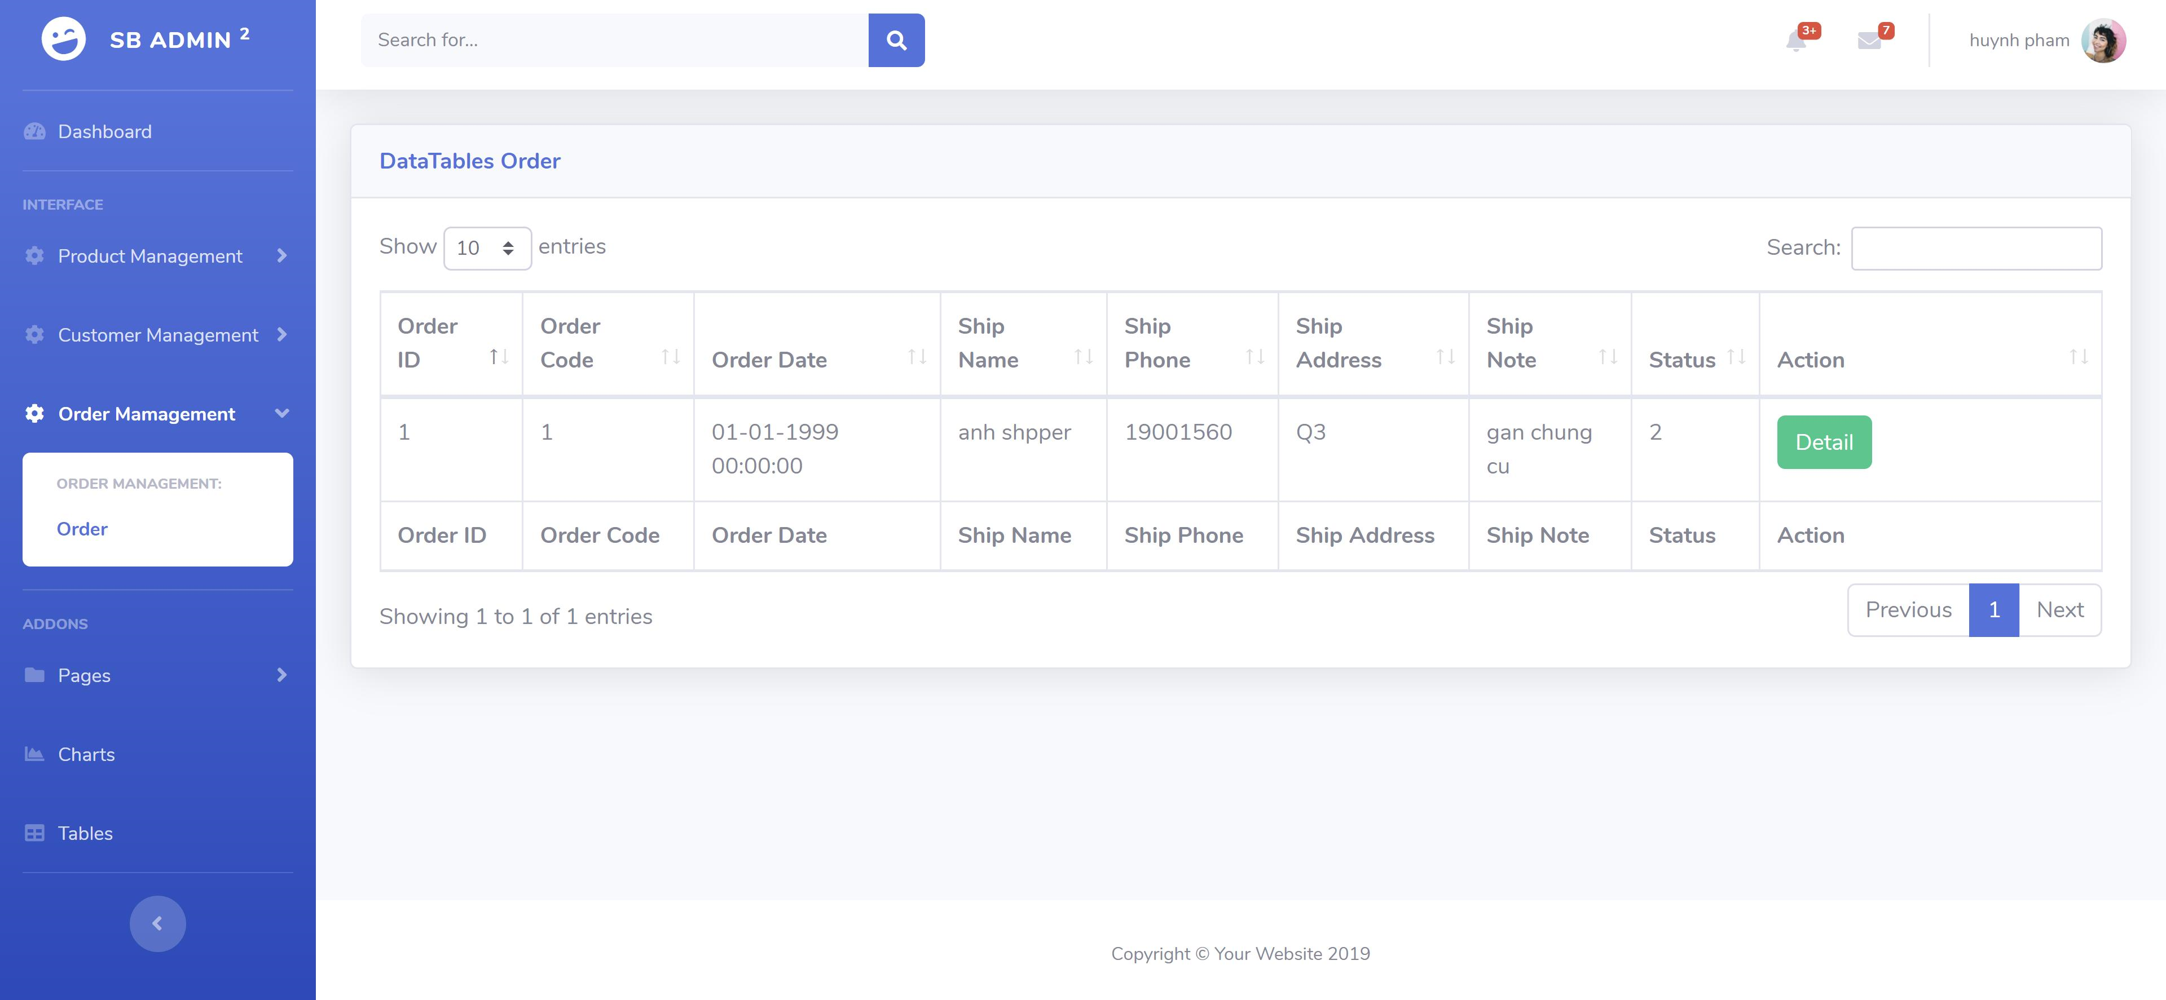

|  |  |  |  |  |  |
| --- | --- | --- | --- | --- | --- |
| **No.** | **Name** | **Type** | **Validation** | **Event** | **Description** |
| 1 | Order List | Table |  |  | Order list |
| 2 | Search | EditText |  |  | Admin type to search |
| 5 | Details | Button |  | Click | Admin click to go to Update order page to update status |

## 25. Update order status page

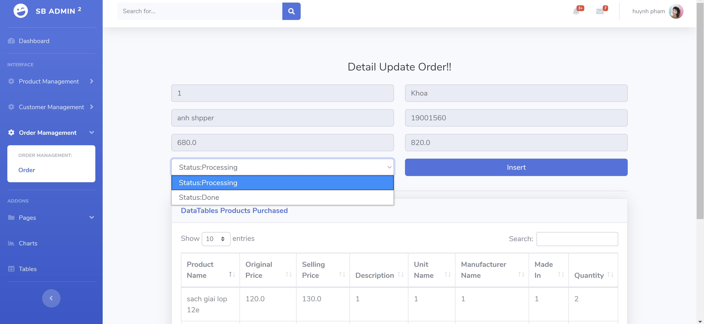

|  |  |  |  |  |  |
| --- | --- | --- | --- | --- | --- |
| **No.** | **Name** | **Type** | **Validation** | **Event** | **Description** |
| 1 | Order Id | Text |  |  | Order Id |
| 2 | Receiver’s name | Text |  |  | Receiver’s name |
| 5 | Receiver’s phone | Text |  |  | Receiver’s phone |
| 6 | Receiver’s address | Text |  |  | Receiver’s address |
| 7 | Original sum | Text |  |  | Original sum |
| 8 | Selling sum | Text |  |  | Selling sum |
| 9 | Order’s status | Select |  | Click | Order’s status. |
| 10 | Update | Button |  |  | Update status of order. If status is NEW, can only update to PROCESSING. If status is PROCESSING, can only update to DONE. |
| 11 | Product list in order | Table list |  |  | Product list in order |

## 26. Report page

# VI. Task sheet Review 3

|  |  |  |  |  |  |  |
| --- | --- | --- | --- | --- | --- | --- |
| Project Ref. No: | | Project Title:  HKTT Store | Date of Preparation of Activity Plan | | | |
| No. | Task | Description | Start Date | Complete Date | Team Member Names | Status |
| 01 | Review 1 | I. Database Relationship Diagram  II. Table Definiton  III. Site map  IV. Customer GUI design  - Home screen  - Cart screen  - Check out screen  - Search by product name  - Filtered by sub category  - Orders list  - Order details  - Report | 22/05/2020 | 27/05/2020 | Le Ngoc Dang Khoa |  |
| 02 | IV. Customer GUI design  - Splash screen  - Login screen  - Sign up  - Profile  - Change password  - Update information  - Product details  - Report | Hoang Thanh Tai |  |
| 03 | V. Admin GUI design  - Category  - Manufacturer  - Unit  - SubCategory  - Report | Ha Minh Tan |  |
| 04 | V. Admin GUI design  - Product  - Promotion  - Customer  - Order  - Report | Pham Huynh |  |

|  |  |  |
| --- | --- | --- |
|  | Prepare By: Group 1 | Approved By: |
| Date: 01/06/2020 | Team Leader  Le Ngoc Dang Khoa | Mr. Ngô Phước Nguyên |